options(warn=-1)  
setwd('/Users/dsing001/LV/R')  
  
#load the csv file and provide the name as lv  
  
library(ggplot2)  
library(discretization)  
library(randomForest)

## randomForest 4.6-10  
## Type rfNews() to see new features/changes/bug fixes.

library(ROCR)

## Loading required package: gplots  
## KernSmooth 2.23 loaded  
## Copyright M. P. Wand 1997-2009  
##   
## Attaching package: 'gplots'  
##   
## The following object is masked from 'package:stats':  
##   
## lowess

library(LV)  
  
filename <- 'LendingClub.csv'  
header <- TRUE  
filename

## [1] "LendingClub.csv"

clscol='Class'  
  
# remove all the uncomplete data  
X <- read.csv(file=filename,header=header)  
clscolpos <- match(clscol,colnames(X))  
X <- X[complete.cases(X),]  
X <- moveclasscolintheend(X,clscolpos)  
X[,clscolpos] <- as.character(X[,clscolpos])  
  
# Change the levels to 0 and 1  
X[X[,clscolpos]=='Creditworthy',clscolpos] <- '0'  
X[X[,clscolpos]=='Uncreditworthy',clscolpos] <- '1'  
X[,clscolpos] <- as.factor(as.numeric(X[,clscol]))  
  
readfromiles=TRUE  
  
  
#After prelim processing I found that some of the data has vey few values in some of the levels and this could be an issue.  
#Also, based on graphs It looked like that some of the data in these factors is independent i.e. chi square test.  
#Thus running whether a process which will merge all the levels of a column which are independent base on chi square. I.e. these levels does not have discrimintaive power w.r.t. class.  
  
# However, first create 3 subsets to make sure that we run this process only on the train data and doesnt do it on test data otherwise there might be a bias in our model.  
  
# Generate the 3 sets. i.e test set 0.3 Valid set is 0.07 and train is 0.63  
  
  
  
dt_set <- generte_train_test_validset(X,test_ratio=0.3,valid_ratio=0.1)

## [1] "we have valid test"  
## [1] "valid set is generated"

train_data <- dt_set$train_data  
test_data <- dt_set$test_data  
valid_data <- dt_set$valid_data  
  
  
  
  
#plotvariousgraphs(train_data,individualplots=TRUE,crossplot=TRUE,byfactcols=FALSE,plotall=FALSE,clscol=clscol,timetovieweachinput=0)  
  
#Run the merge level proces. Not that independence will be tested only on the train data but to be consstent we have to merge the same lable in test data and valid data as well.  
td <- merge_lvls(train_data,test_data,valid_data)

## [1] 0 0 0 0 0 0  
## Levels: 0 1  
## [1] 2 4 6 7 9 15 20 21  
## 'data.frame': 15578 obs. of 21 variables:  
## $ Loan.Amount : int 1200 10800 4000 3200 10625 2800 3000 10000 18000 5000 ...  
## $ Loan.Term : Factor w/ 2 levels "36 Months","60 Months": 1 1 1 1 1 2 1 1 1 1 ...  
## $ Employment.Length : num 10 6 0.5 5 10 0.5 9 10 10 2 ...  
## $ Home.Ownership : Factor w/ 5 levels "MORTGAGE","NOne",..: 4 5 1 5 1 5 1 1 1 5 ...  
## $ Annual.Income : num 54000 32000 148000 54000 34000 ...  
## $ Loan.Purpose : Factor w/ 15 levels "0","Car","Credit Card",..: 4 4 3 4 4 4 13 8 4 8 ...  
## $ Address.State : Factor w/ 51 levels "","AK","AL","AR",..: 44 8 44 21 27 6 12 29 48 19 ...  
## $ Debt.To.Income.Ratio : num 5.47 11.63 16.98 6.51 22.09 ...  
## $ No..Delinquencies.In.Last.2.Years: Factor w/ 10 levels "Eight","Five",..: 5 5 5 5 5 5 6 5 5 5 ...  
## $ Earliest.Credit.Line.Opened : num 31068 35411 34095 38872 33085 ...  
## $ FICO.Credit.Score : int 675 680 725 740 675 705 745 700 710 665 ...  
## $ No..Inquiries.In.Last.6.Months : int 0 1 0 0 2 0 0 1 0 3 ...  
## $ Months.Since.Last.Delinquency : int 64 58 0 0 57 0 16 45 0 0 ...  
## $ No..Of.Credit.Lines : int 5 14 11 7 5 7 14 7 2 2 ...  
## $ No..Adverse.Public.Records : Factor w/ 5 levels "Four","None",..: 2 2 2 2 3 3 2 2 2 2 ...  
## $ Total.Credit.Balance : int 2584 3511 50000 3198 13846 2183 3021 5394 8311 591 ...  
## $ Use.Of.Credit.Line : num 40.4 25.6 51 51.1 71 19.5 4.8 53.4 59.8 84.4 ...  
## $ Total.Number.Of.Credit.Lines : int 31 40 19 11 16 23 25 23 9 6 ...  
## $ Loan.Application.Description : int 748 403 363 141 62 302 651 40 55 192 ...  
## $ No..Of.Public.Record.Bankruptcies: Factor w/ 3 levels "None","One","Two": 1 1 1 1 2 2 1 1 1 1 ...  
## $ Class : Factor w/ 2 levels "0","1": 1 1 1 1 1 1 1 1 1 1 ...  
## NULL  
## [1] "Home.Ownership"  
## [1] "MORTGAGE" "NOne" "OTHER" "OWN" "RENT"   
## [1] 4  
## [1] FALSE  
## [1] "usual"  
## [1] 4  
## [1] "print the p values for factor levels which are independent.These are order by p values. It is for column Home.Ownership"  
## col lvl1 lvl2 pvalue  
## 6 Home.Ownership NOne OTHER 1  
## [1] "here"  
## [1] "OTHER"  
## [1] "Home.Ownership"  
## [1] "MORTGAGE" "NOne" "OWN" "RENT"   
## [1] 4  
## [1] FALSE  
## [1] "usual"  
## [1] 3  
## [1] "print the p values for factor levels which are independent.These are order by p values. It is for column Home.Ownership"  
## col lvl1 lvl2 pvalue  
## 2 Home.Ownership MORTGAGE NOne 0.3363219  
## [1] "here"  
## [1] "NOne"  
## [1] "Home.Ownership"  
## [1] "MORTGAGE" "OWN" "RENT"   
## [1] 4  
## [1] FALSE  
## [1] "usual"  
## [1] 2  
## [1] "print the p values for factor levels which are independent.These are order by p values. It is for column Home.Ownership"  
## col lvl1 lvl2 pvalue  
## 4 Home.Ownership OWN RENT 0.2441458  
## [1] "here"  
## [1] "RENT"  
## 'data.frame': 15578 obs. of 21 variables:  
## $ Loan.Amount : int 1200 10800 4000 3200 10625 2800 3000 10000 18000 5000 ...  
## $ Loan.Term : Factor w/ 2 levels "36 Months","60 Months": 1 1 1 1 1 2 1 1 1 1 ...  
## $ Employment.Length : num 10 6 0.5 5 10 0.5 9 10 10 2 ...  
## $ Home.Ownership : Factor w/ 2 levels "MORTGAGE","OWN": 2 2 1 2 1 2 1 1 1 2 ...  
## $ Annual.Income : num 54000 32000 148000 54000 34000 ...  
## $ Loan.Purpose : Factor w/ 15 levels "0","Car","Credit Card",..: 4 4 3 4 4 4 13 8 4 8 ...  
## $ Address.State : Factor w/ 51 levels "","AK","AL","AR",..: 44 8 44 21 27 6 12 29 48 19 ...  
## $ Debt.To.Income.Ratio : num 5.47 11.63 16.98 6.51 22.09 ...  
## $ No..Delinquencies.In.Last.2.Years: Factor w/ 10 levels "Eight","Five",..: 5 5 5 5 5 5 6 5 5 5 ...  
## $ Earliest.Credit.Line.Opened : num 31068 35411 34095 38872 33085 ...  
## $ FICO.Credit.Score : int 675 680 725 740 675 705 745 700 710 665 ...  
## $ No..Inquiries.In.Last.6.Months : int 0 1 0 0 2 0 0 1 0 3 ...  
## $ Months.Since.Last.Delinquency : int 64 58 0 0 57 0 16 45 0 0 ...  
## $ No..Of.Credit.Lines : int 5 14 11 7 5 7 14 7 2 2 ...  
## $ No..Adverse.Public.Records : Factor w/ 5 levels "Four","None",..: 2 2 2 2 3 3 2 2 2 2 ...  
## $ Total.Credit.Balance : int 2584 3511 50000 3198 13846 2183 3021 5394 8311 591 ...  
## $ Use.Of.Credit.Line : num 40.4 25.6 51 51.1 71 19.5 4.8 53.4 59.8 84.4 ...  
## $ Total.Number.Of.Credit.Lines : int 31 40 19 11 16 23 25 23 9 6 ...  
## $ Loan.Application.Description : int 748 403 363 141 62 302 651 40 55 192 ...  
## $ No..Of.Public.Record.Bankruptcies: Factor w/ 3 levels "None","One","Two": 1 1 1 1 2 2 1 1 1 1 ...  
## $ Class : Factor w/ 2 levels "0","1": 1 1 1 1 1 1 1 1 1 1 ...  
## NULL  
## [1] "Loan.Purpose"  
## [1] "0" "Car" "Credit Card"   
## [4] "Debt Consolidation" "Educationalal" "Home Improvement"   
## [7] "House" "Major Purchase" "Medical"   
## [10] "Moving" "Other" "Renewable Energy"   
## [13] "Small Business" "Vacation" "Wedding"   
## [1] 6  
## [1] FALSE  
## [1] "usual"  
## [1] 14  
## [1] "print the p values for factor levels which are independent.These are order by p values. It is for column Loan.Purpose"  
## col lvl1 lvl2 pvalue  
## 2 Loan.Purpose 0 Car 1  
## [1] "here"  
## [1] "Car"  
## [1] "Loan.Purpose"  
## [1] "0" "Credit Card" "Debt Consolidation"  
## [4] "Educationalal" "Home Improvement" "House"   
## [7] "Major Purchase" "Medical" "Moving"   
## [10] "Other" "Renewable Energy" "Small Business"   
## [13] "Vacation" "Wedding"   
## [1] 6  
## [1] FALSE  
## [1] "usual"  
## [1] 13  
## [1] "print the p values for factor levels which are independent.These are order by p values. It is for column Loan.Purpose"  
## col lvl1 lvl2 pvalue  
## 88 Loan.Purpose Renewable Energy Vacation 1  
## [1] "here"  
## [1] "Vacation"  
## [1] "Loan.Purpose"  
## [1] "0" "Credit Card" "Debt Consolidation"  
## [4] "Educationalal" "Home Improvement" "House"   
## [7] "Major Purchase" "Medical" "Moving"   
## [10] "Other" "Renewable Energy" "Small Business"   
## [13] "Wedding"   
## [1] 6  
## [1] FALSE  
## [1] "usual"  
## [1] 12  
## [1] "print the p values for factor levels which are independent.These are order by p values. It is for column Loan.Purpose"  
## col lvl1 lvl2 pvalue  
## 36 Loan.Purpose Educationalal House 1  
## [1] "here"  
## [1] "House"  
## [1] "Loan.Purpose"  
## [1] "0" "Credit Card" "Debt Consolidation"  
## [4] "Educationalal" "Home Improvement" "Major Purchase"   
## [7] "Medical" "Moving" "Other"   
## [10] "Renewable Energy" "Small Business" "Wedding"   
## [1] 6  
## [1] FALSE  
## [1] "usual"  
## [1] 11  
## [1] "print the p values for factor levels which are independent.These are order by p values. It is for column Loan.Purpose"  
## col lvl1 lvl2 pvalue  
## 55 Loan.Purpose Medical Renewable Energy 1  
## [1] "here"  
## [1] "Renewable Energy"  
## [1] "Loan.Purpose"  
## [1] "0" "Credit Card" "Debt Consolidation"  
## [4] "Educationalal" "Home Improvement" "Major Purchase"   
## [7] "Medical" "Moving" "Other"   
## [10] "Small Business" "Wedding"   
## [1] 6  
## [1] FALSE  
## [1] "usual"  
## [1] 10  
## [1] "print the p values for factor levels which are independent.These are order by p values. It is for column Loan.Purpose"  
## col lvl1 lvl2 pvalue  
## 47 Loan.Purpose Medical Moving 0.9371964  
## [1] "here"  
## [1] "Moving"  
## [1] "Loan.Purpose"  
## [1] "0" "Credit Card" "Debt Consolidation"  
## [4] "Educationalal" "Home Improvement" "Major Purchase"   
## [7] "Medical" "Other" "Small Business"   
## [10] "Wedding"   
## [1] 6  
## [1] FALSE  
## [1] "usual"  
## [1] 9  
## [1] "print the p values for factor levels which are independent.These are order by p values. It is for column Loan.Purpose"  
## col lvl1 lvl2 pvalue  
## 31 Loan.Purpose Educationalal Wedding 0.9043969  
## [1] "here"  
## [1] "Wedding"  
## [1] "Loan.Purpose"  
## [1] "0" "Credit Card" "Debt Consolidation"  
## [4] "Educationalal" "Home Improvement" "Major Purchase"   
## [7] "Medical" "Other" "Small Business"   
## [1] 6  
## [1] FALSE  
## [1] "usual"  
## [1] 8  
## [1] "print the p values for factor levels which are independent.These are order by p values. It is for column Loan.Purpose"  
## col lvl1 lvl2 pvalue  
## 35 Loan.Purpose Medical Other 0.6539202  
## [1] "here"  
## [1] "Other"  
## [1] "Loan.Purpose"  
## [1] "0" "Credit Card" "Debt Consolidation"  
## [4] "Educationalal" "Home Improvement" "Major Purchase"   
## [7] "Medical" "Small Business"   
## [1] 6  
## [1] FALSE  
## [1] "usual"  
## [1] 7  
## [1] "print the p values for factor levels which are independent.These are order by p values. It is for column Loan.Purpose"  
## col lvl1 lvl2 pvalue  
## 15 Loan.Purpose Debt Consolidation Educationalal 0.6098976  
## [1] "here"  
## [1] "Educationalal"  
## [1] "Loan.Purpose"  
## [1] "0" "Credit Card" "Debt Consolidation"  
## [4] "Home Improvement" "Major Purchase" "Medical"   
## [7] "Small Business"   
## [1] 6  
## [1] FALSE  
## [1] "usual"  
## [1] 6  
## [1] "print the p values for factor levels which are independent.These are order by p values. It is for column Loan.Purpose"  
## col lvl1 lvl2 pvalue  
## 17 Loan.Purpose Home Improvement Major Purchase 0.5880102  
## [1] "here"  
## [1] "Major Purchase"  
## [1] "Loan.Purpose"  
## [1] "0" "Credit Card" "Debt Consolidation"  
## [4] "Home Improvement" "Medical" "Small Business"   
## [1] 6  
## [1] FALSE  
## [1] "usual"  
## [1] 5  
## [1] "print the p values for factor levels which are independent.These are order by p values. It is for column Loan.Purpose"  
## col lvl1 lvl2 pvalue  
## 2 Loan.Purpose 0 Credit Card 0.458742  
## [1] "here"  
## [1] "Credit Card"  
## [1] "Loan.Purpose"  
## [1] "0" "Debt Consolidation" "Home Improvement"   
## [4] "Medical" "Small Business"   
## [1] 6  
## [1] FALSE  
## [1] "usual"  
## [1] 4  
## [1] "print the p values for factor levels which are independent.These are order by p values. It is for column Loan.Purpose"  
## col lvl1 lvl2 pvalue  
## 7 Loan.Purpose Debt Consolidation Medical 0.002007988  
## [1] "thr"  
## 'data.frame': 15578 obs. of 21 variables:  
## $ Loan.Amount : int 1200 10800 4000 3200 10625 2800 3000 10000 18000 5000 ...  
## $ Loan.Term : Factor w/ 2 levels "36 Months","60 Months": 1 1 1 1 1 2 1 1 1 1 ...  
## $ Employment.Length : num 10 6 0.5 5 10 0.5 9 10 10 2 ...  
## $ Home.Ownership : Factor w/ 2 levels "MORTGAGE","OWN": 2 2 1 2 1 2 1 1 1 2 ...  
## $ Annual.Income : num 54000 32000 148000 54000 34000 ...  
## $ Loan.Purpose : Factor w/ 5 levels "0","Debt Consolidation",..: 2 2 1 2 2 2 5 3 2 3 ...  
## $ Address.State : Factor w/ 51 levels "","AK","AL","AR",..: 44 8 44 21 27 6 12 29 48 19 ...  
## $ Debt.To.Income.Ratio : num 5.47 11.63 16.98 6.51 22.09 ...  
## $ No..Delinquencies.In.Last.2.Years: Factor w/ 10 levels "Eight","Five",..: 5 5 5 5 5 5 6 5 5 5 ...  
## $ Earliest.Credit.Line.Opened : num 31068 35411 34095 38872 33085 ...  
## $ FICO.Credit.Score : int 675 680 725 740 675 705 745 700 710 665 ...  
## $ No..Inquiries.In.Last.6.Months : int 0 1 0 0 2 0 0 1 0 3 ...  
## $ Months.Since.Last.Delinquency : int 64 58 0 0 57 0 16 45 0 0 ...  
## $ No..Of.Credit.Lines : int 5 14 11 7 5 7 14 7 2 2 ...  
## $ No..Adverse.Public.Records : Factor w/ 5 levels "Four","None",..: 2 2 2 2 3 3 2 2 2 2 ...  
## $ Total.Credit.Balance : int 2584 3511 50000 3198 13846 2183 3021 5394 8311 591 ...  
## $ Use.Of.Credit.Line : num 40.4 25.6 51 51.1 71 19.5 4.8 53.4 59.8 84.4 ...  
## $ Total.Number.Of.Credit.Lines : int 31 40 19 11 16 23 25 23 9 6 ...  
## $ Loan.Application.Description : int 748 403 363 141 62 302 651 40 55 192 ...  
## $ No..Of.Public.Record.Bankruptcies: Factor w/ 3 levels "None","One","Two": 1 1 1 1 2 2 1 1 1 1 ...  
## $ Class : Factor w/ 2 levels "0","1": 1 1 1 1 1 1 1 1 1 1 ...  
## NULL  
## [1] "Address.State"  
## [1] "" "AK" "AL" "AR" "AZ" "CA" "CO" "CT" "DC" "DE" "FL" "GA" "HI" "IA"  
## [15] "ID" "IL" "IN" "KS" "KY" "LA" "MA" "MD" "ME" "MI" "MN" "MO" "MS" "MT"  
## [29] "NC" "NE" "NH" "NJ" "NM" "NV" "NY" "OH" "OK" "OR" "PA" "RI" "SC" "SD"  
## [43] "TN" "TX" "UT" "VA" "VT" "WA" "WI" "WV" "WY"  
## [1] 7  
## [1] FALSE  
## [1] "usual"  
## [1] 50  
## [1] "print the p values for factor levels which are independent.These are order by p values. It is for column Address.State"  
## col lvl1 lvl2 pvalue  
## 2 Address.State AK 1  
## [1] "here"  
## [1] "AK"  
## [1] "Address.State"  
## [1] "" "AL" "AR" "AZ" "CA" "CO" "CT" "DC" "DE" "FL" "GA" "HI" "IA" "ID"  
## [15] "IL" "IN" "KS" "KY" "LA" "MA" "MD" "ME" "MI" "MN" "MO" "MS" "MT" "NC"  
## [29] "NE" "NH" "NJ" "NM" "NV" "NY" "OH" "OK" "OR" "PA" "RI" "SC" "SD" "TN"  
## [43] "TX" "UT" "VA" "VT" "WA" "WI" "WV" "WY"  
## [1] 7  
## [1] FALSE  
## [1] "usual"  
## [1] 49  
## [1] "print the p values for factor levels which are independent.These are order by p values. It is for column Address.State"  
## col lvl1 lvl2 pvalue  
## 13 Address.State IA 1  
## [1] "here"  
## [1] "IA"  
## [1] "Address.State"  
## [1] "" "AL" "AR" "AZ" "CA" "CO" "CT" "DC" "DE" "FL" "GA" "HI" "ID" "IL"  
## [15] "IN" "KS" "KY" "LA" "MA" "MD" "ME" "MI" "MN" "MO" "MS" "MT" "NC" "NE"  
## [29] "NH" "NJ" "NM" "NV" "NY" "OH" "OK" "OR" "PA" "RI" "SC" "SD" "TN" "TX"  
## [43] "UT" "VA" "VT" "WA" "WI" "WV" "WY"  
## [1] 7  
## [1] FALSE  
## [1] "usual"  
## [1] 48  
## [1] "print the p values for factor levels which are independent.These are order by p values. It is for column Address.State"  
## col lvl1 lvl2 pvalue  
## 15 Address.State IN 1  
## [1] "here"  
## [1] "IN"  
## [1] "Address.State"  
## [1] "" "AL" "AR" "AZ" "CA" "CO" "CT" "DC" "DE" "FL" "GA" "HI" "ID" "IL"  
## [15] "KS" "KY" "LA" "MA" "MD" "ME" "MI" "MN" "MO" "MS" "MT" "NC" "NE" "NH"  
## [29] "NJ" "NM" "NV" "NY" "OH" "OK" "OR" "PA" "RI" "SC" "SD" "TN" "TX" "UT"  
## [43] "VA" "VT" "WA" "WI" "WV" "WY"  
## [1] 7  
## [1] FALSE  
## [1] "usual"  
## [1] 47  
## [1] "print the p values for factor levels which are independent.These are order by p values. It is for column Address.State"  
## col lvl1 lvl2 pvalue  
## 20 Address.State ME 1  
## [1] "here"  
## [1] "ME"  
## [1] "Address.State"  
## [1] "" "AL" "AR" "AZ" "CA" "CO" "CT" "DC" "DE" "FL" "GA" "HI" "ID" "IL"  
## [15] "KS" "KY" "LA" "MA" "MD" "MI" "MN" "MO" "MS" "MT" "NC" "NE" "NH" "NJ"  
## [29] "NM" "NV" "NY" "OH" "OK" "OR" "PA" "RI" "SC" "SD" "TN" "TX" "UT" "VA"  
## [43] "VT" "WA" "WI" "WV" "WY"  
## [1] 7  
## [1] FALSE  
## [1] "usual"  
## [1] 46  
## [1] "print the p values for factor levels which are independent.These are order by p values. It is for column Address.State"  
## col lvl1 lvl2 pvalue  
## 23 Address.State MS 1  
## [1] "here"  
## [1] "MS"  
## [1] "Address.State"  
## [1] "" "AL" "AR" "AZ" "CA" "CO" "CT" "DC" "DE" "FL" "GA" "HI" "ID" "IL"  
## [15] "KS" "KY" "LA" "MA" "MD" "MI" "MN" "MO" "MT" "NC" "NE" "NH" "NJ" "NM"  
## [29] "NV" "NY" "OH" "OK" "OR" "PA" "RI" "SC" "SD" "TN" "TX" "UT" "VA" "VT"  
## [43] "WA" "WI" "WV" "WY"  
## [1] 7  
## [1] FALSE  
## [1] "usual"  
## [1] 45  
## [1] "print the p values for factor levels which are independent.These are order by p values. It is for column Address.State"  
## col lvl1 lvl2 pvalue  
## 13 Address.State ID 1  
## [1] "here"  
## [1] "ID"  
## [1] "Address.State"  
## [1] "" "AL" "AR" "AZ" "CA" "CO" "CT" "DC" "DE" "FL" "GA" "HI" "IL" "KS"  
## [15] "KY" "LA" "MA" "MD" "MI" "MN" "MO" "MT" "NC" "NE" "NH" "NJ" "NM" "NV"  
## [29] "NY" "OH" "OK" "OR" "PA" "RI" "SC" "SD" "TN" "TX" "UT" "VA" "VT" "WA"  
## [43] "WI" "WV" "WY"  
## [1] 7  
## [1] FALSE  
## [1] "usual"  
## [1] 44  
## [1] "print the p values for factor levels which are independent.These are order by p values. It is for column Address.State"  
## col lvl1 lvl2 pvalue  
## 22 Address.State MT 1  
## [1] "here"  
## [1] "MT"  
## [1] "Address.State"  
## [1] "" "AL" "AR" "AZ" "CA" "CO" "CT" "DC" "DE" "FL" "GA" "HI" "IL" "KS"  
## [15] "KY" "LA" "MA" "MD" "MI" "MN" "MO" "NC" "NE" "NH" "NJ" "NM" "NV" "NY"  
## [29] "OH" "OK" "OR" "PA" "RI" "SC" "SD" "TN" "TX" "UT" "VA" "VT" "WA" "WI"  
## [43] "WV" "WY"  
## [1] 7  
## [1] FALSE  
## [1] "usual"  
## [1] 43  
## [1] "print the p values for factor levels which are independent.These are order by p values. It is for column Address.State"  
## col lvl1 lvl2 pvalue  
## 56 Address.State AL KS 1  
## [1] "here"  
## [1] "KS"  
## [1] "Address.State"  
## [1] "" "AL" "AR" "AZ" "CA" "CO" "CT" "DC" "DE" "FL" "GA" "HI" "IL" "KY"  
## [15] "LA" "MA" "MD" "MI" "MN" "MO" "NC" "NE" "NH" "NJ" "NM" "NV" "NY" "OH"  
## [29] "OK" "OR" "PA" "RI" "SC" "SD" "TN" "TX" "UT" "VA" "VT" "WA" "WI" "WV"  
## [43] "WY"  
## [1] 7  
## [1] FALSE  
## [1] "usual"  
## [1] 42  
## [1] "print the p values for factor levels which are independent.These are order by p values. It is for column Address.State"  
## col lvl1 lvl2 pvalue  
## 80 Address.State AL VT 1  
## [1] "here"  
## [1] "VT"  
## [1] "Address.State"  
## [1] "" "AL" "AR" "AZ" "CA" "CO" "CT" "DC" "DE" "FL" "GA" "HI" "IL" "KY"  
## [15] "LA" "MA" "MD" "MI" "MN" "MO" "NC" "NE" "NH" "NJ" "NM" "NV" "NY" "OH"  
## [29] "OK" "OR" "PA" "RI" "SC" "SD" "TN" "TX" "UT" "VA" "WA" "WI" "WV" "WY"  
## [1] 7  
## [1] FALSE  
## [1] "usual"  
## [1] 41  
## [1] "print the p values for factor levels which are independent.These are order by p values. It is for column Address.State"  
## col lvl1 lvl2 pvalue  
## 65 Address.State AL NM 1  
## [1] "here"  
## [1] "NM"  
## [1] "Address.State"  
## [1] "" "AL" "AR" "AZ" "CA" "CO" "CT" "DC" "DE" "FL" "GA" "HI" "IL" "KY"  
## [15] "LA" "MA" "MD" "MI" "MN" "MO" "NC" "NE" "NH" "NJ" "NV" "NY" "OH" "OK"  
## [29] "OR" "PA" "RI" "SC" "SD" "TN" "TX" "UT" "VA" "WA" "WI" "WV" "WY"  
## [1] 7  
## [1] FALSE  
## [1] "usual"  
## [1] 40  
## [1] "print the p values for factor levels which are independent.These are order by p values. It is for column Address.State"  
## col lvl1 lvl2 pvalue  
## 70 Address.State AL RI 1  
## [1] "here"  
## [1] "RI"  
## [1] "Address.State"  
## [1] "" "AL" "AR" "AZ" "CA" "CO" "CT" "DC" "DE" "FL" "GA" "HI" "IL" "KY"  
## [15] "LA" "MA" "MD" "MI" "MN" "MO" "NC" "NE" "NH" "NJ" "NV" "NY" "OH" "OK"  
## [29] "OR" "PA" "SC" "SD" "TN" "TX" "UT" "VA" "WA" "WI" "WV" "WY"  
## [1] 7  
## [1] FALSE  
## [1] "usual"  
## [1] 39  
## [1] "print the p values for factor levels which are independent.These are order by p values. It is for column Address.State"  
## col lvl1 lvl2 pvalue  
## 132 Address.State AZ NC 1  
## [1] "here"  
## [1] "NC"  
## [1] "Address.State"  
## [1] "" "AL" "AR" "AZ" "CA" "CO" "CT" "DC" "DE" "FL" "GA" "HI" "IL" "KY"  
## [15] "LA" "MA" "MD" "MI" "MN" "MO" "NE" "NH" "NJ" "NV" "NY" "OH" "OK" "OR"  
## [29] "PA" "SC" "SD" "TN" "TX" "UT" "VA" "WA" "WI" "WV" "WY"  
## [1] 7  
## [1] FALSE  
## [1] "usual"  
## [1] 38  
## [1] "print the p values for factor levels which are independent.These are order by p values. It is for column Address.State"  
## col lvl1 lvl2 pvalue  
## 290 Address.State DE NH 1  
## [1] "here"  
## [1] "NH"  
## [1] "Address.State"  
## [1] "" "AL" "AR" "AZ" "CA" "CO" "CT" "DC" "DE" "FL" "GA" "HI" "IL" "KY"  
## [15] "LA" "MA" "MD" "MI" "MN" "MO" "NE" "NJ" "NV" "NY" "OH" "OK" "OR" "PA"  
## [29] "SC" "SD" "TN" "TX" "UT" "VA" "WA" "WI" "WV" "WY"  
## [1] 7  
## [1] FALSE  
## [1] "usual"  
## [1] 37  
## [1] "print the p values for factor levels which are independent.These are order by p values. It is for column Address.State"  
## col lvl1 lvl2 pvalue  
## 374 Address.State HI UT 1  
## [1] "here"  
## [1] "UT"  
## [1] "Address.State"  
## [1] "" "AL" "AR" "AZ" "CA" "CO" "CT" "DC" "DE" "FL" "GA" "HI" "IL" "KY"  
## [15] "LA" "MA" "MD" "MI" "MN" "MO" "NE" "NJ" "NV" "NY" "OH" "OK" "OR" "PA"  
## [29] "SC" "SD" "TN" "TX" "VA" "WA" "WI" "WV" "WY"  
## [1] 7  
## [1] FALSE  
## [1] "usual"  
## [1] 36  
## [1] "print the p values for factor levels which are independent.These are order by p values. It is for column Address.State"  
## col lvl1 lvl2 pvalue  
## 413 Address.State KY WV 1  
## [1] "here"  
## [1] "WV"  
## [1] "Address.State"  
## [1] "" "AL" "AR" "AZ" "CA" "CO" "CT" "DC" "DE" "FL" "GA" "HI" "IL" "KY"  
## [15] "LA" "MA" "MD" "MI" "MN" "MO" "NE" "NJ" "NV" "NY" "OH" "OK" "OR" "PA"  
## [29] "SC" "SD" "TN" "TX" "VA" "WA" "WI" "WY"  
## [1] 7  
## [1] FALSE  
## [1] "usual"  
## [1] 35  
## [1] "print the p values for factor levels which are independent.These are order by p values. It is for column Address.State"  
## col lvl1 lvl2 pvalue  
## 555 Address.State NY OK 1  
## [1] "here"  
## [1] "OK"  
## [1] "Address.State"  
## [1] "" "AL" "AR" "AZ" "CA" "CO" "CT" "DC" "DE" "FL" "GA" "HI" "IL" "KY"  
## [15] "LA" "MA" "MD" "MI" "MN" "MO" "NE" "NJ" "NV" "NY" "OH" "OR" "PA" "SC"  
## [29] "SD" "TN" "TX" "VA" "WA" "WI" "WY"  
## [1] 7  
## [1] FALSE  
## [1] "usual"  
## [1] 34  
## [1] "print the p values for factor levels which are independent.These are order by p values. It is for column Address.State"  
## col lvl1 lvl2 pvalue  
## 586 Address.State TN WY 1  
## [1] "here"  
## [1] "WY"  
## [1] "Address.State"  
## [1] "" "AL" "AR" "AZ" "CA" "CO" "CT" "DC" "DE" "FL" "GA" "HI" "IL" "KY"  
## [15] "LA" "MA" "MD" "MI" "MN" "MO" "NE" "NJ" "NV" "NY" "OH" "OR" "PA" "SC"  
## [29] "SD" "TN" "TX" "VA" "WA" "WI"  
## [1] 7  
## [1] FALSE  
## [1] "usual"  
## [1] 33  
## [1] "print the p values for factor levels which are independent.These are order by p values. It is for column Address.State"  
## col lvl1 lvl2 pvalue  
## 233 Address.State DC TN 1  
## [1] "here"  
## [1] "TN"  
## [1] "Address.State"  
## [1] "" "AL" "AR" "AZ" "CA" "CO" "CT" "DC" "DE" "FL" "GA" "HI" "IL" "KY"  
## [15] "LA" "MA" "MD" "MI" "MN" "MO" "NE" "NJ" "NV" "NY" "OH" "OR" "PA" "SC"  
## [29] "SD" "TX" "VA" "WA" "WI"  
## [1] 7  
## [1] FALSE  
## [1] "usual"  
## [1] 32  
## [1] "print the p values for factor levels which are independent.These are order by p values. It is for column Address.State"  
## col lvl1 lvl2 pvalue  
## 76 Address.State AR LA 1  
## [1] "here"  
## [1] "LA"  
## [1] "Address.State"  
## [1] "" "AL" "AR" "AZ" "CA" "CO" "CT" "DC" "DE" "FL" "GA" "HI" "IL" "KY"  
## [15] "MA" "MD" "MI" "MN" "MO" "NE" "NJ" "NV" "NY" "OH" "OR" "PA" "SC" "SD"  
## [29] "TX" "VA" "WA" "WI"  
## [1] 7  
## [1] FALSE  
## [1] "usual"  
## [1] 31  
## [1] "print the p values for factor levels which are independent.These are order by p values. It is for column Address.State"  
## col lvl1 lvl2 pvalue  
## 149 Address.State CO DE 1  
## [1] "here"  
## [1] "DE"  
## [1] "Address.State"  
## [1] "" "AL" "AR" "AZ" "CA" "CO" "CT" "DC" "FL" "GA" "HI" "IL" "KY" "MA"  
## [15] "MD" "MI" "MN" "MO" "NE" "NJ" "NV" "NY" "OH" "OR" "PA" "SC" "SD" "TX"  
## [29] "VA" "WA" "WI"  
## [1] 7  
## [1] FALSE  
## [1] "usual"  
## [1] 30  
## [1] "print the p values for factor levels which are independent.These are order by p values. It is for column Address.State"  
## col lvl1 lvl2 pvalue  
## 147 Address.State CO IL 1  
## [1] "here"  
## [1] "IL"  
## [1] "Address.State"  
## [1] "" "AL" "AR" "AZ" "CA" "CO" "CT" "DC" "FL" "GA" "HI" "KY" "MA" "MD"  
## [15] "MI" "MN" "MO" "NE" "NJ" "NV" "NY" "OH" "OR" "PA" "SC" "SD" "TX" "VA"  
## [29] "WA" "WI"  
## [1] 7  
## [1] FALSE  
## [1] "usual"  
## [1] 29  
## [1] "print the p values for factor levels which are independent.These are order by p values. It is for column Address.State"  
## col lvl1 lvl2 pvalue  
## 168 Address.State CT MI 1  
## [1] "here"  
## [1] "MI"  
## [1] "Address.State"  
## [1] "" "AL" "AR" "AZ" "CA" "CO" "CT" "DC" "FL" "GA" "HI" "KY" "MA" "MD"  
## [15] "MN" "MO" "NE" "NJ" "NV" "NY" "OH" "OR" "PA" "SC" "SD" "TX" "VA" "WA"  
## [29] "WI"  
## [1] 7  
## [1] FALSE  
## [1] "usual"  
## [1] 28  
## [1] "print the p values for factor levels which are independent.These are order by p values. It is for column Address.State"  
## col lvl1 lvl2 pvalue  
## 271 Address.State KY WI 1  
## [1] "here"  
## [1] "WI"  
## [1] "Address.State"  
## [1] "" "AL" "AR" "AZ" "CA" "CO" "CT" "DC" "FL" "GA" "HI" "KY" "MA" "MD"  
## [15] "MN" "MO" "NE" "NJ" "NV" "NY" "OH" "OR" "PA" "SC" "SD" "TX" "VA" "WA"  
## [1] 7  
## [1] FALSE  
## [1] "usual"  
## [1] 27  
## [1] "print the p values for factor levels which are independent.These are order by p values. It is for column Address.State"  
## col lvl1 lvl2 pvalue  
## 259 Address.State KY WA 1  
## [1] "here"  
## [1] "WA"  
## [1] "Address.State"  
## [1] "" "AL" "AR" "AZ" "CA" "CO" "CT" "DC" "FL" "GA" "HI" "KY" "MA" "MD"  
## [15] "MN" "MO" "NE" "NJ" "NV" "NY" "OH" "OR" "PA" "SC" "SD" "TX" "VA"  
## [1] 7  
## [1] FALSE  
## [1] "usual"  
## [1] 26  
## [1] "print the p values for factor levels which are independent.These are order by p values. It is for column Address.State"  
## col lvl1 lvl2 pvalue  
## 94 Address.State AZ OR 1  
## [1] "here"  
## [1] "OR"  
## [1] "Address.State"  
## [1] "" "AL" "AR" "AZ" "CA" "CO" "CT" "DC" "FL" "GA" "HI" "KY" "MA" "MD"  
## [15] "MN" "MO" "NE" "NJ" "NV" "NY" "OH" "PA" "SC" "SD" "TX" "VA"  
## [1] 7  
## [1] FALSE  
## [1] "usual"  
## [1] 25  
## [1] "print the p values for factor levels which are independent.These are order by p values. It is for column Address.State"  
## col lvl1 lvl2 pvalue  
## 144 Address.State CT MN 1  
## [1] "here"  
## [1] "MN"  
## [1] "Address.State"  
## [1] "" "AL" "AR" "AZ" "CA" "CO" "CT" "DC" "FL" "GA" "HI" "KY" "MA" "MD"  
## [15] "MO" "NE" "NJ" "NV" "NY" "OH" "PA" "SC" "SD" "TX" "VA"  
## [1] 7  
## [1] FALSE  
## [1] "usual"  
## [1] 24  
## [1] "print the p values for factor levels which are independent.These are order by p values. It is for column Address.State"  
## col lvl1 lvl2 pvalue  
## 125 Address.State CO OH 1  
## [1] "here"  
## [1] "OH"  
## [1] "Address.State"  
## [1] "" "AL" "AR" "AZ" "CA" "CO" "CT" "DC" "FL" "GA" "HI" "KY" "MA" "MD"  
## [15] "MO" "NE" "NJ" "NV" "NY" "PA" "SC" "SD" "TX" "VA"  
## [1] 7  
## [1] FALSE  
## [1] "usual"  
## [1] 23  
## [1] "print the p values for factor levels which are independent.These are order by p values. It is for column Address.State"  
## col lvl1 lvl2 pvalue  
## 266 Address.State NY TX 0.9969609  
## [1] "here"  
## [1] "TX"  
## [1] "Address.State"  
## [1] "" "AL" "AR" "AZ" "CA" "CO" "CT" "DC" "FL" "GA" "HI" "KY" "MA" "MD"  
## [15] "MO" "NE" "NJ" "NV" "NY" "PA" "SC" "SD" "VA"  
## [1] 7  
## [1] FALSE  
## [1] "usual"  
## [1] 22  
## [1] "print the p values for factor levels which are independent.These are order by p values. It is for column Address.State"  
## col lvl1 lvl2 pvalue  
## 34 Address.State AL MA 0.9917388  
## [1] "here"  
## [1] "MA"  
## [1] "Address.State"  
## [1] "" "AL" "AR" "AZ" "CA" "CO" "CT" "DC" "FL" "GA" "HI" "KY" "MD" "MO"  
## [15] "NE" "NJ" "NV" "NY" "PA" "SC" "SD" "VA"  
## [1] 7  
## [1] FALSE  
## [1] "usual"  
## [1] 21  
## [1] "print the p values for factor levels which are independent.These are order by p values. It is for column Address.State"  
## col lvl1 lvl2 pvalue  
## 202 Address.State MO SC 0.9729005  
## [1] "here"  
## [1] "SC"  
## [1] "Address.State"  
## [1] "" "AL" "AR" "AZ" "CA" "CO" "CT" "DC" "FL" "GA" "HI" "KY" "MD" "MO"  
## [15] "NE" "NJ" "NV" "NY" "PA" "SD" "VA"  
## [1] 7  
## [1] FALSE  
## [1] "usual"  
## [1] 20  
## [1] "print the p values for factor levels which are independent.These are order by p values. It is for column Address.State"  
## col lvl1 lvl2 pvalue  
## 210 Address.State PA VA 0.9175623  
## [1] "here"  
## [1] "VA"  
## [1] "Address.State"  
## [1] "" "AL" "AR" "AZ" "CA" "CO" "CT" "DC" "FL" "GA" "HI" "KY" "MD" "MO"  
## [15] "NE" "NJ" "NV" "NY" "PA" "SD"  
## [1] 7  
## [1] FALSE  
## [1] "usual"  
## [1] 19  
## [1] "print the p values for factor levels which are independent.These are order by p values. It is for column Address.State"  
## col lvl1 lvl2 pvalue  
## 8 Address.State DC 0.9072167  
## [1] "here"  
## [1] "DC"  
## [1] "Address.State"  
## [1] "" "AL" "AR" "AZ" "CA" "CO" "CT" "FL" "GA" "HI" "KY" "MD" "MO" "NE"  
## [15] "NJ" "NV" "NY" "PA" "SD"  
## [1] 7  
## [1] FALSE  
## [1] "usual"  
## [1] 18  
## [1] "print the p values for factor levels which are independent.These are order by p values. It is for column Address.State"  
## col lvl1 lvl2 pvalue  
## 71 Address.State CA GA 0.9045635  
## [1] "here"  
## [1] "GA"  
## [1] "Address.State"  
## [1] "" "AL" "AR" "AZ" "CA" "CO" "CT" "FL" "HI" "KY" "MD" "MO" "NE" "NJ"  
## [15] "NV" "NY" "PA" "SD"  
## [1] 7  
## [1] FALSE  
## [1] "usual"  
## [1] 17  
## [1] "print the p values for factor levels which are independent.These are order by p values. It is for column Address.State"  
## col lvl1 lvl2 pvalue  
## 100 Address.State FL HI 0.9014224  
## [1] "here"  
## [1] "HI"  
## [1] "Address.State"  
## [1] "" "AL" "AR" "AZ" "CA" "CO" "CT" "FL" "KY" "MD" "MO" "NE" "NJ" "NV"  
## [15] "NY" "PA" "SD"  
## [1] 7  
## [1] FALSE  
## [1] "usual"  
## [1] 16  
## [1] "print the p values for factor levels which are independent.These are order by p values. It is for column Address.State"  
## col lvl1 lvl2 pvalue  
## 46 Address.State AR SD 0.8934581  
## [1] "here"  
## [1] "SD"  
## [1] "Address.State"  
## [1] "" "AL" "AR" "AZ" "CA" "CO" "CT" "FL" "KY" "MD" "MO" "NE" "NJ" "NV"  
## [15] "NY" "PA"  
## [1] 7  
## [1] FALSE  
## [1] "usual"  
## [1] 15  
## [1] "print the p values for factor levels which are independent.These are order by p values. It is for column Address.State"  
## col lvl1 lvl2 pvalue  
## 29 Address.State AL NY 0.8731317  
## [1] "here"  
## [1] "NY"  
## [1] "Address.State"  
## [1] "" "AL" "AR" "AZ" "CA" "CO" "CT" "FL" "KY" "MD" "MO" "NE" "NJ" "NV"  
## [15] "PA"  
## [1] 7  
## [1] FALSE  
## [1] "usual"  
## [1] 14  
## [1] "print the p values for factor levels which are independent.These are order by p values. It is for column Address.State"  
## col lvl1 lvl2 pvalue  
## 46 Address.State AZ MD 0.8572335  
## [1] "here"  
## [1] "MD"  
## [1] "Address.State"  
## [1] "" "AL" "AR" "AZ" "CA" "CO" "CT" "FL" "KY" "MO" "NE" "NJ" "NV" "PA"  
## [1] 7  
## [1] FALSE  
## [1] "usual"  
## [1] 13  
## [1] "print the p values for factor levels which are independent.These are order by p values. It is for column Address.State"  
## col lvl1 lvl2 pvalue  
## 80 Address.State KY NJ 0.7729114  
## [1] "here"  
## [1] "NJ"  
## [1] "Address.State"  
## [1] "" "AL" "AR" "AZ" "CA" "CO" "CT" "FL" "KY" "MO" "NE" "NV" "PA"  
## [1] 7  
## [1] FALSE  
## [1] "usual"  
## [1] 12  
## [1] "print the p values for factor levels which are independent.These are order by p values. It is for column Address.State"  
## col lvl1 lvl2 pvalue  
## 34 Address.State AR PA 0.7054207  
## [1] "here"  
## [1] "PA"  
## [1] "Address.State"  
## [1] "" "AL" "AR" "AZ" "CA" "CO" "CT" "FL" "KY" "MO" "NE" "NV"  
## [1] 7  
## [1] FALSE  
## [1] "usual"  
## [1] 11  
## [1] "print the p values for factor levels which are independent.These are order by p values. It is for column Address.State"  
## col lvl1 lvl2 pvalue  
## 44 Address.State CA MO 0.6664527  
## [1] "here"  
## [1] "MO"  
## [1] "Address.State"  
## [1] "" "AL" "AR" "AZ" "CA" "CO" "CT" "FL" "KY" "NE" "NV"  
## [1] 7  
## [1] FALSE  
## [1] "usual"  
## [1] 10  
## [1] "print the p values for factor levels which are independent.These are order by p values. It is for column Address.State"  
## col lvl1 lvl2 pvalue  
## 42 Address.State CO CT 0.5772338  
## [1] "here"  
## [1] "CT"  
## [1] "Address.State"  
## [1] "" "AL" "AR" "AZ" "CA" "CO" "FL" "KY" "NE" "NV"  
## [1] 7  
## [1] FALSE  
## [1] "usual"  
## [1] 9  
## [1] "print the p values for factor levels which are independent.These are order by p values. It is for column Address.State"  
## col lvl1 lvl2 pvalue  
## 43 Address.State FL NV 0.5422247  
## [1] "here"  
## [1] "NV"  
## [1] "Address.State"  
## [1] "" "AL" "AR" "AZ" "CA" "CO" "FL" "KY" "NE"  
## [1] 7  
## [1] FALSE  
## [1] "usual"  
## [1] 8  
## [1] "print the p values for factor levels which are independent.These are order by p values. It is for column Address.State"  
## col lvl1 lvl2 pvalue  
## 26 Address.State AZ KY 0.3200969  
## [1] "here"  
## [1] "KY"  
## [1] "Address.State"  
## [1] "" "AL" "AR" "AZ" "CA" "CO" "FL" "NE"  
## [1] 7  
## [1] FALSE  
## [1] "usual"  
## [1] 7  
## [1] "print the p values for factor levels which are independent.These are order by p values. It is for column Address.State"  
## col lvl1 lvl2 pvalue  
## 9 Address.State AL AR 0.2309667  
## [1] "here"  
## [1] "AR"  
## [1] "Address.State"  
## [1] "" "AL" "AZ" "CA" "CO" "FL" "NE"  
## [1] 7  
## [1] FALSE  
## [1] "usual"  
## [1] 6  
## [1] "print the p values for factor levels which are independent.These are order by p values. It is for column Address.State"  
## col lvl1 lvl2 pvalue  
## 22 Address.State FL NE 0.09044053  
## [1] "here"  
## [1] "NE"  
## [1] "Address.State"  
## [1] "" "AL" "AZ" "CA" "CO" "FL"  
## [1] 7  
## [1] FALSE  
## [1] "usual"  
## [1] 5  
## [1] "print the p values for factor levels which are independent.These are order by p values. It is for column Address.State"  
## col lvl1 lvl2 pvalue  
## 9 Address.State AL CO 0.08278339  
## [1] "here"  
## [1] "CO"  
## [1] "Address.State"  
## [1] "" "AL" "AZ" "CA" "FL"  
## [1] 7  
## [1] FALSE  
## [1] "usual"  
## [1] 4  
## [1] "print the p values for factor levels which are independent.These are order by p values. It is for column Address.State"  
## col lvl1 lvl2 pvalue  
## 9 Address.State AZ CA 0.01781471  
## [1] "here"  
## [1] "CA"  
## [1] "Address.State"  
## [1] "" "AL" "AZ" "FL"  
## [1] 7  
## [1] FALSE  
## [1] "usual"  
## [1] 3  
## [1] "print the p values for factor levels which are independent.These are order by p values. It is for column Address.State"  
## col lvl1 lvl2 pvalue  
## 2 Address.State AL 3.251222e-05  
## [1] "thr"  
## 'data.frame': 15578 obs. of 21 variables:  
## $ Loan.Amount : int 1200 10800 4000 3200 10625 2800 3000 10000 18000 5000 ...  
## $ Loan.Term : Factor w/ 2 levels "36 Months","60 Months": 1 1 1 1 1 2 1 1 1 1 ...  
## $ Employment.Length : num 10 6 0.5 5 10 0.5 9 10 10 2 ...  
## $ Home.Ownership : Factor w/ 2 levels "MORTGAGE","OWN": 2 2 1 2 1 2 1 1 1 2 ...  
## $ Annual.Income : num 54000 32000 148000 54000 34000 ...  
## $ Loan.Purpose : Factor w/ 5 levels "0","Debt Consolidation",..: 2 2 1 2 2 2 5 3 2 3 ...  
## $ Address.State : Factor w/ 4 levels "","AL","AZ","FL": 2 2 2 2 1 3 3 3 3 3 ...  
## $ Debt.To.Income.Ratio : num 5.47 11.63 16.98 6.51 22.09 ...  
## $ No..Delinquencies.In.Last.2.Years: Factor w/ 10 levels "Eight","Five",..: 5 5 5 5 5 5 6 5 5 5 ...  
## $ Earliest.Credit.Line.Opened : num 31068 35411 34095 38872 33085 ...  
## $ FICO.Credit.Score : int 675 680 725 740 675 705 745 700 710 665 ...  
## $ No..Inquiries.In.Last.6.Months : int 0 1 0 0 2 0 0 1 0 3 ...  
## $ Months.Since.Last.Delinquency : int 64 58 0 0 57 0 16 45 0 0 ...  
## $ No..Of.Credit.Lines : int 5 14 11 7 5 7 14 7 2 2 ...  
## $ No..Adverse.Public.Records : Factor w/ 5 levels "Four","None",..: 2 2 2 2 3 3 2 2 2 2 ...  
## $ Total.Credit.Balance : int 2584 3511 50000 3198 13846 2183 3021 5394 8311 591 ...  
## $ Use.Of.Credit.Line : num 40.4 25.6 51 51.1 71 19.5 4.8 53.4 59.8 84.4 ...  
## $ Total.Number.Of.Credit.Lines : int 31 40 19 11 16 23 25 23 9 6 ...  
## $ Loan.Application.Description : int 748 403 363 141 62 302 651 40 55 192 ...  
## $ No..Of.Public.Record.Bankruptcies: Factor w/ 3 levels "None","One","Two": 1 1 1 1 2 2 1 1 1 1 ...  
## $ Class : Factor w/ 2 levels "0","1": 1 1 1 1 1 1 1 1 1 1 ...  
## NULL  
## [1] "No..Delinquencies.In.Last.2.Years"  
## [1] "Eight" "Five" "Four" "Nine" "None" "One" "Seven" "Six"   
## [9] "Three" "Two"   
## [1] 9  
## [1] FALSE  
## [1] "usual"  
## [1] 9  
## [1] "print the p values for factor levels which are independent.These are order by p values. It is for column No..Delinquencies.In.Last.2.Years"  
## col lvl1 lvl2 pvalue  
## 2 No..Delinquencies.In.Last.2.Years Eight Five 1  
## [1] "here"  
## [1] "Five"  
## [1] "No..Delinquencies.In.Last.2.Years"  
## [1] "Eight" "Four" "Nine" "None" "One" "Seven" "Six" "Three" "Two"   
## [1] 9  
## [1] FALSE  
## [1] "usual"  
## [1] 8  
## [1] "print the p values for factor levels which are independent.These are order by p values. It is for column No..Delinquencies.In.Last.2.Years"  
## col lvl1 lvl2 pvalue  
## 6 No..Delinquencies.In.Last.2.Years Eight Seven 1  
## [1] "here"  
## [1] "Seven"  
## [1] "No..Delinquencies.In.Last.2.Years"  
## [1] "Eight" "Four" "Nine" "None" "One" "Six" "Three" "Two"   
## [1] 9  
## [1] FALSE  
## [1] "usual"  
## [1] 7  
## [1] "print the p values for factor levels which are independent.These are order by p values. It is for column No..Delinquencies.In.Last.2.Years"  
## col lvl1 lvl2 pvalue  
## 6 No..Delinquencies.In.Last.2.Years Eight Six 1  
## [1] "here"  
## [1] "Six"  
## [1] "No..Delinquencies.In.Last.2.Years"  
## [1] "Eight" "Four" "Nine" "None" "One" "Three" "Two"   
## [1] 9  
## [1] FALSE  
## [1] "usual"  
## [1] 6  
## [1] "print the p values for factor levels which are independent.These are order by p values. It is for column No..Delinquencies.In.Last.2.Years"  
## col lvl1 lvl2 pvalue  
## 22 No..Delinquencies.In.Last.2.Years Three Two 1  
## [1] "here"  
## [1] "Two"  
## [1] "No..Delinquencies.In.Last.2.Years"  
## [1] "Eight" "Four" "Nine" "None" "One" "Three"  
## [1] 9  
## [1] FALSE  
## [1] "usual"  
## [1] 5  
## [1] "print the p values for factor levels which are independent.These are order by p values. It is for column No..Delinquencies.In.Last.2.Years"  
## col lvl1 lvl2 pvalue  
## 7 No..Delinquencies.In.Last.2.Years Four Nine 1  
## [1] "here"  
## [1] "Nine"  
## [1] "No..Delinquencies.In.Last.2.Years"  
## [1] "Eight" "Four" "None" "One" "Three"  
## [1] 9  
## [1] FALSE  
## [1] "usual"  
## [1] 4  
## [1] "print the p values for factor levels which are independent.These are order by p values. It is for column No..Delinquencies.In.Last.2.Years"  
## col lvl1 lvl2 pvalue  
## 3 No..Delinquencies.In.Last.2.Years Eight None 1  
## [1] "here"  
## [1] "None"  
## [1] "No..Delinquencies.In.Last.2.Years"  
## [1] "Eight" "Four" "One" "Three"  
## [1] 9  
## [1] FALSE  
## [1] "usual"  
## [1] 3  
## [1] "print the p values for factor levels which are independent.These are order by p values. It is for column No..Delinquencies.In.Last.2.Years"  
## col lvl1 lvl2 pvalue  
## 7 No..Delinquencies.In.Last.2.Years One Three 0.8975737  
## [1] "here"  
## [1] "Three"  
## [1] "No..Delinquencies.In.Last.2.Years"  
## [1] "Eight" "Four" "One"   
## [1] 9  
## [1] FALSE  
## [1] "usual"  
## [1] 2  
## [1] "print the p values for factor levels which are independent.These are order by p values. It is for column No..Delinquencies.In.Last.2.Years"  
## col lvl1 lvl2 pvalue  
## 4 No..Delinquencies.In.Last.2.Years Four One 0.2206159  
## [1] "here"  
## [1] "One"  
## 'data.frame': 15578 obs. of 21 variables:  
## $ Loan.Amount : int 1200 10800 4000 3200 10625 2800 3000 10000 18000 5000 ...  
## $ Loan.Term : Factor w/ 2 levels "36 Months","60 Months": 1 1 1 1 1 2 1 1 1 1 ...  
## $ Employment.Length : num 10 6 0.5 5 10 0.5 9 10 10 2 ...  
## $ Home.Ownership : Factor w/ 2 levels "MORTGAGE","OWN": 2 2 1 2 1 2 1 1 1 2 ...  
## $ Annual.Income : num 54000 32000 148000 54000 34000 ...  
## $ Loan.Purpose : Factor w/ 5 levels "0","Debt Consolidation",..: 2 2 1 2 2 2 5 3 2 3 ...  
## $ Address.State : Factor w/ 4 levels "","AL","AZ","FL": 2 2 2 2 1 3 3 3 3 3 ...  
## $ Debt.To.Income.Ratio : num 5.47 11.63 16.98 6.51 22.09 ...  
## $ No..Delinquencies.In.Last.2.Years: Factor w/ 2 levels "Eight","Four": 1 1 1 1 1 1 2 1 1 1 ...  
## $ Earliest.Credit.Line.Opened : num 31068 35411 34095 38872 33085 ...  
## $ FICO.Credit.Score : int 675 680 725 740 675 705 745 700 710 665 ...  
## $ No..Inquiries.In.Last.6.Months : int 0 1 0 0 2 0 0 1 0 3 ...  
## $ Months.Since.Last.Delinquency : int 64 58 0 0 57 0 16 45 0 0 ...  
## $ No..Of.Credit.Lines : int 5 14 11 7 5 7 14 7 2 2 ...  
## $ No..Adverse.Public.Records : Factor w/ 5 levels "Four","None",..: 2 2 2 2 3 3 2 2 2 2 ...  
## $ Total.Credit.Balance : int 2584 3511 50000 3198 13846 2183 3021 5394 8311 591 ...  
## $ Use.Of.Credit.Line : num 40.4 25.6 51 51.1 71 19.5 4.8 53.4 59.8 84.4 ...  
## $ Total.Number.Of.Credit.Lines : int 31 40 19 11 16 23 25 23 9 6 ...  
## $ Loan.Application.Description : int 748 403 363 141 62 302 651 40 55 192 ...  
## $ No..Of.Public.Record.Bankruptcies: Factor w/ 3 levels "None","One","Two": 1 1 1 1 2 2 1 1 1 1 ...  
## $ Class : Factor w/ 2 levels "0","1": 1 1 1 1 1 1 1 1 1 1 ...  
## NULL  
## [1] "No..Adverse.Public.Records"  
## [1] "Four" "None" "One" "Three" "Two"   
## [1] 15  
## [1] FALSE  
## [1] "usual"  
## [1] 4  
## [1] "print the p values for factor levels which are independent.These are order by p values. It is for column No..Adverse.Public.Records"  
## col lvl1 lvl2 pvalue  
## 2 No..Adverse.Public.Records Four None 1  
## [1] "here"  
## [1] "None"  
## [1] "No..Adverse.Public.Records"  
## [1] "Four" "One" "Three" "Two"   
## [1] 15  
## [1] FALSE  
## [1] "usual"  
## [1] 3  
## [1] "print the p values for factor levels which are independent.These are order by p values. It is for column No..Adverse.Public.Records"  
## col lvl1 lvl2 pvalue  
## 3 No..Adverse.Public.Records Four Three 0.9656416  
## [1] "here"  
## [1] "Three"  
## [1] "No..Adverse.Public.Records"  
## [1] "Four" "One" "Two"   
## [1] 15  
## [1] FALSE  
## [1] "usual"  
## [1] 2  
## [1] "print the p values for factor levels which are independent.These are order by p values. It is for column No..Adverse.Public.Records"  
## col lvl1 lvl2 pvalue  
## 3 No..Adverse.Public.Records Four Two 0.9267797  
## [1] "here"  
## [1] "Two"  
## 'data.frame': 15578 obs. of 21 variables:  
## $ Loan.Amount : int 1200 10800 4000 3200 10625 2800 3000 10000 18000 5000 ...  
## $ Loan.Term : Factor w/ 2 levels "36 Months","60 Months": 1 1 1 1 1 2 1 1 1 1 ...  
## $ Employment.Length : num 10 6 0.5 5 10 0.5 9 10 10 2 ...  
## $ Home.Ownership : Factor w/ 2 levels "MORTGAGE","OWN": 2 2 1 2 1 2 1 1 1 2 ...  
## $ Annual.Income : num 54000 32000 148000 54000 34000 ...  
## $ Loan.Purpose : Factor w/ 5 levels "0","Debt Consolidation",..: 2 2 1 2 2 2 5 3 2 3 ...  
## $ Address.State : Factor w/ 4 levels "","AL","AZ","FL": 2 2 2 2 1 3 3 3 3 3 ...  
## $ Debt.To.Income.Ratio : num 5.47 11.63 16.98 6.51 22.09 ...  
## $ No..Delinquencies.In.Last.2.Years: Factor w/ 2 levels "Eight","Four": 1 1 1 1 1 1 2 1 1 1 ...  
## $ Earliest.Credit.Line.Opened : num 31068 35411 34095 38872 33085 ...  
## $ FICO.Credit.Score : int 675 680 725 740 675 705 745 700 710 665 ...  
## $ No..Inquiries.In.Last.6.Months : int 0 1 0 0 2 0 0 1 0 3 ...  
## $ Months.Since.Last.Delinquency : int 64 58 0 0 57 0 16 45 0 0 ...  
## $ No..Of.Credit.Lines : int 5 14 11 7 5 7 14 7 2 2 ...  
## $ No..Adverse.Public.Records : Factor w/ 2 levels "Four","One": 1 1 1 1 2 2 1 1 1 1 ...  
## $ Total.Credit.Balance : int 2584 3511 50000 3198 13846 2183 3021 5394 8311 591 ...  
## $ Use.Of.Credit.Line : num 40.4 25.6 51 51.1 71 19.5 4.8 53.4 59.8 84.4 ...  
## $ Total.Number.Of.Credit.Lines : int 31 40 19 11 16 23 25 23 9 6 ...  
## $ Loan.Application.Description : int 748 403 363 141 62 302 651 40 55 192 ...  
## $ No..Of.Public.Record.Bankruptcies: Factor w/ 3 levels "None","One","Two": 1 1 1 1 2 2 1 1 1 1 ...  
## $ Class : Factor w/ 2 levels "0","1": 1 1 1 1 1 1 1 1 1 1 ...  
## NULL  
## [1] "No..Of.Public.Record.Bankruptcies"  
## [1] "None" "One" "Two"   
## [1] 20  
## [1] FALSE  
## [1] "usual"  
## [1] 2  
## [1] "print the p values for factor levels which are independent.These are order by p values. It is for column No..Of.Public.Record.Bankruptcies"  
## col lvl1 lvl2 pvalue  
## 3 No..Of.Public.Record.Bankruptcies None Two 1  
## [1] "here"  
## [1] "Two"  
## 'data.frame': 15578 obs. of 21 variables:  
## $ Loan.Amount : int 1200 10800 4000 3200 10625 2800 3000 10000 18000 5000 ...  
## $ Loan.Term : Factor w/ 2 levels "36 Months","60 Months": 1 1 1 1 1 2 1 1 1 1 ...  
## $ Employment.Length : num 10 6 0.5 5 10 0.5 9 10 10 2 ...  
## $ Home.Ownership : Factor w/ 2 levels "MORTGAGE","OWN": 2 2 1 2 1 2 1 1 1 2 ...  
## $ Annual.Income : num 54000 32000 148000 54000 34000 ...  
## $ Loan.Purpose : Factor w/ 5 levels "0","Debt Consolidation",..: 2 2 1 2 2 2 5 3 2 3 ...  
## $ Address.State : Factor w/ 4 levels "","AL","AZ","FL": 2 2 2 2 1 3 3 3 3 3 ...  
## $ Debt.To.Income.Ratio : num 5.47 11.63 16.98 6.51 22.09 ...  
## $ No..Delinquencies.In.Last.2.Years: Factor w/ 2 levels "Eight","Four": 1 1 1 1 1 1 2 1 1 1 ...  
## $ Earliest.Credit.Line.Opened : num 31068 35411 34095 38872 33085 ...  
## $ FICO.Credit.Score : int 675 680 725 740 675 705 745 700 710 665 ...  
## $ No..Inquiries.In.Last.6.Months : int 0 1 0 0 2 0 0 1 0 3 ...  
## $ Months.Since.Last.Delinquency : int 64 58 0 0 57 0 16 45 0 0 ...  
## $ No..Of.Credit.Lines : int 5 14 11 7 5 7 14 7 2 2 ...  
## $ No..Adverse.Public.Records : Factor w/ 2 levels "Four","One": 1 1 1 1 2 2 1 1 1 1 ...  
## $ Total.Credit.Balance : int 2584 3511 50000 3198 13846 2183 3021 5394 8311 591 ...  
## $ Use.Of.Credit.Line : num 40.4 25.6 51 51.1 71 19.5 4.8 53.4 59.8 84.4 ...  
## $ Total.Number.Of.Credit.Lines : int 31 40 19 11 16 23 25 23 9 6 ...  
## $ Loan.Application.Description : int 748 403 363 141 62 302 651 40 55 192 ...  
## $ No..Of.Public.Record.Bankruptcies: Factor w/ 2 levels "None","One": 1 1 1 1 2 2 1 1 1 1 ...  
## $ Class : Factor w/ 2 levels "0","1": 1 1 1 1 1 1 1 1 1 1 ...  
## NULL

train_data <- td[[1]]  
test_data <- td[[2]]  
valid_data <- td[[3]]  
  
  
#Now write all the data to the files so taht we use this data for modelling and other purposes.  
write.csv(train_data,'fs_train_data.csv',row.names=FALSE,quote=TRUE)  
write.csv(test_data,'fs_test_data.csv',row.names=FALSE,quote=TRUE)  
write.csv(valid_data,'fs_validdata.csv',row.names=FALSE,quote=TRUE)  
  
#Generate graph. It might take long time but these graphs might be useful as we have merged some of the level. You can skip these steps if you want.  
plotvariousgraphs(train_data,individualplots=TRUE,crossplot=TRUE,byfactcols=FALSE,plotall=FALSE,clscol=clscol,timetovieweachinput=0)

## [1] "now generating the first set of plots i.e. individual plots for each column"  
## [1] "generating graph for the column Loan.Amount"

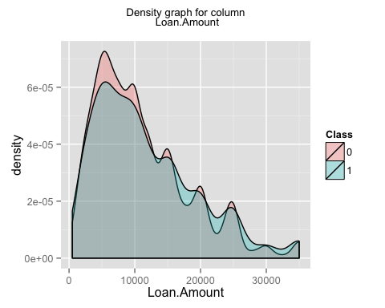

## [1] "generating graph for the column Loan.Term"

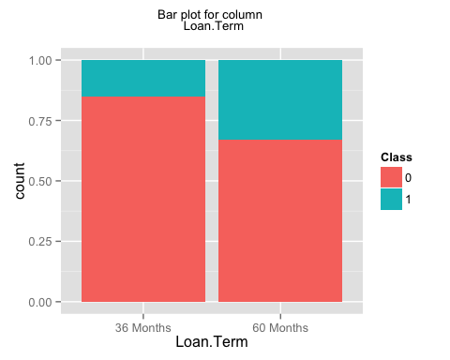

## [1] "generating graph for the column Employment.Length"

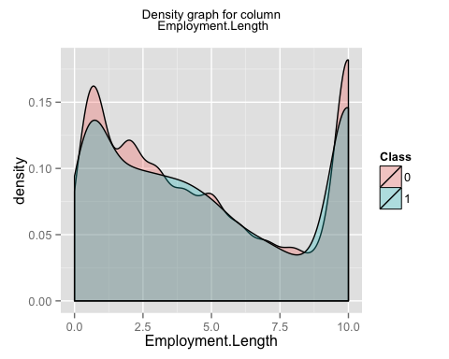

## [1] "generating graph for the column Home.Ownership"

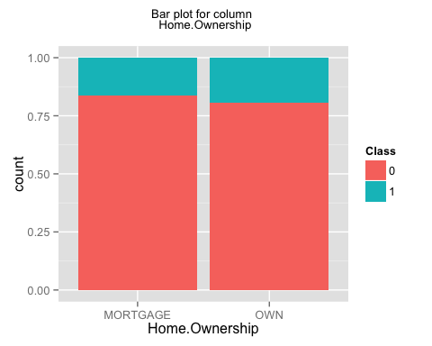

## [1] "generating graph for the column Annual.Income"

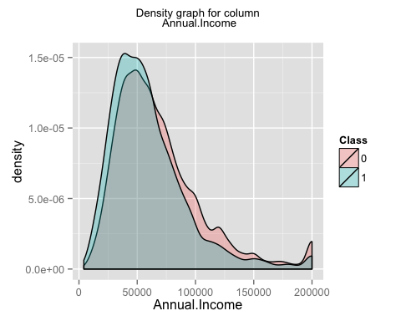

## [1] "generating graph for the column Loan.Purpose"

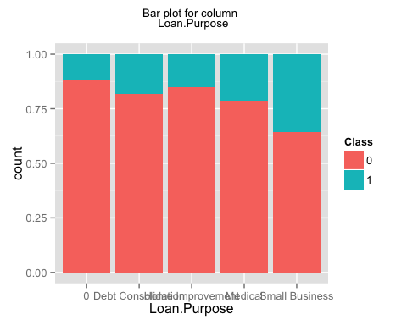

## [1] "generating graph for the column Address.State"

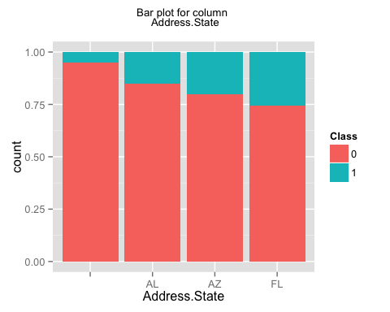

## [1] "generating graph for the column Debt.To.Income.Ratio"

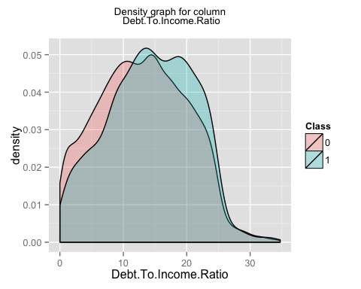

## [1] "generating graph for the column No..Delinquencies.In.Last.2.Years"

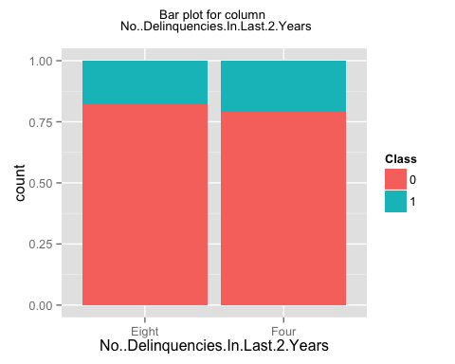

## [1] "generating graph for the column Earliest.Credit.Line.Opened"

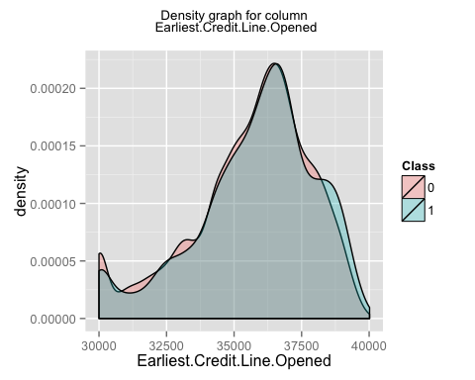

## [1] "generating graph for the column FICO.Credit.Score"

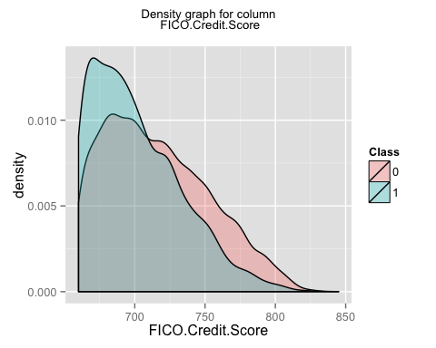

## [1] "generating graph for the column No..Inquiries.In.Last.6.Months"

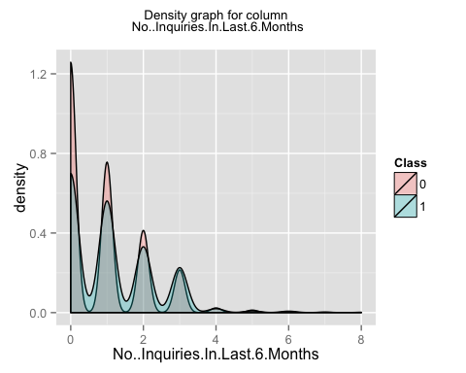

## [1] "generating graph for the column Months.Since.Last.Delinquency"

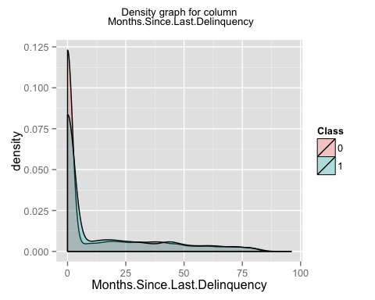

## [1] "generating graph for the column No..Of.Credit.Lines"

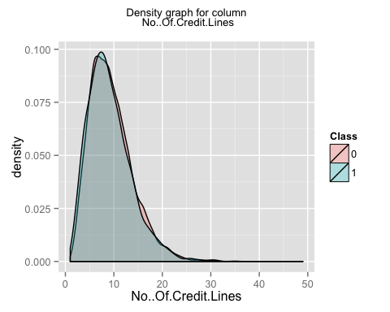

## [1] "generating graph for the column No..Adverse.Public.Records"

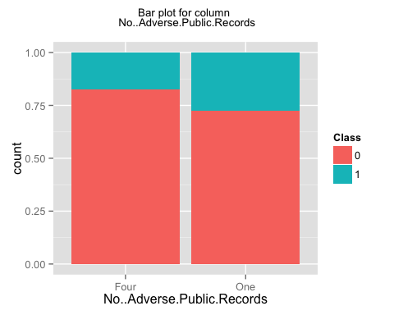

## [1] "generating graph for the column Total.Credit.Balance"

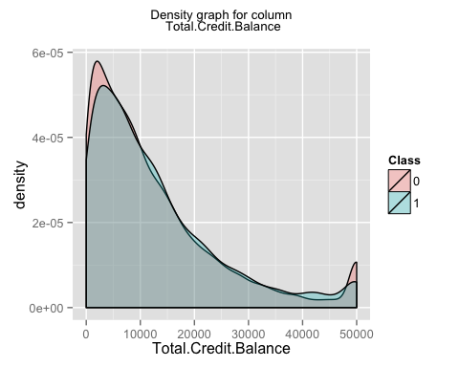

## [1] "generating graph for the column Use.Of.Credit.Line"

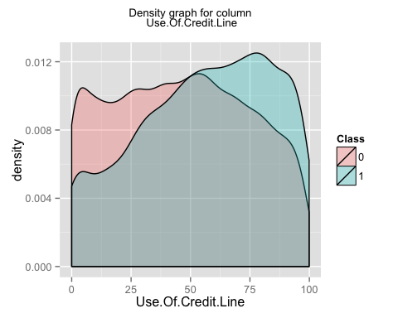

## [1] "generating graph for the column Total.Number.Of.Credit.Lines"

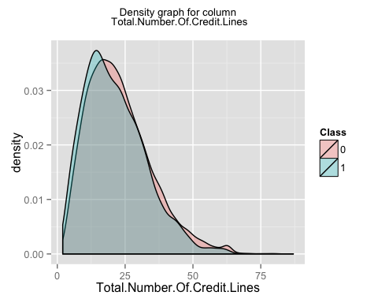

## [1] "generating graph for the column Loan.Application.Description"

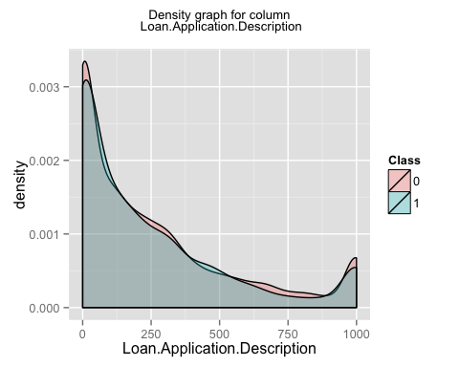

## [1] "generating graph for the column No..Of.Public.Record.Bankruptcies"

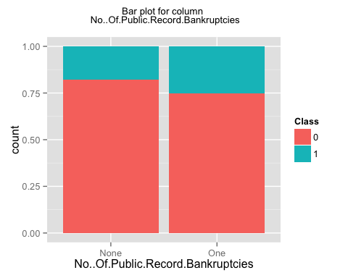

## [1] "generating graph for the column Class"

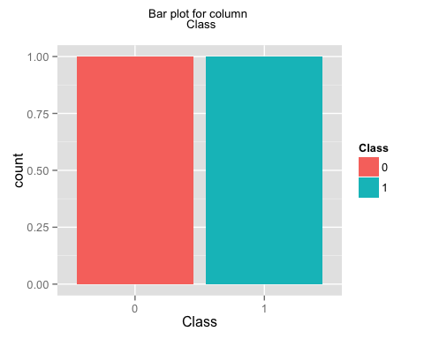

## [1] "finished generating the first set of plots i.e. individual plots for each column"  
## [1] "now generating the second set of plots i.e. plots for a pair of columns"

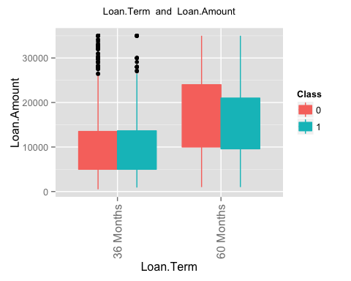 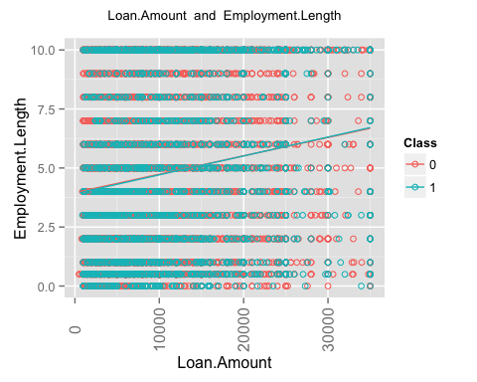 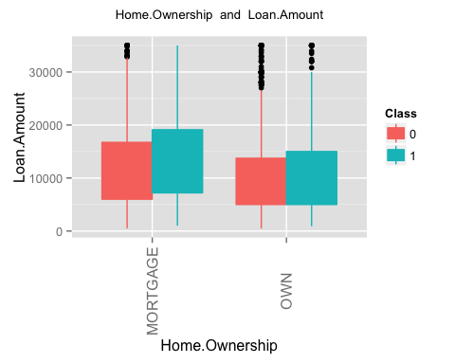 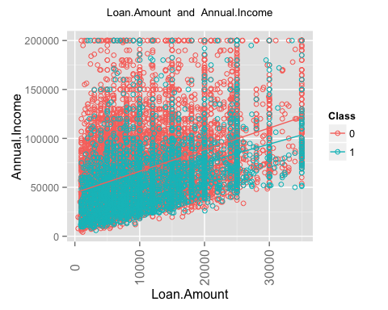 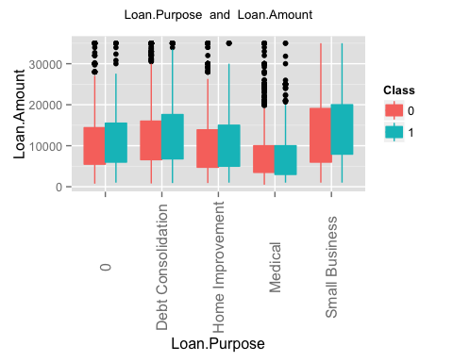 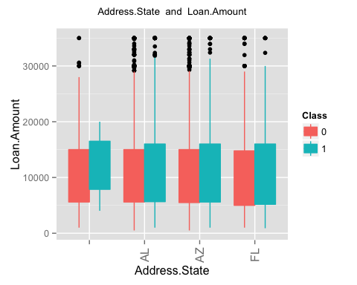 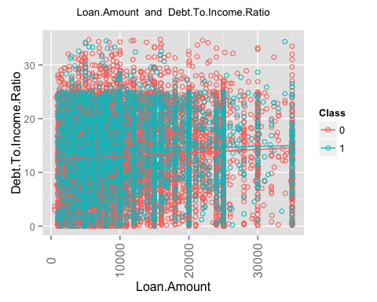 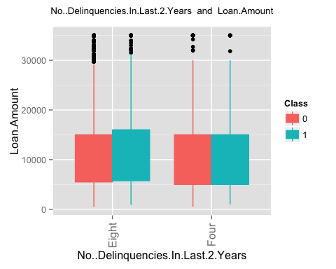 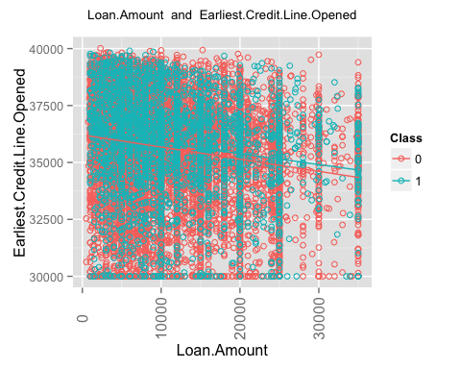 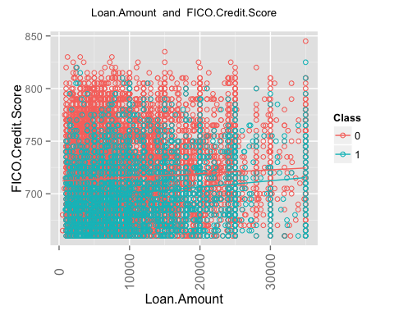 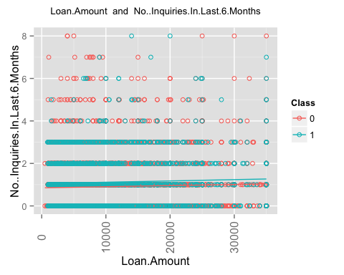 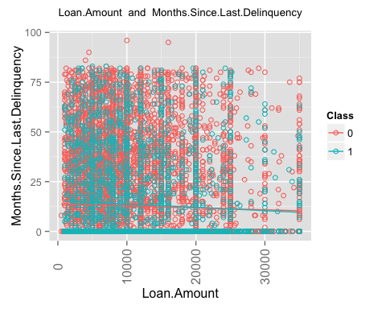 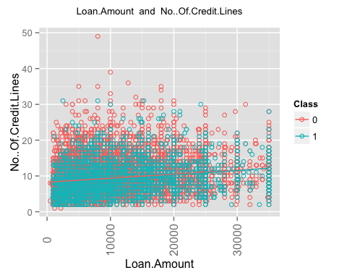 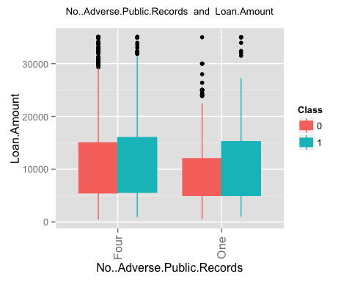 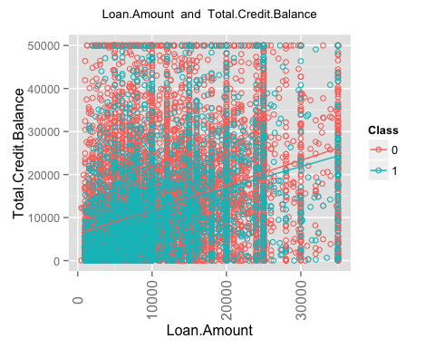 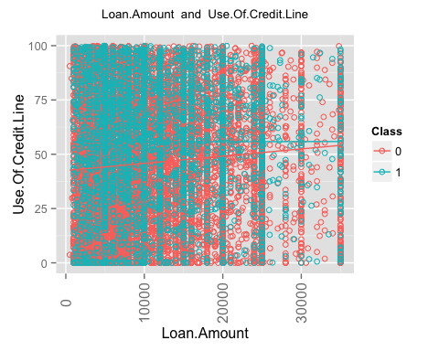 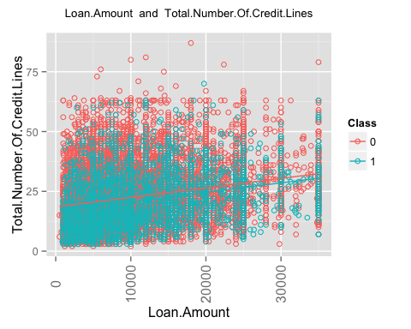 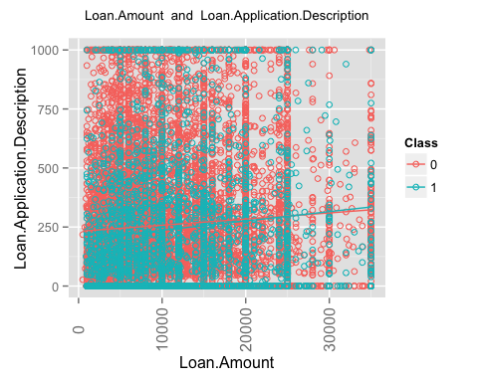 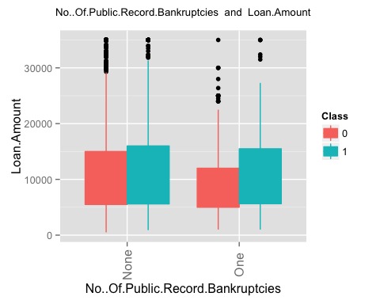 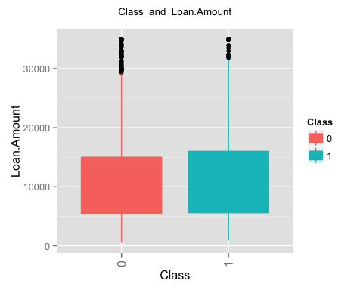 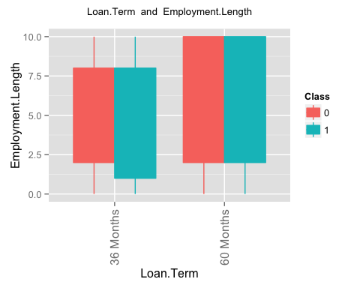 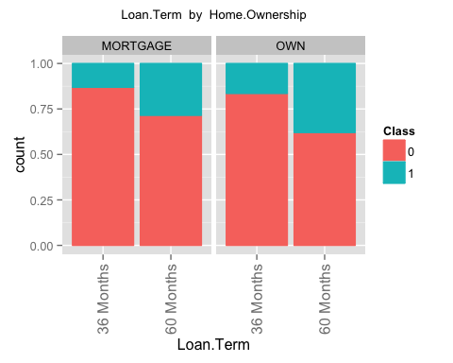 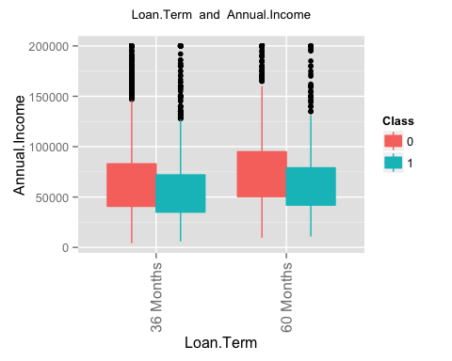 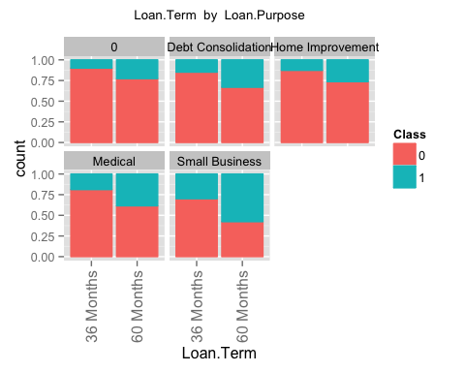 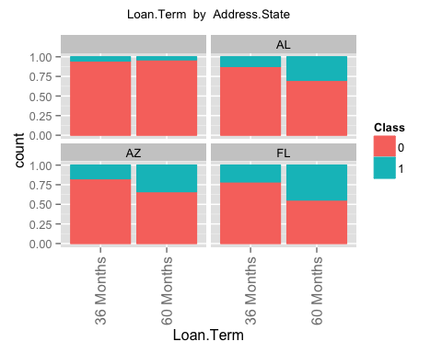 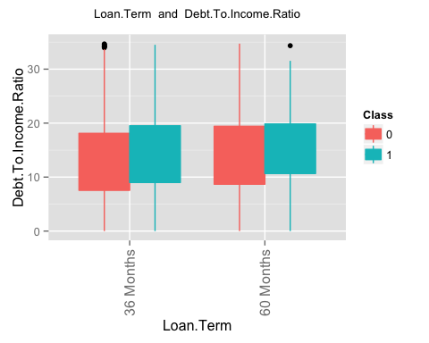 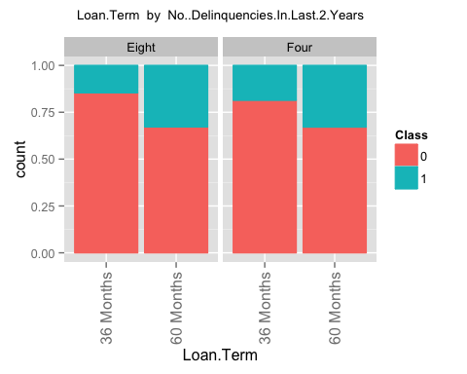 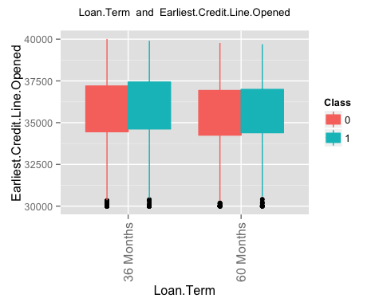 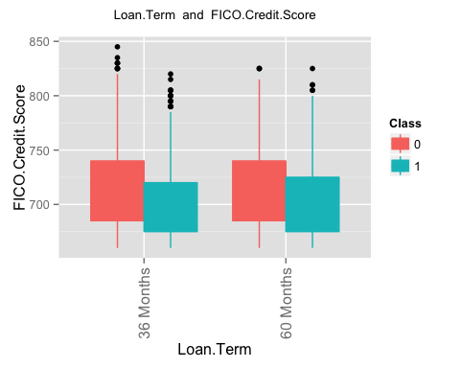 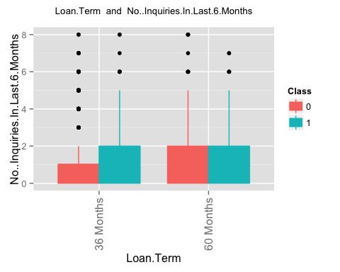 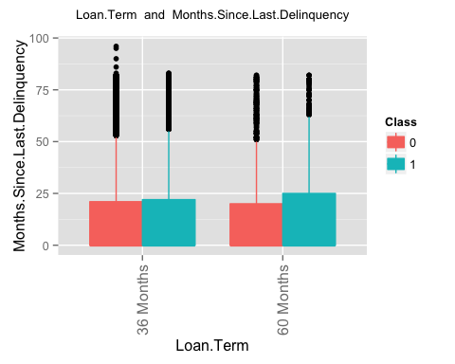 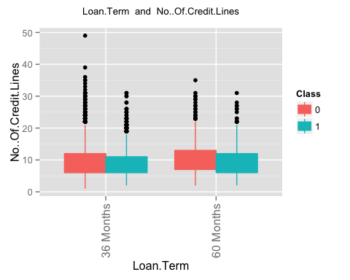 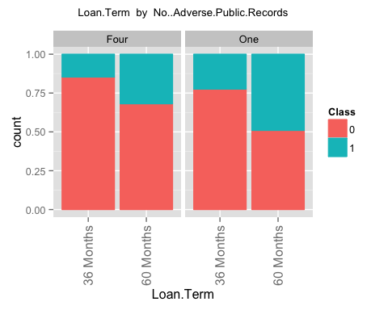 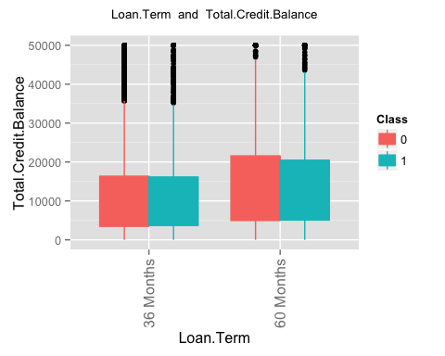 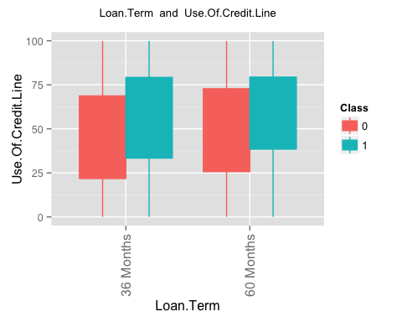 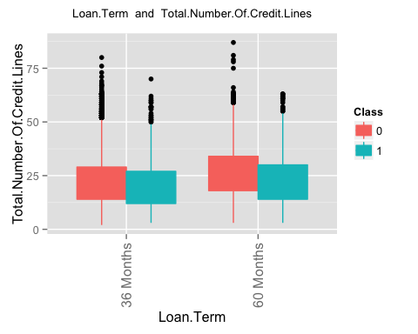 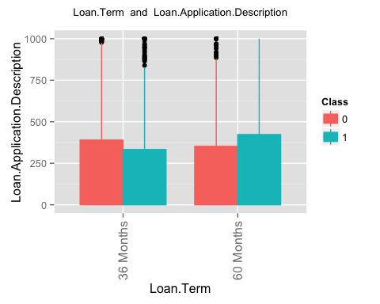 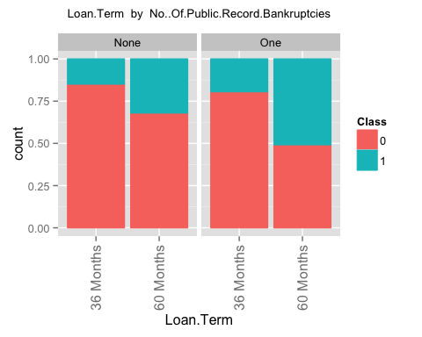 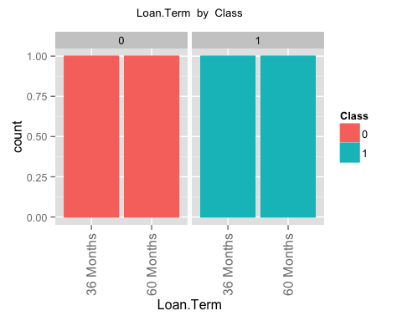 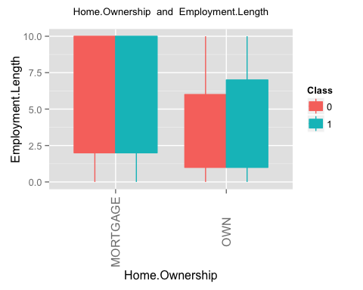 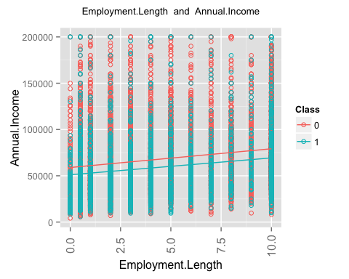 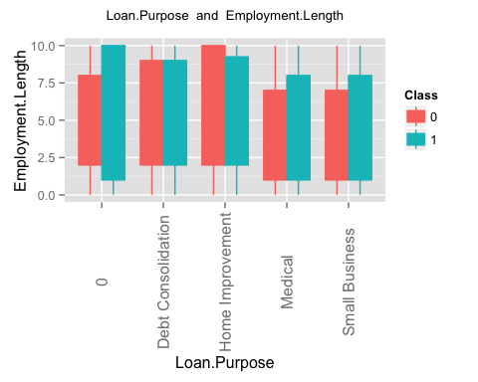 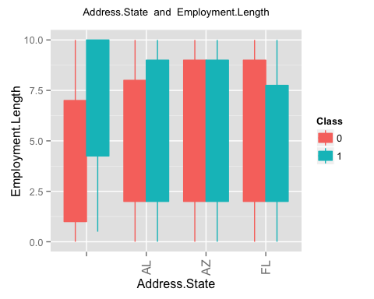 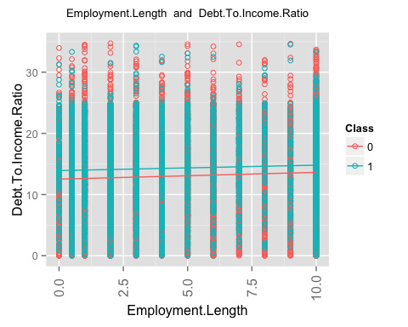 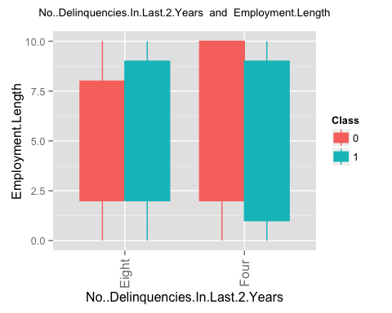 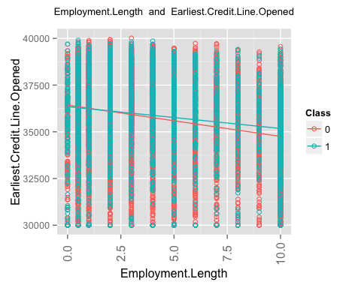 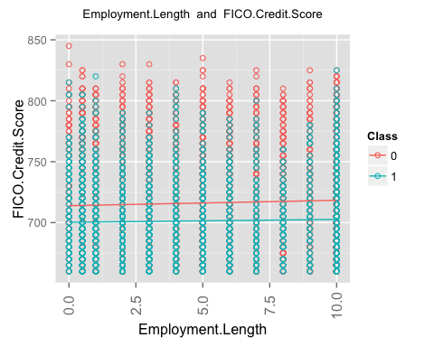 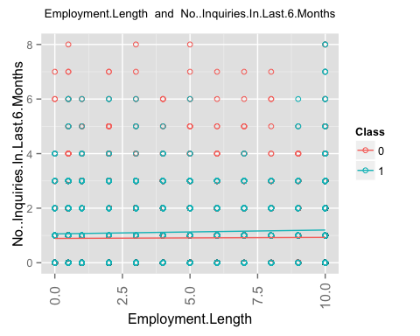 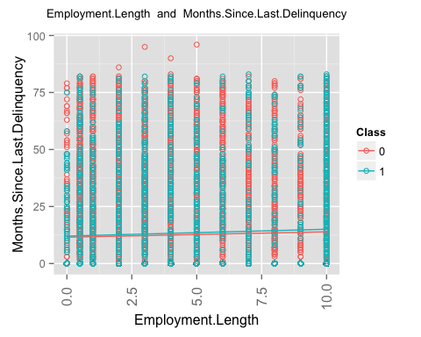 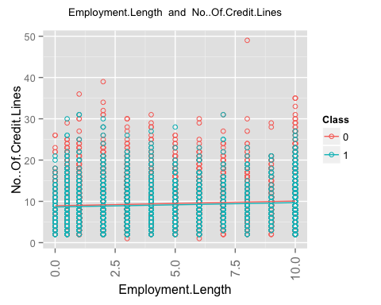 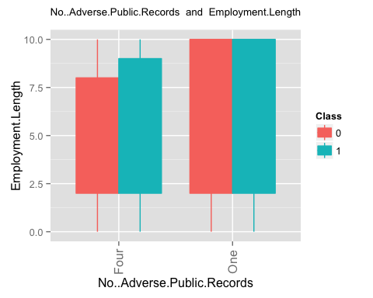 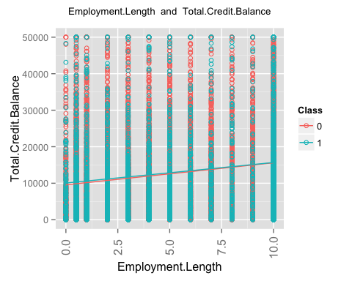 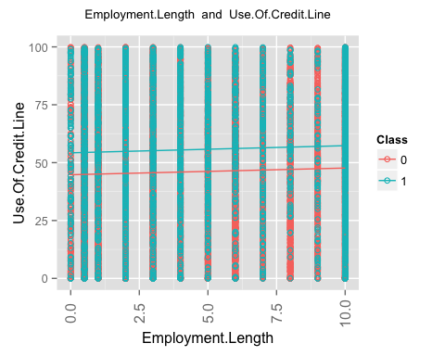 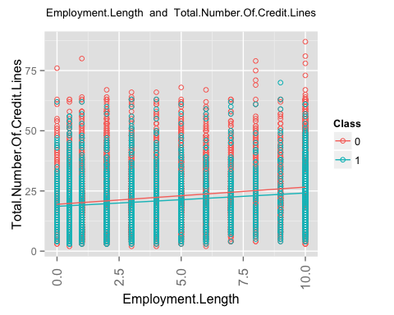 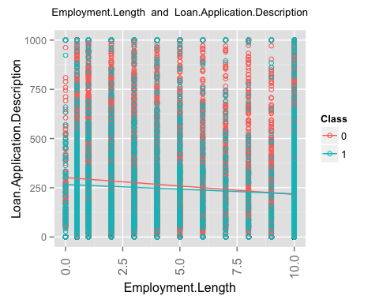 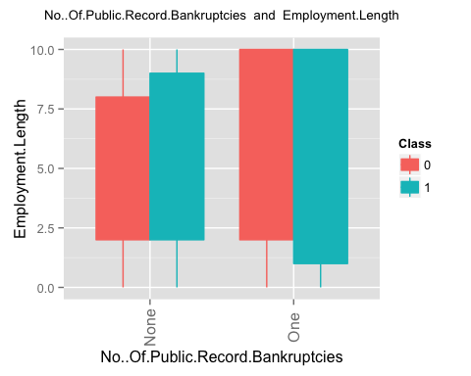 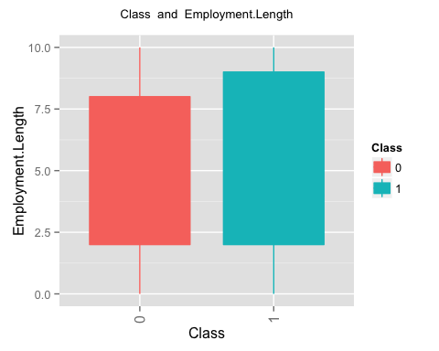 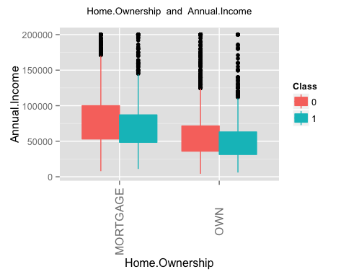 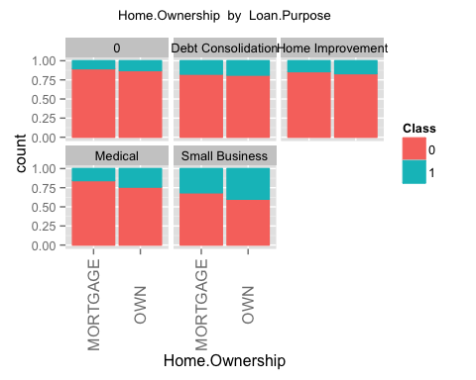 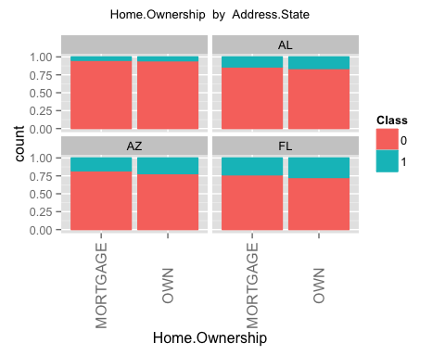 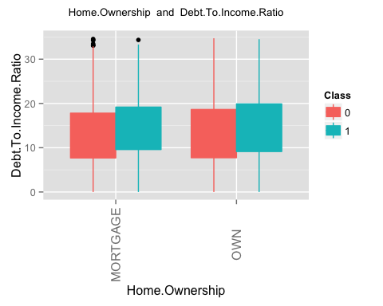 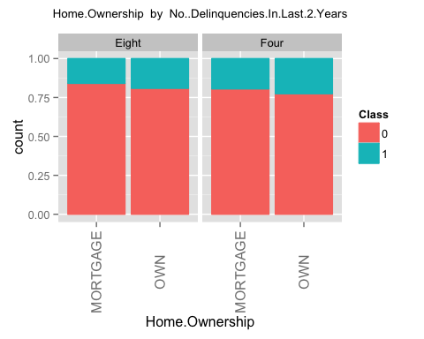 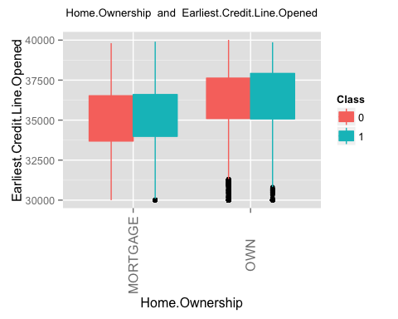 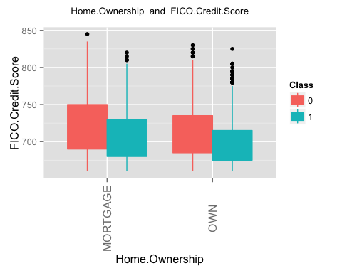 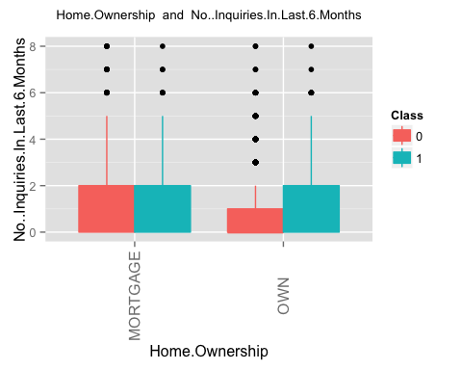 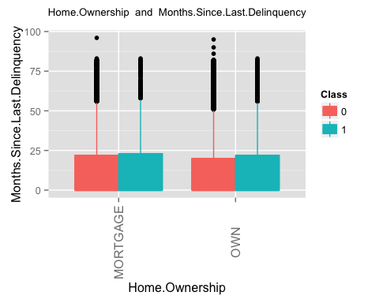 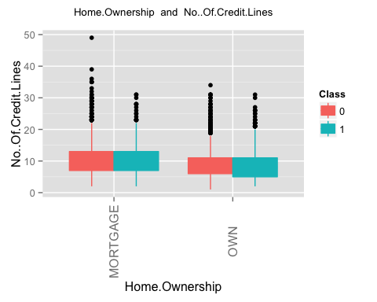 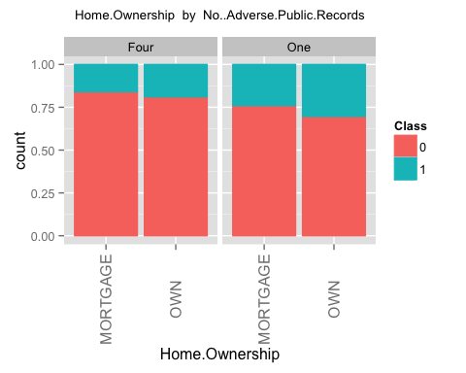 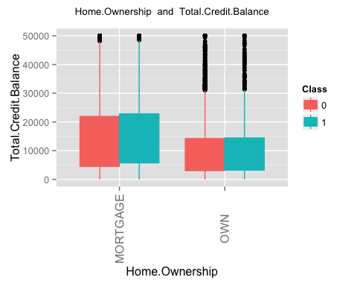 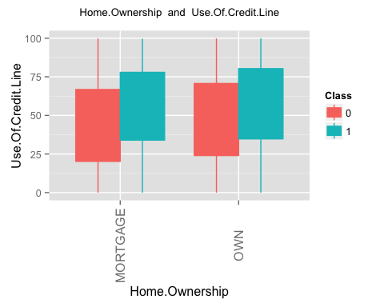 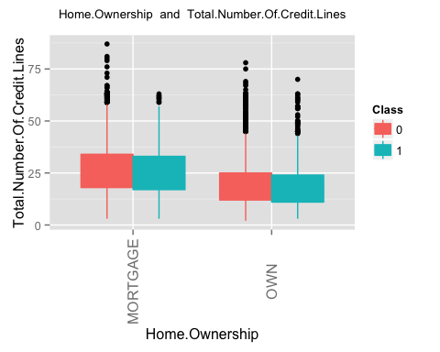 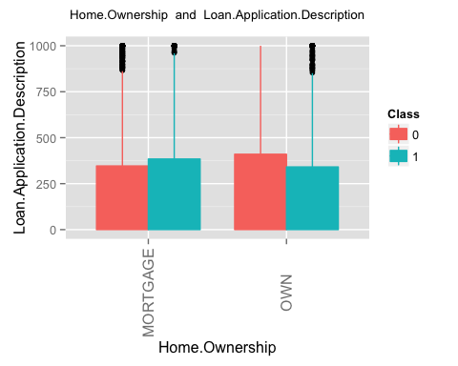 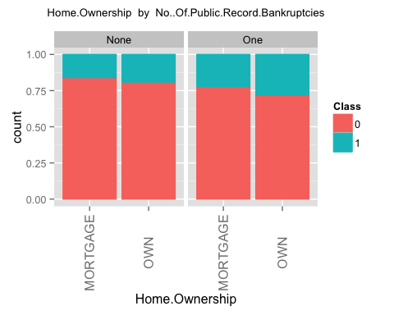 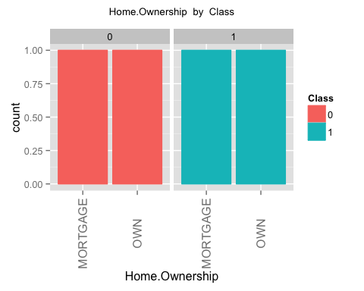 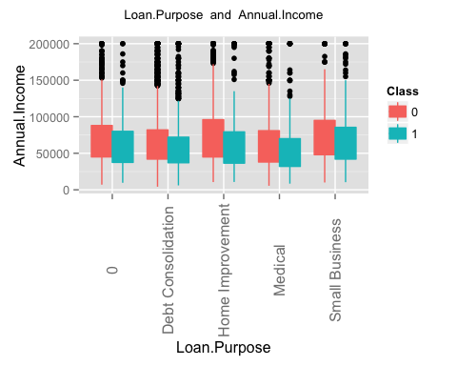 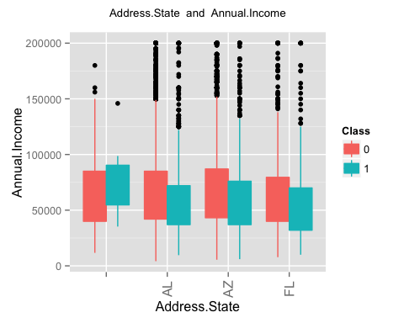 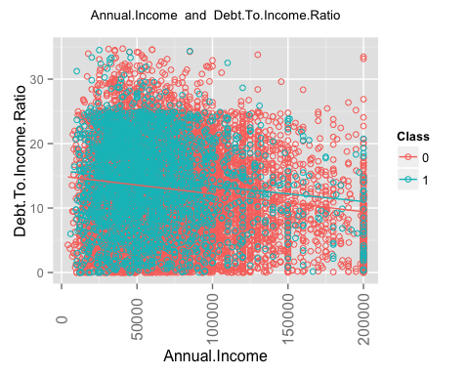 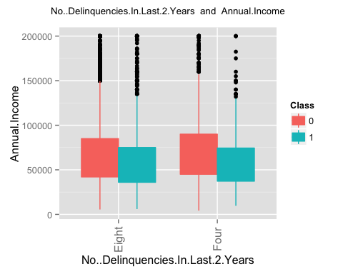 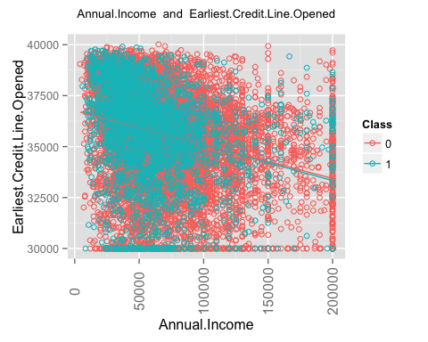 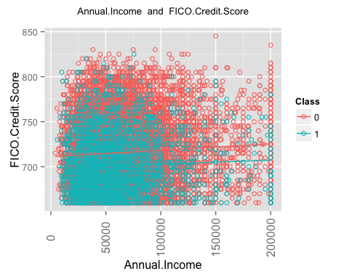 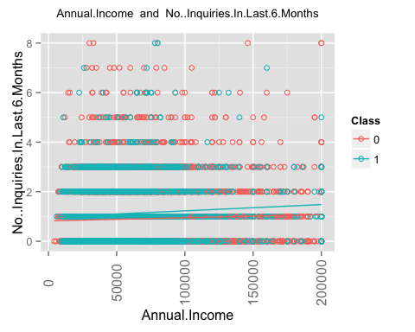 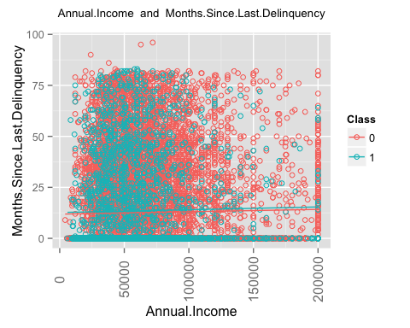 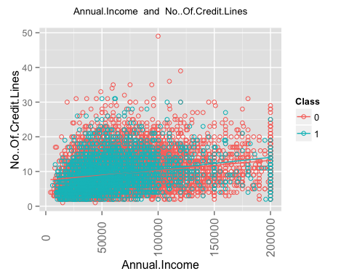 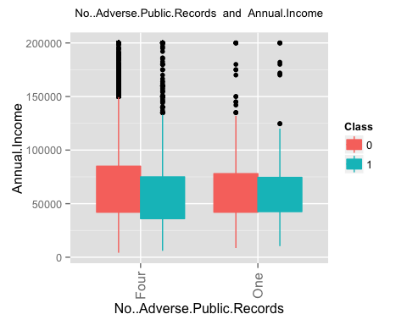 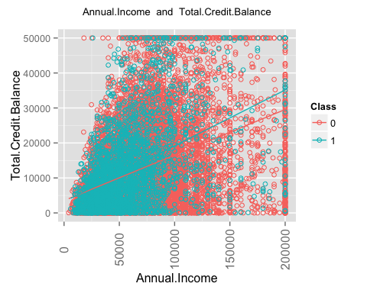 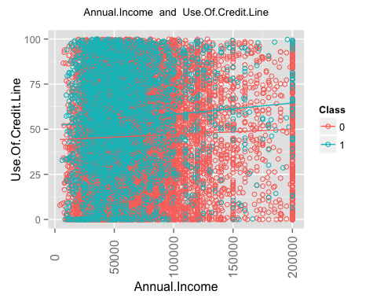 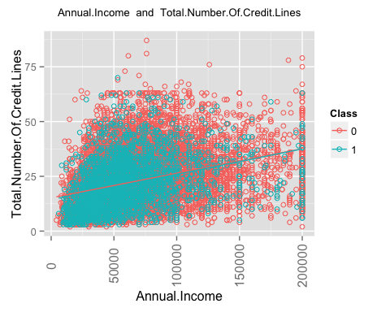 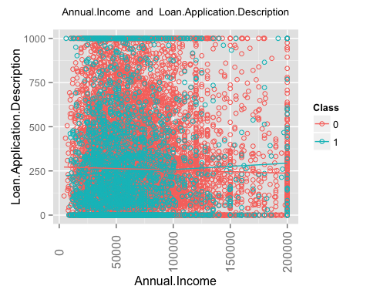 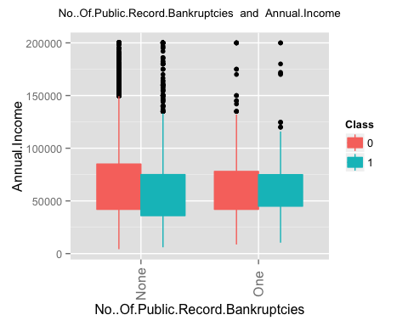 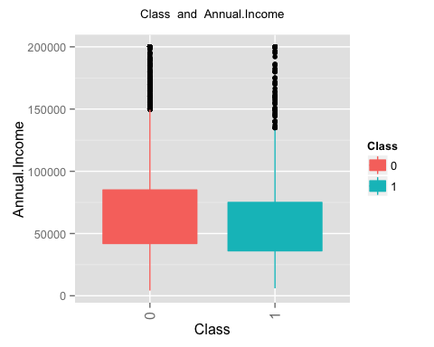 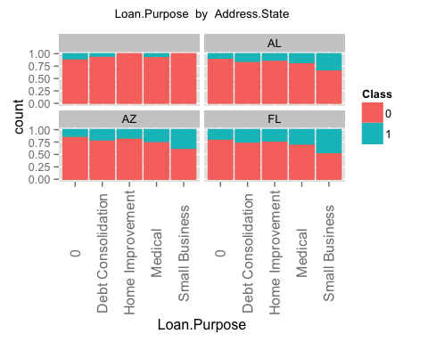 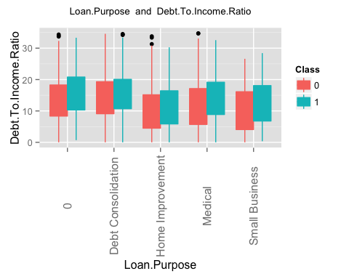 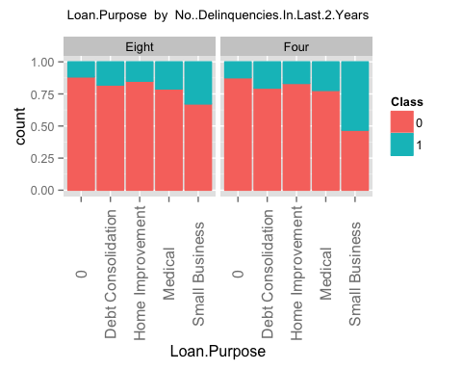 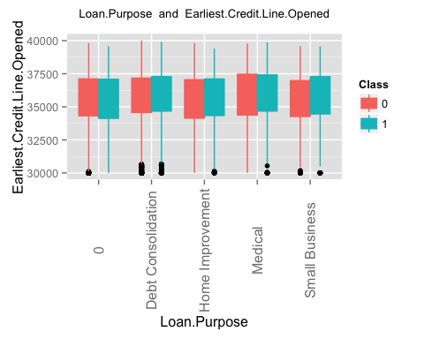 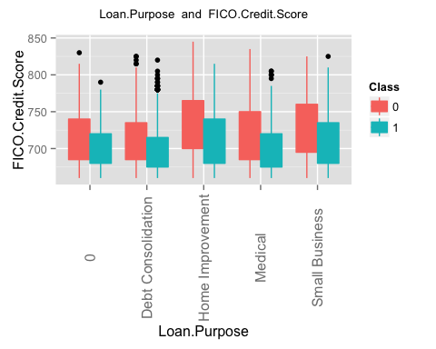 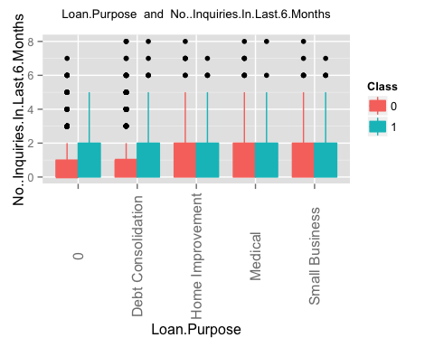 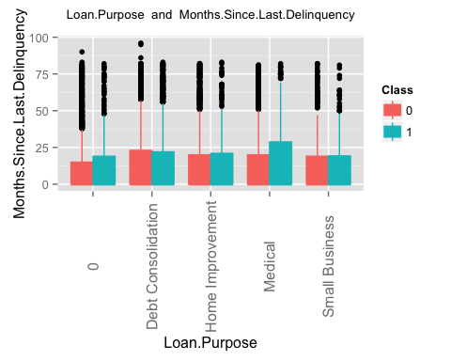 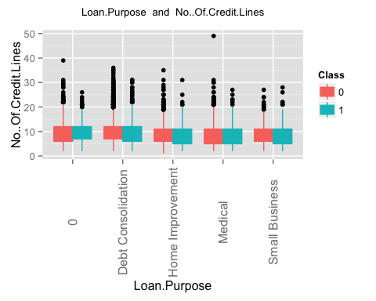 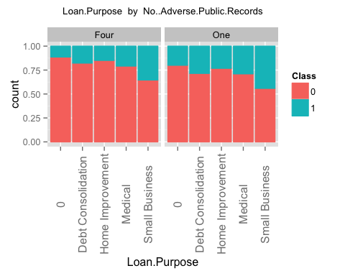 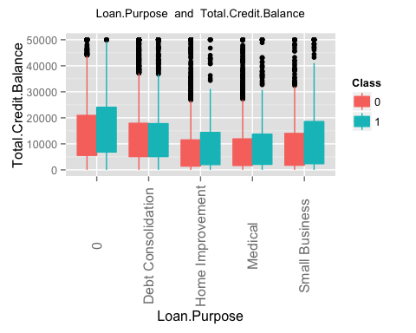 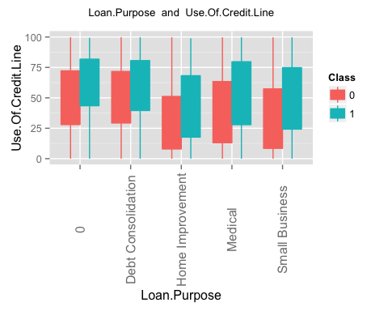 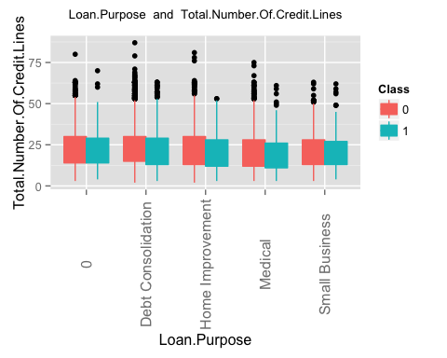 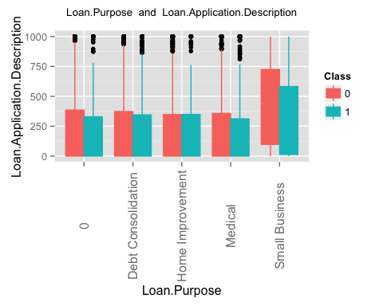 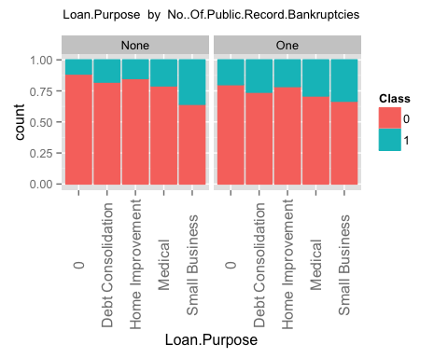 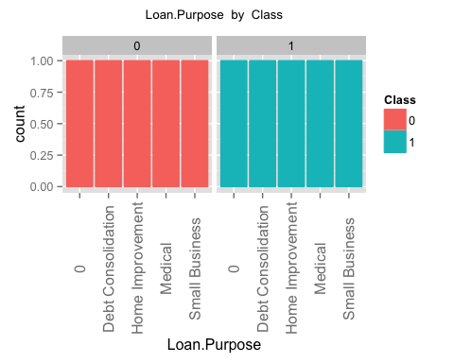 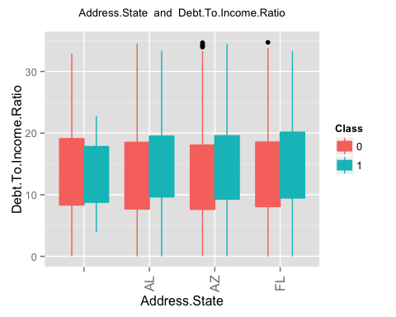 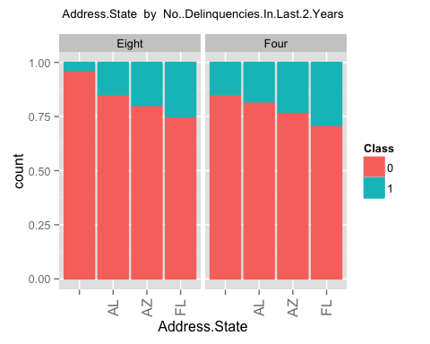 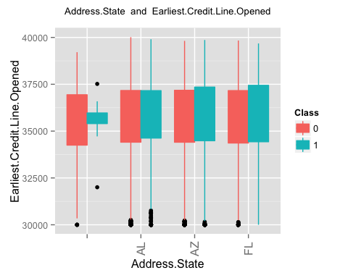 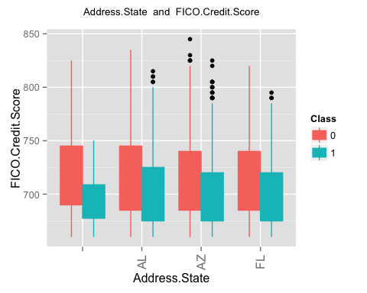 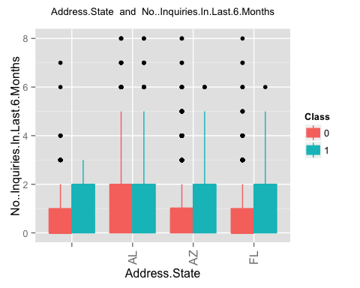 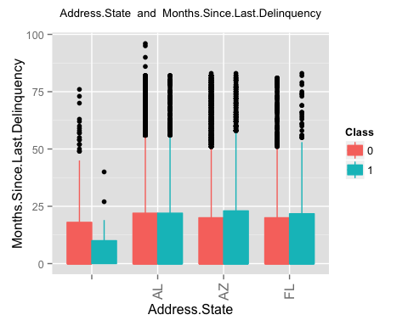 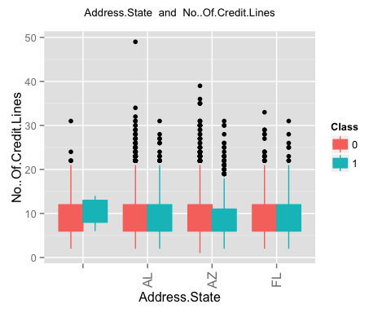 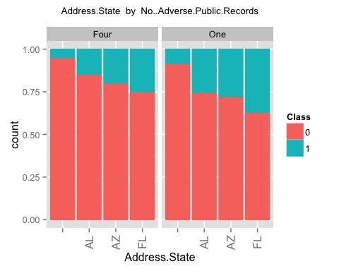 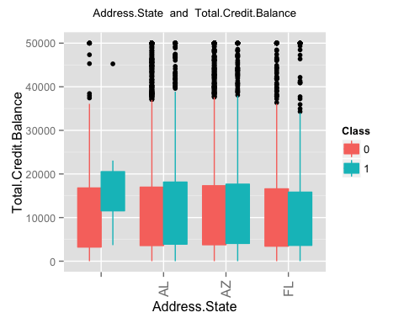 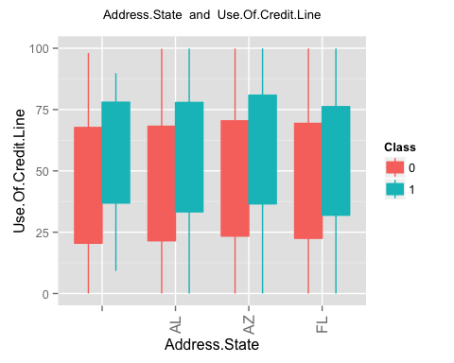 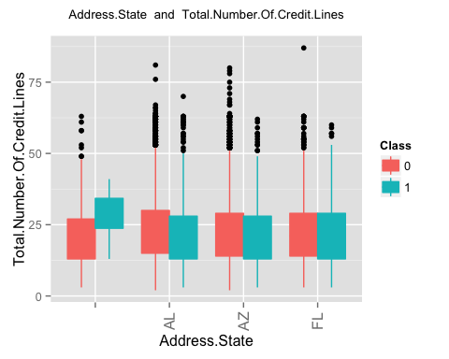 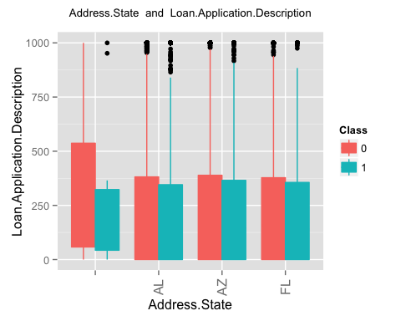 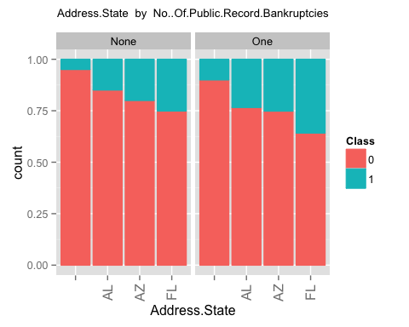 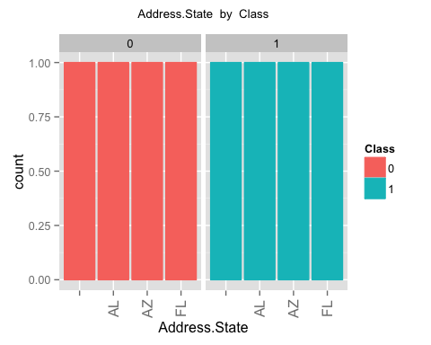 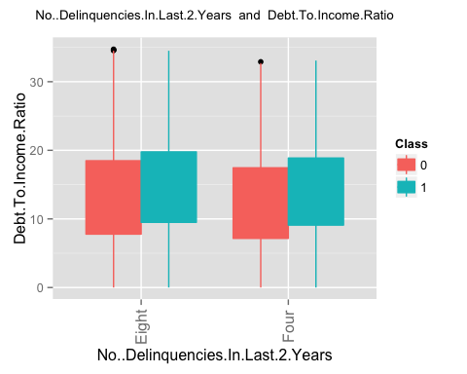 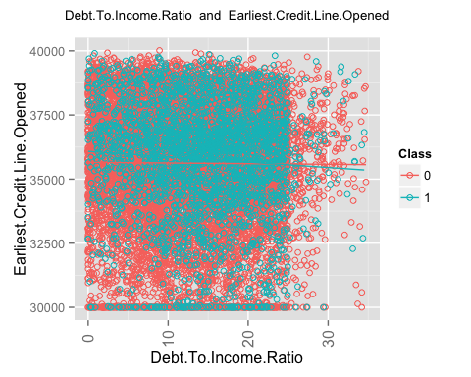 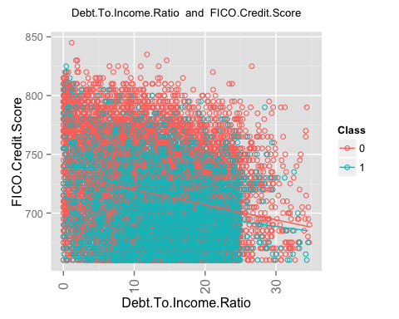 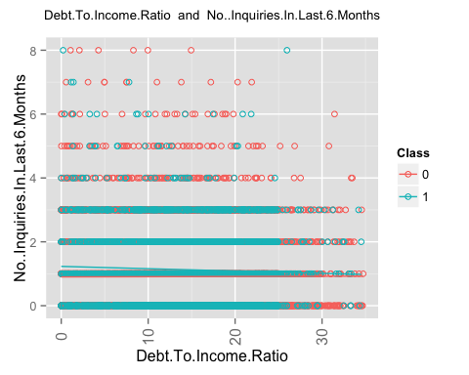 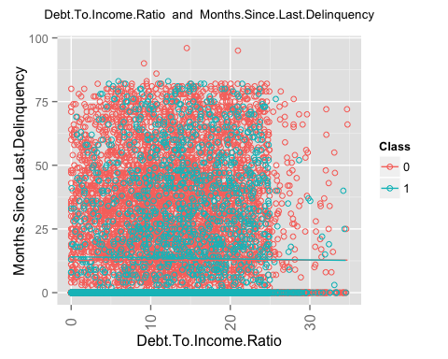 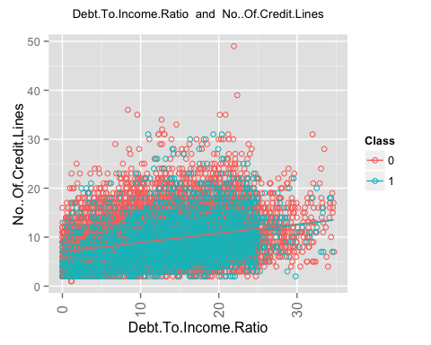 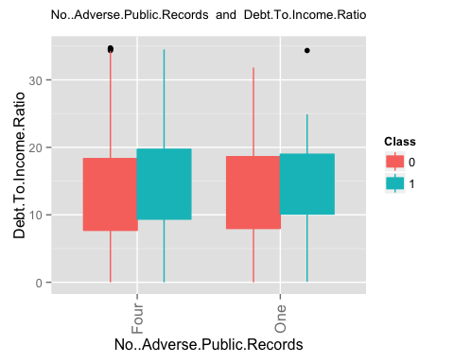 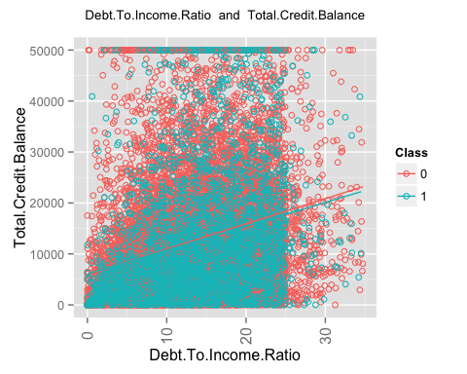 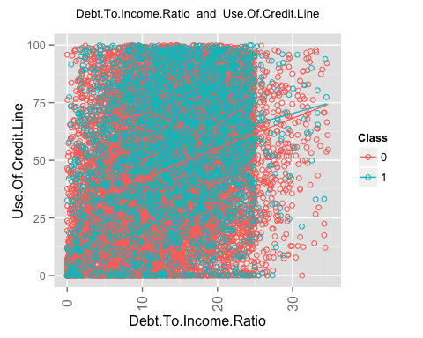 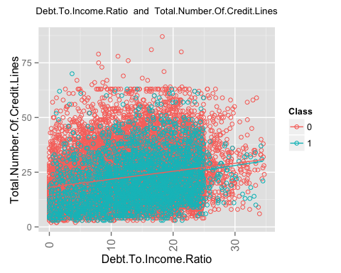 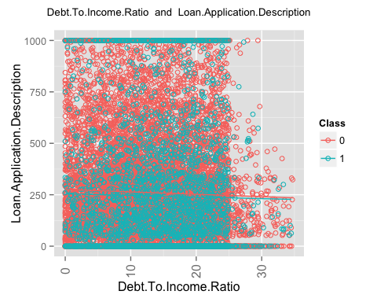 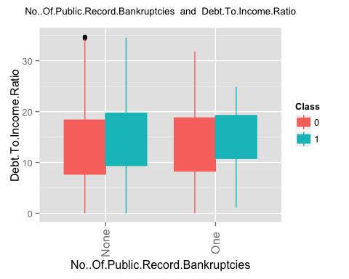 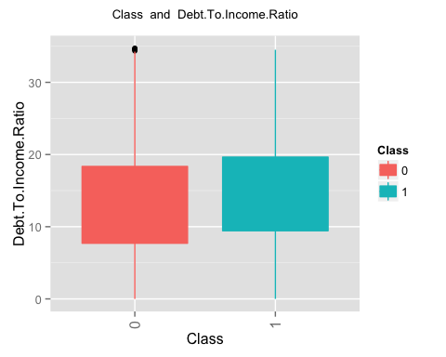 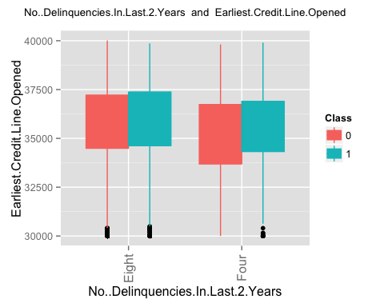 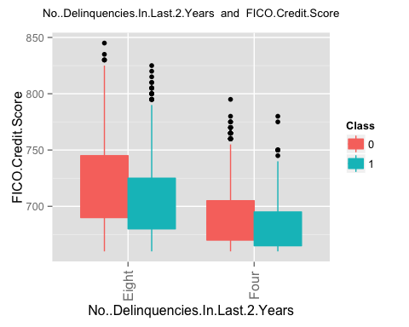 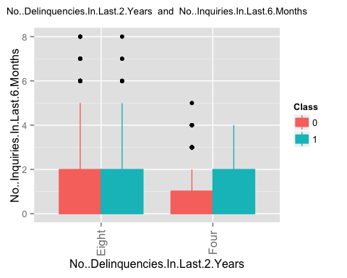 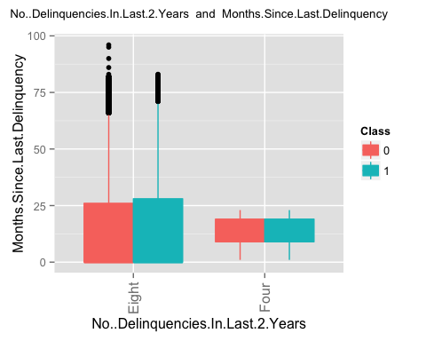 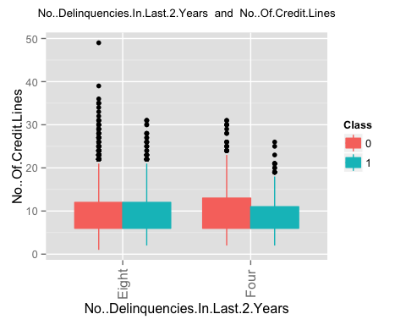 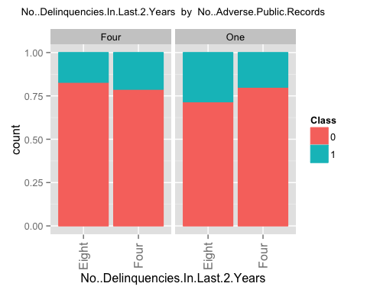 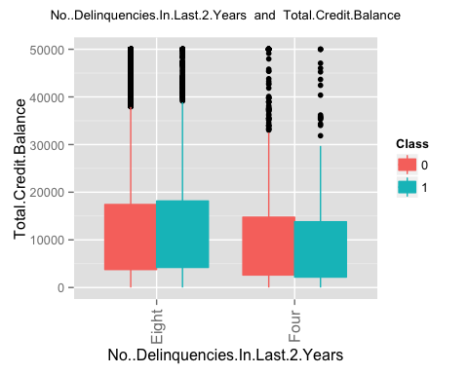 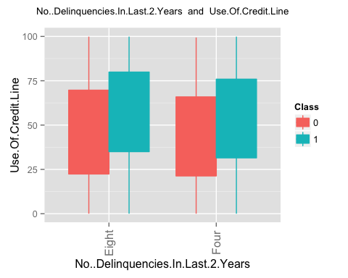 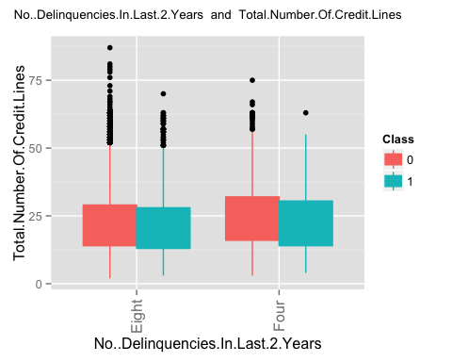 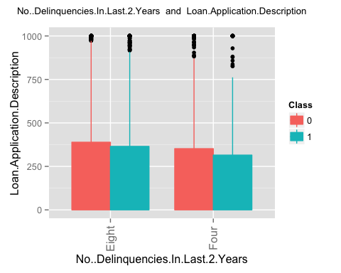 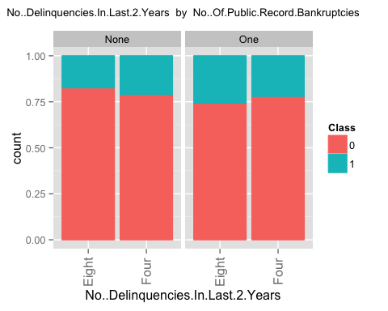 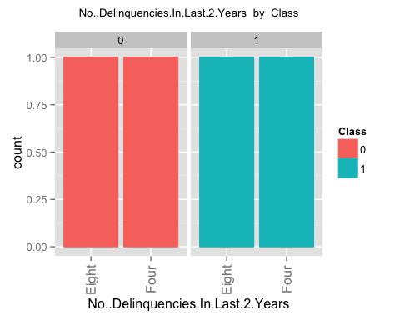 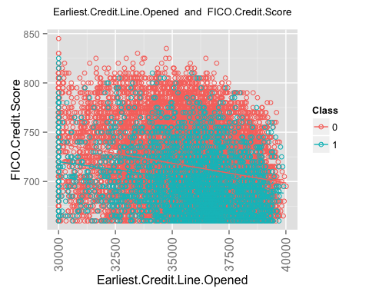 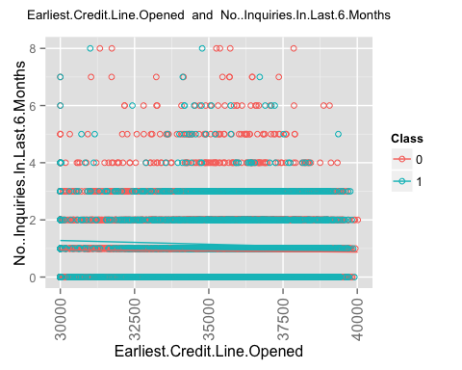 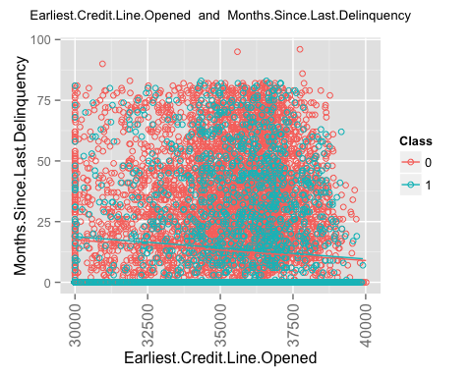 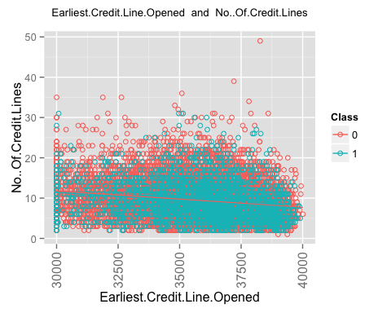 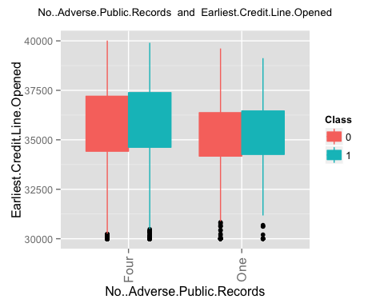 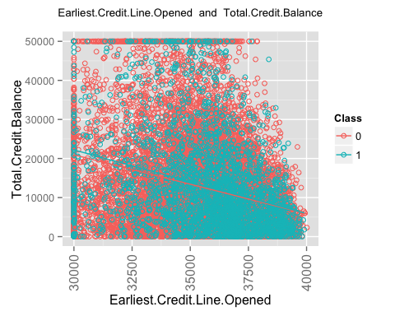 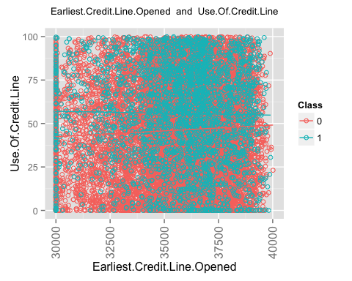 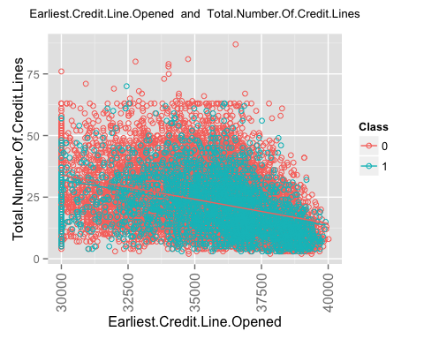 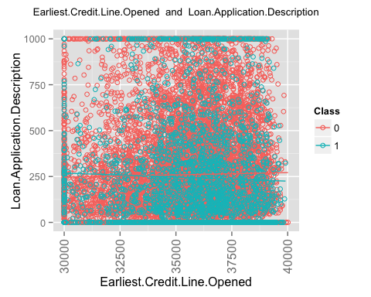 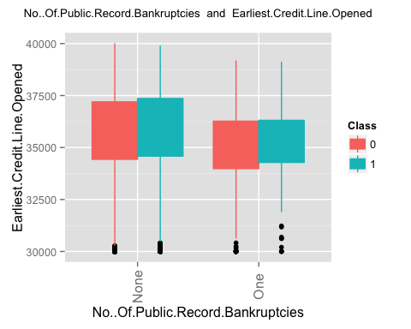 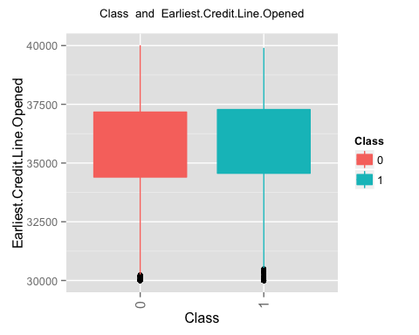 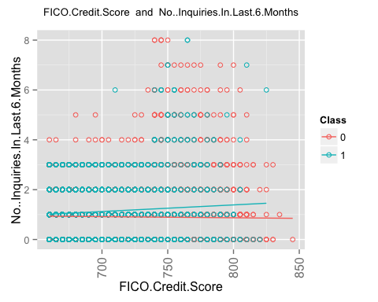 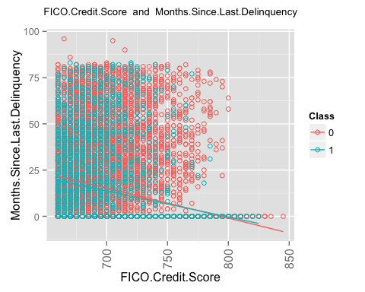 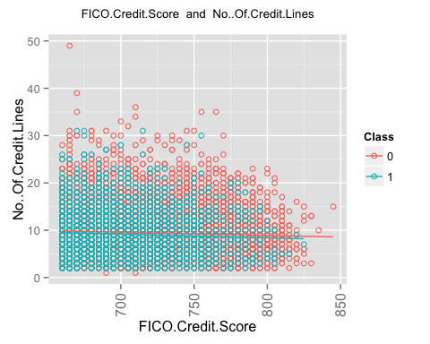 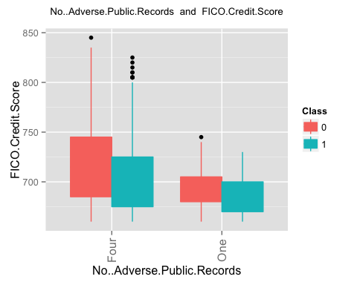 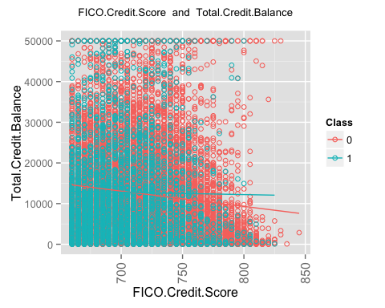 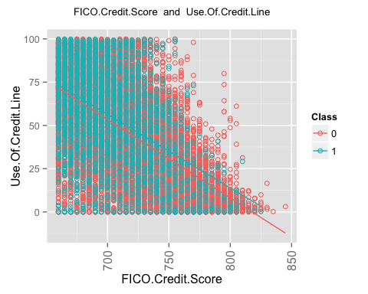 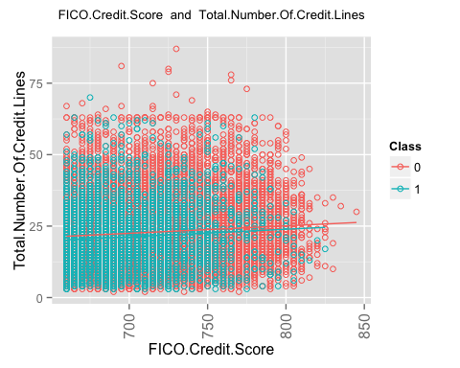 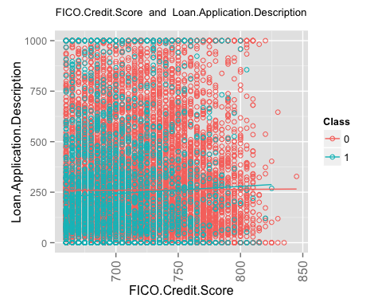 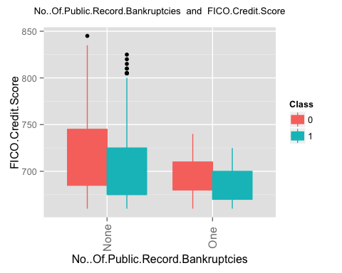 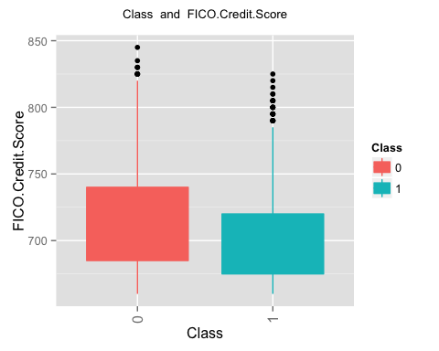 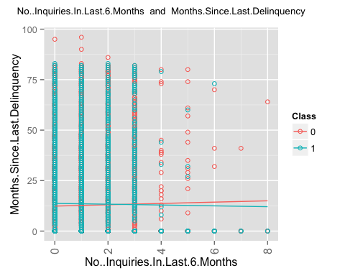 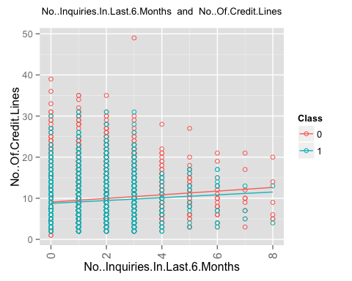 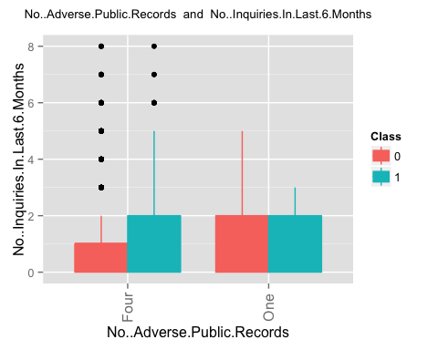 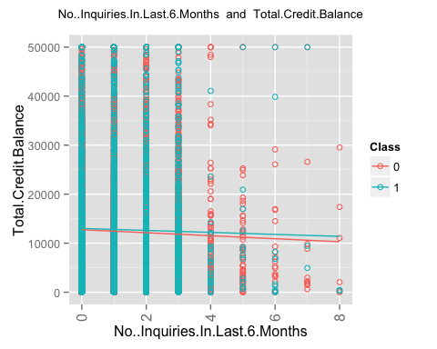 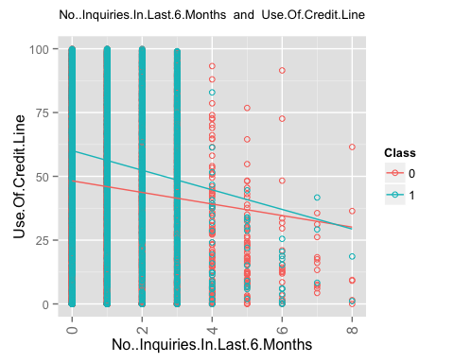 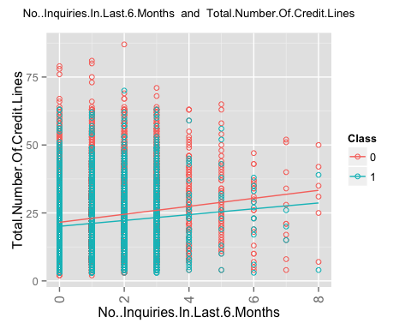 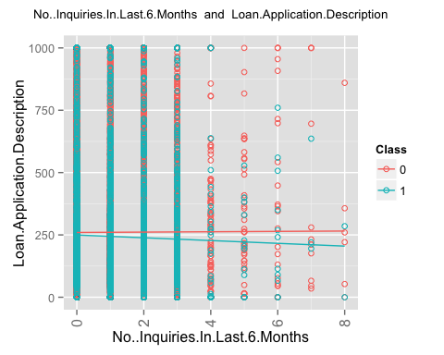 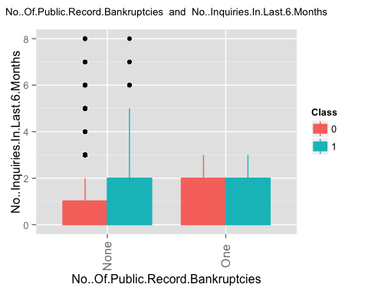 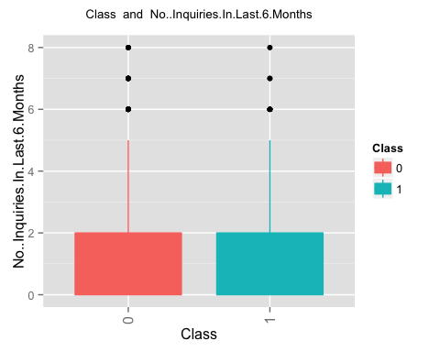 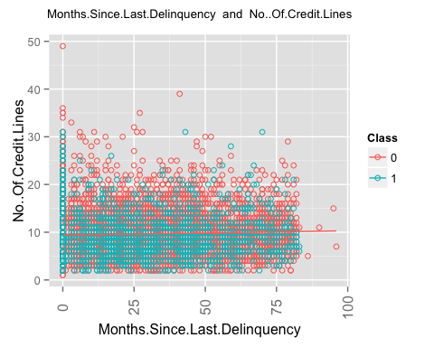 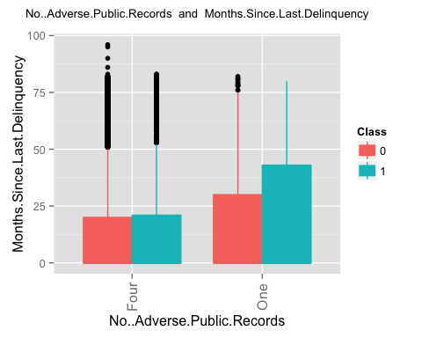 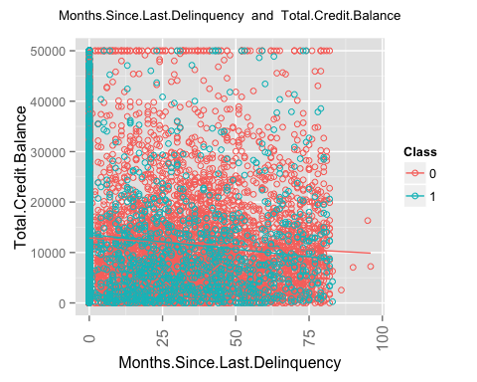 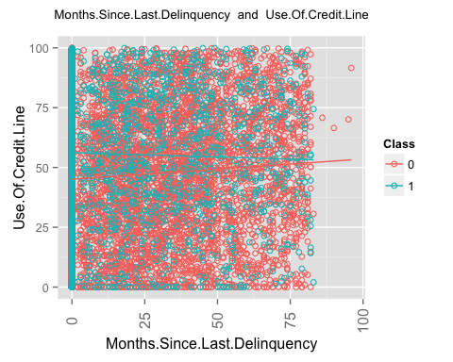 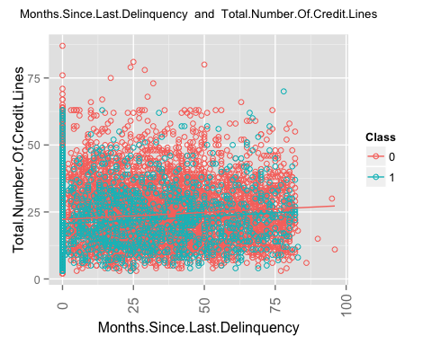 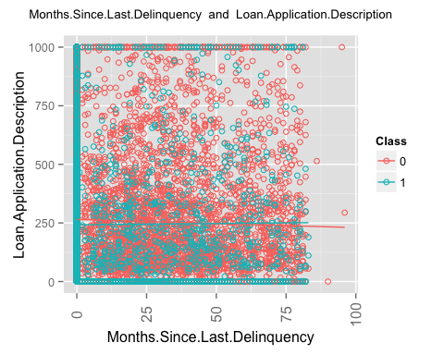 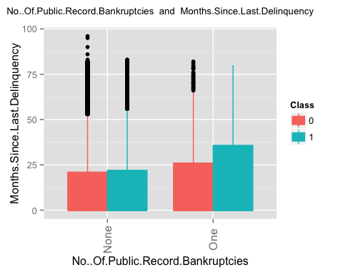 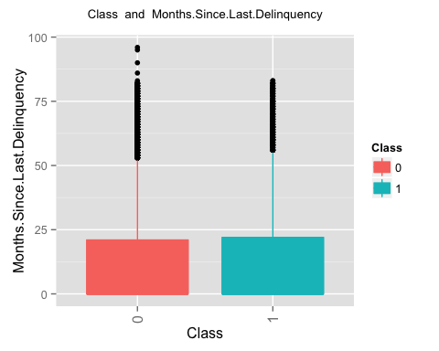 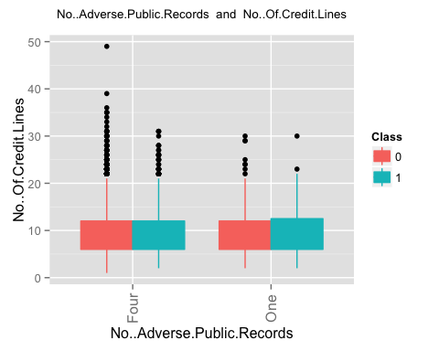 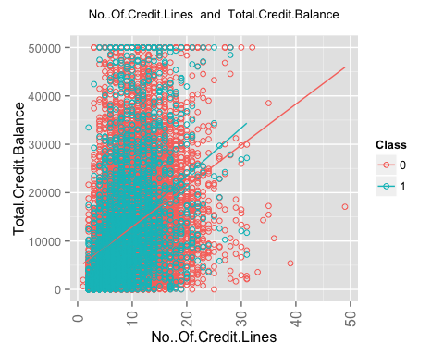 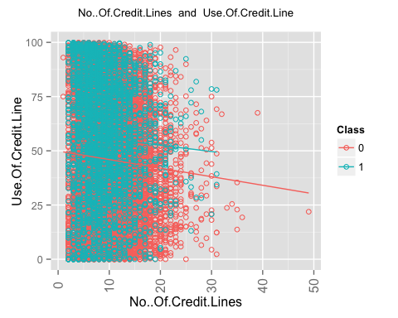 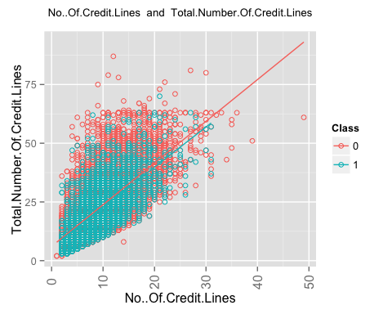 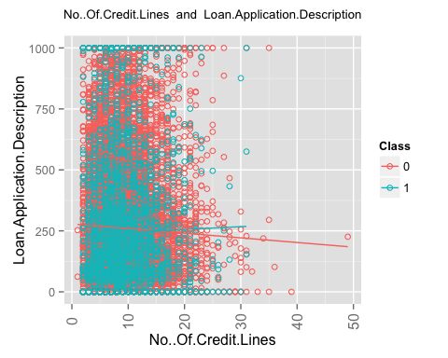 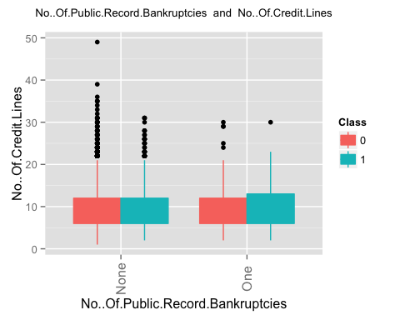 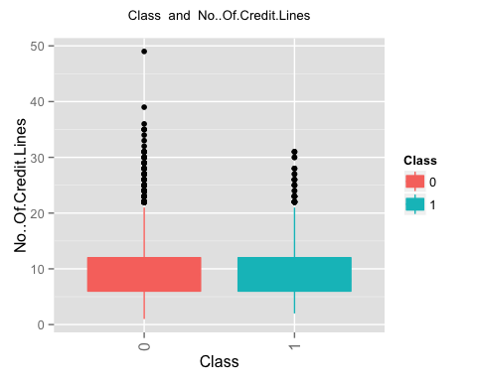 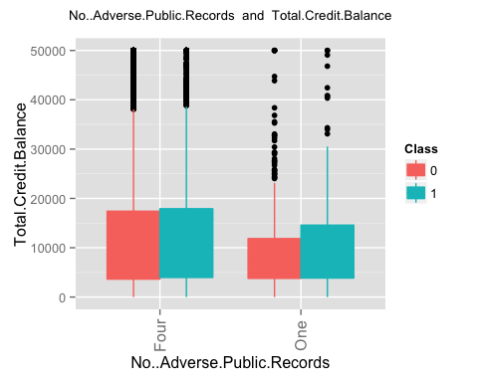 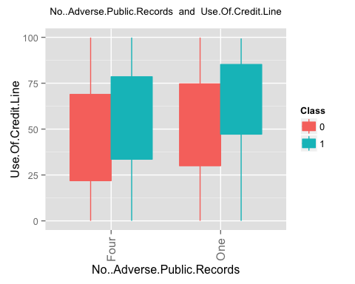 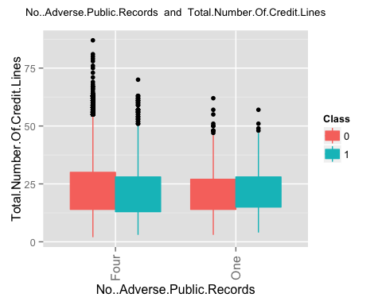 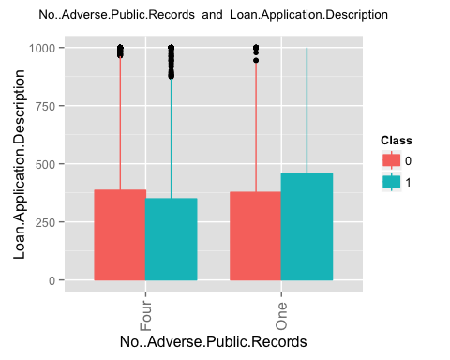 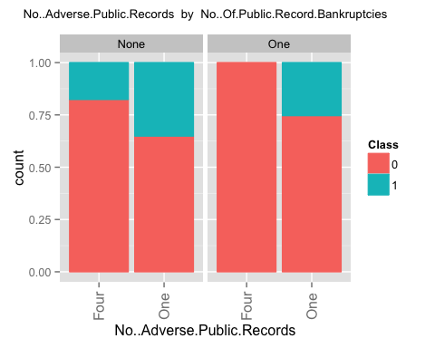 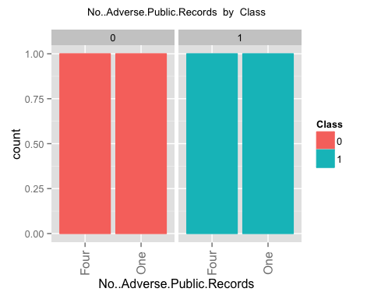 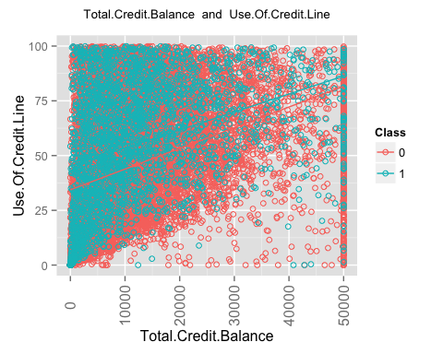 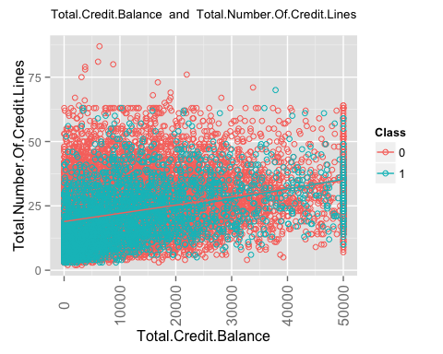 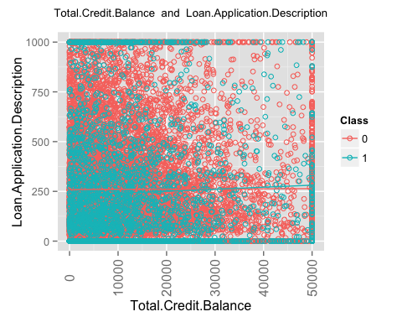 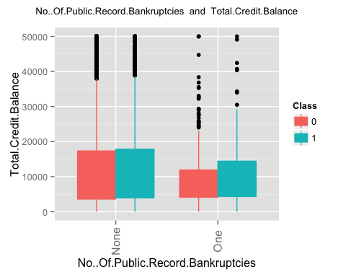 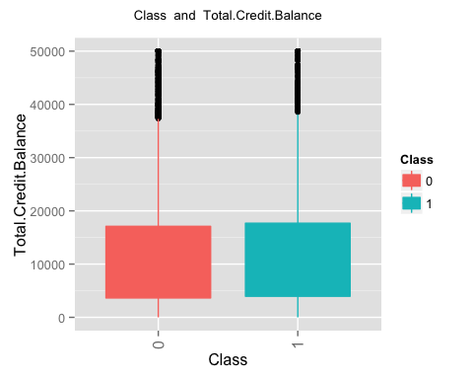 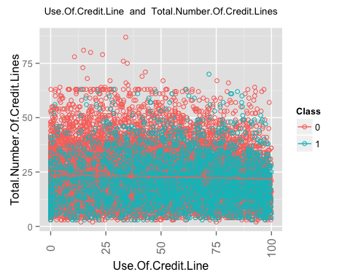 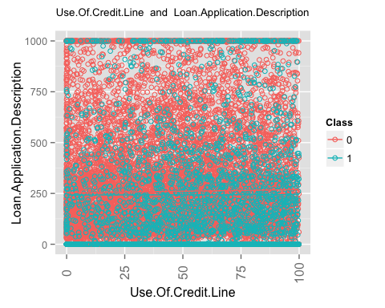 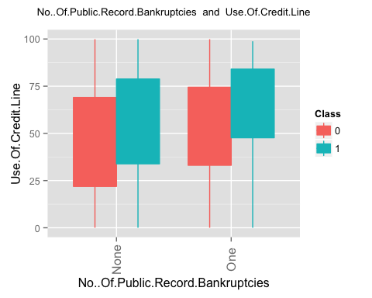 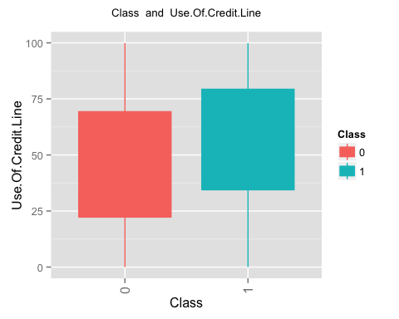 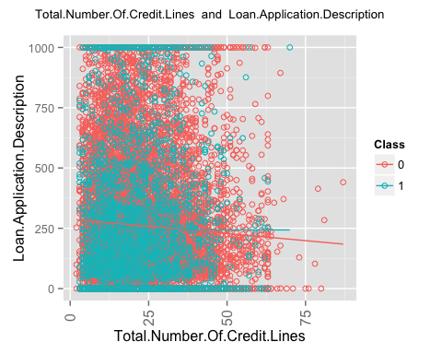 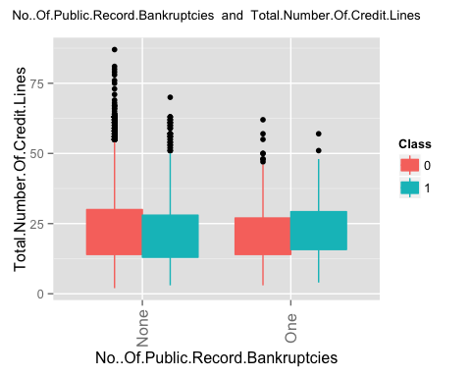 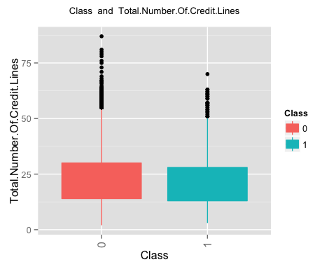 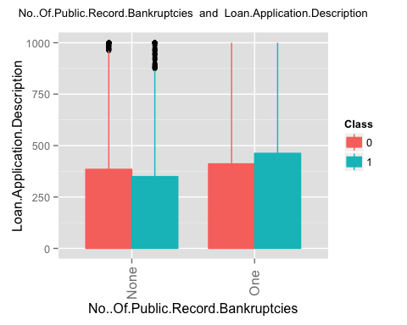 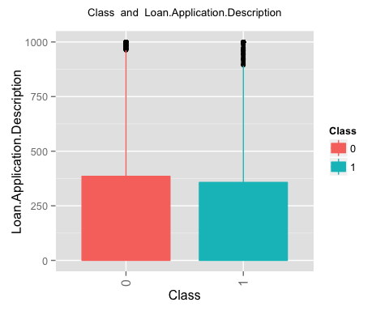

## [1] "finished generating the second set of plots i.e. plots for a pair of columns"

#  
# Now run the feature selection process. It will do following.  
# 1. It will find the top 20 features using random forest  
# 2. It will run a logistic regression based on a single column at a time.  
# 3. It will run a logistic regression based on interaction of just 2 columns at a time.  
# 4. It wil generate a decision tree based on single column at a time.  
# 5. It will generate a decision tree based on 2 column at a time.  
  
  
frml1 <- as.formula(paste0(clscol,' ~ .'))  
findusefulfeatures(train_data,alpha = 0.05,ranking='accuracy',k=20,frml1,ntree=100,cp = 0.001,valid_data)

## [1] 1 11 12 13 14 16 18 19  
## [1] 1 3 5 8 10 11 12 13 14 16 17 18 19  
## [1] 1 2 3 4 5 6 7 8 9 10 11 12  
## col1 col1_pvalue  
## 2 Loan.Amount 6.067007e-05  
## 3 Loan.Term 3.550672e-104  
## 4 Employment.Length 1.208073e-01  
## 5 Home.Ownership 5.929201e-07  
## 6 Annual.Income 3.428384e-30  
## 7 Loan.Purpose 1.057791e-52  
## 8 Address.State 3.937717e-31  
## 9 Debt.To.Income.Ratio 1.846836e-14  
## 10 No..Delinquencies.In.Last.2.Years 5.853385e-04  
## 11 Earliest.Credit.Line.Opened 4.802414e-02  
## 12 FICO.Credit.Score 1.000015e-65  
## 13 No..Inquiries.In.Last.6.Months 1.532724e-01  
## 14 Months.Since.Last.Delinquency 1.902116e-01  
## 15 No..Of.Credit.Lines 0.000000e+00  
## 16 No..Adverse.Public.Records 2.906538e-12  
## 17 Total.Credit.Balance 7.295338e-01  
## 18 Use.Of.Credit.Line 1.093319e-51  
## 19 Total.Number.Of.Credit.Lines 1.132938e-05  
## 20 Loan.Application.Description 1.467445e-03  
## 21 No..Of.Public.Record.Bankruptcies 1.631744e-06  
## [1] "here"  
## 'data.frame': 20 obs. of 4 variables:  
## $ 0 : num 17.33 18.32 9.91 3.22 18.04 ...  
## $ 1 : num -9.6414 14.0773 -0.4161 -1.9334 0.0531 ...  
## $ MeanDecreaseAccuracy: num 12.89 21.31 8.49 2.5 19.05 ...  
## $ MeanDecreaseGini : num 349.5 136.5 228.3 40.6 408.7 ...  
## NULL  
## [1] "top ranked features based on random forest accuracy"  
## [1] "Loan.Term"   
## [2] "Total.Credit.Balance"   
## [3] "Use.Of.Credit.Line"   
## [4] "Annual.Income"   
## [5] "FICO.Credit.Score"   
## [6] "Total.Number.Of.Credit.Lines"   
## [7] "Loan.Amount"   
## [8] "Loan.Purpose"   
## [9] "Earliest.Credit.Line.Opened"   
## [10] "No..Of.Credit.Lines"   
## [11] "Employment.Length"   
## [12] "Months.Since.Last.Delinquency"   
## [13] "No..Delinquencies.In.Last.2.Years"  
## [14] "Debt.To.Income.Ratio"   
## [15] "Address.State"   
## [16] "No..Adverse.Public.Records"   
## [17] "Loan.Application.Description"   
## [18] "No..Of.Public.Record.Bankruptcies"  
## [19] "Home.Ownership"   
## [20] "No..Inquiries.In.Last.6.Months"   
## [1] "now rankinsg based on logistic regression. This is custom log reg"  
## [1] "Loan.Amount" "0.494395981250042"  
## [1] "here"  
## [1] "Loan.Term" "0.571190541146868"  
## [1] "here"  
## [1] "Employment.Length" "0.474561520198593"  
## [1] "here"  
## [1] "Home.Ownership" "0.534674795556467"  
## [1] "here"  
## [1] "Annual.Income" "0.59462686096036"  
## [1] "here"  
## [1] "Loan.Purpose" "0.602831658478403"  
## [1] "here"  
## [1] "Address.State" "0.548268289438381"  
## [1] "here"  
## [1] "Debt.To.Income.Ratio" "0.560818991659921"   
## [1] "here"  
## [1] "No..Delinquencies.In.Last.2.Years" "0.500864671571357"   
## [1] "here"  
## [1] "Earliest.Credit.Line.Opened" "0.534017554974849"   
## [1] "here"  
## [1] "FICO.Credit.Score" "0.606598109221435"  
## [1] "here"  
## [1] "No..Inquiries.In.Last.6.Months" "0.542388071816216"   
## [1] "here"  
## [1] "Months.Since.Last.Delinquency" "0.500170228692666"   
## [1] "here"  
## [1] "No..Of.Credit.Lines" "0.508771850712819"   
## [1] "here"  
## [1] "No..Adverse.Public.Records" "0.515383713510747"   
## [1] "here"  
## [1] "Total.Credit.Balance" "0.487377147868985"   
## [1] "here"  
## [1] "Use.Of.Credit.Line" "0.581541798471775"   
## [1] "here"  
## [1] "Total.Number.Of.Credit.Lines" "0.565382473434178"   
## [1] "here"  
## [1] "Loan.Application.Description" "0.533408790113659"   
## [1] "here"  
## [1] "No..Of.Public.Record.Bankruptcies" "0.513767104601586"   
## [1] "here"  
## [1] "importance of single columns"  
## col1 col1_aucvalue  
## 2 Loan.Amount 0.4943960  
## 3 Loan.Term 0.5711905  
## 4 Employment.Length 0.4745615  
## 5 Home.Ownership 0.5346748  
## 6 Annual.Income 0.5946269  
## 7 Loan.Purpose 0.6028317  
## 8 Address.State 0.5482683  
## 9 Debt.To.Income.Ratio 0.5608190  
## 10 No..Delinquencies.In.Last.2.Years 0.5008647  
## 11 Earliest.Credit.Line.Opened 0.5340176  
## 12 FICO.Credit.Score 0.6065981  
## 13 No..Inquiries.In.Last.6.Months 0.5423881  
## 14 Months.Since.Last.Delinquency 0.5001702  
## 15 No..Of.Credit.Lines 0.5087719  
## 16 No..Adverse.Public.Records 0.5153837  
## 17 Total.Credit.Balance 0.4873771  
## 18 Use.Of.Credit.Line 0.5815418  
## 19 Total.Number.Of.Credit.Lines 0.5653825  
## 20 Loan.Application.Description 0.5334088  
## 21 No..Of.Public.Record.Bankruptcies 0.5137671  
## col1 col2  
## 18 Loan.Amount Total.Number.Of.Credit.Lines  
## 19 Loan.Amount Loan.Application.Description  
## 51 Employment.Length Total.Credit.Balance  
## 44 Employment.Length No..Delinquencies.In.Last.2.Years  
## 124 Debt.To.Income.Ratio Loan.Application.Description  
## 3 Loan.Amount Employment.Length  
## 187 Use.Of.Credit.Line Loan.Application.Description  
## 45 Employment.Length Earliest.Credit.Line.Opened  
## 55 Employment.Length No..Of.Public.Record.Bankruptcies  
## 151 FICO.Credit.Score Total.Credit.Balance  
## 132 No..Delinquencies.In.Last.2.Years Total.Credit.Balance  
## 11 Loan.Amount FICO.Credit.Score  
## 16 Loan.Amount Total.Credit.Balance  
## 142 Earliest.Credit.Line.Opened Total.Credit.Balance  
## 172 No..Of.Credit.Lines Total.Credit.Balance  
## 14 Loan.Amount No..Of.Credit.Lines  
## 169 Months.Since.Last.Delinquency Loan.Application.Description  
## 48 Employment.Length Months.Since.Last.Delinquency  
## 9 Loan.Amount No..Delinquencies.In.Last.2.Years  
## 10 Loan.Amount Earliest.Credit.Line.Opened  
## 166 Months.Since.Last.Delinquency Total.Credit.Balance  
## 64 Home.Ownership Months.Since.Last.Delinquency  
## 148 FICO.Credit.Score Months.Since.Last.Delinquency  
## 129 No..Delinquencies.In.Last.2.Years Months.Since.Last.Delinquency  
## 13 Loan.Amount Months.Since.Last.Delinquency  
## 139 Earliest.Credit.Line.Opened Months.Since.Last.Delinquency  
## 167 Months.Since.Last.Delinquency Use.Of.Credit.Line  
## 170 Months.Since.Last.Delinquency No..Of.Public.Record.Bankruptcies  
## 168 Months.Since.Last.Delinquency Total.Number.Of.Credit.Lines  
## 165 Months.Since.Last.Delinquency No..Adverse.Public.Records  
## 79 Annual.Income Months.Since.Last.Delinquency  
## 162 No..Inquiries.In.Last.6.Months Loan.Application.Description  
## 164 Months.Since.Last.Delinquency No..Of.Credit.Lines  
## 123 Debt.To.Income.Ratio Total.Number.Of.Credit.Lines  
## 140 Earliest.Credit.Line.Opened No..Of.Credit.Lines  
## 83 Annual.Income Use.Of.Credit.Line  
## 118 Debt.To.Income.Ratio Months.Since.Last.Delinquency  
## 185 Total.Credit.Balance No..Of.Public.Record.Bankruptcies  
## 177 No..Adverse.Public.Records Total.Credit.Balance  
## 20 Loan.Amount No..Of.Public.Record.Bankruptcies  
## 43 Employment.Length Debt.To.Income.Ratio  
## 4 Loan.Amount Home.Ownership  
## 15 Loan.Amount No..Adverse.Public.Records  
## 121 Debt.To.Income.Ratio Total.Credit.Balance  
## 136 No..Delinquencies.In.Last.2.Years No..Of.Public.Record.Bankruptcies  
## 131 No..Delinquencies.In.Last.2.Years No..Adverse.Public.Records  
## 181 No..Adverse.Public.Records No..Of.Public.Record.Bankruptcies  
## 52 Employment.Length Use.Of.Credit.Line  
## 78 Annual.Income No..Inquiries.In.Last.6.Months  
## 156 No..Inquiries.In.Last.6.Months Months.Since.Last.Delinquency  
## 130 No..Delinquencies.In.Last.2.Years No..Of.Credit.Lines  
## 159 No..Inquiries.In.Last.6.Months Total.Credit.Balance  
## 176 No..Of.Credit.Lines No..Of.Public.Record.Bankruptcies  
## 149 FICO.Credit.Score No..Of.Credit.Lines  
## 106 Address.State Months.Since.Last.Delinquency  
## 161 No..Inquiries.In.Last.6.Months Total.Number.Of.Credit.Lines  
## 171 No..Of.Credit.Lines No..Adverse.Public.Records  
## 74 Annual.Income Debt.To.Income.Ratio  
## 49 Employment.Length No..Of.Credit.Lines  
## 182 Total.Credit.Balance Use.Of.Credit.Line  
## 8 Loan.Amount Debt.To.Income.Ratio  
## 47 Employment.Length No..Inquiries.In.Last.6.Months  
## 67 Home.Ownership Total.Credit.Balance  
## 186 Use.Of.Credit.Line Total.Number.Of.Credit.Lines  
## 50 Employment.Length No..Adverse.Public.Records  
## 147 FICO.Credit.Score No..Inquiries.In.Last.6.Months  
## 183 Total.Credit.Balance Total.Number.Of.Credit.Lines  
## 39 Employment.Length Home.Ownership  
## 126 No..Delinquencies.In.Last.2.Years Earliest.Credit.Line.Opened  
## 145 Earliest.Credit.Line.Opened Loan.Application.Description  
## 157 No..Inquiries.In.Last.6.Months No..Of.Credit.Lines  
## 60 Home.Ownership No..Delinquencies.In.Last.2.Years  
## 135 No..Delinquencies.In.Last.2.Years Loan.Application.Description  
## 12 Loan.Amount No..Inquiries.In.Last.6.Months  
## 70 Home.Ownership Loan.Application.Description  
## 65 Home.Ownership No..Of.Credit.Lines  
## 154 FICO.Credit.Score Loan.Application.Description  
## 175 No..Of.Credit.Lines Loan.Application.Description  
## 119 Debt.To.Income.Ratio No..Of.Credit.Lines  
## 46 Employment.Length FICO.Credit.Score  
## 71 Home.Ownership No..Of.Public.Record.Bankruptcies  
## 66 Home.Ownership No..Adverse.Public.Records  
## 31 Loan.Term Months.Since.Last.Delinquency  
## 42 Employment.Length Address.State  
## 174 No..Of.Credit.Lines Total.Number.Of.Credit.Lines  
## 128 No..Delinquencies.In.Last.2.Years No..Inquiries.In.Last.6.Months  
## 189 Total.Number.Of.Credit.Lines Loan.Application.Description  
## 17 Loan.Amount Use.Of.Credit.Line  
## 138 Earliest.Credit.Line.Opened No..Inquiries.In.Last.6.Months  
## 82 Annual.Income Total.Credit.Balance  
## 61 Home.Ownership Earliest.Credit.Line.Opened  
## 117 Debt.To.Income.Ratio No..Inquiries.In.Last.6.Months  
## 158 No..Inquiries.In.Last.6.Months No..Adverse.Public.Records  
## 163 No..Inquiries.In.Last.6.Months No..Of.Public.Record.Bankruptcies  
## 160 No..Inquiries.In.Last.6.Months Use.Of.Credit.Line  
## 191 Loan.Application.Description No..Of.Public.Record.Bankruptcies  
## 53 Employment.Length Total.Number.Of.Credit.Lines  
## 54 Employment.Length Loan.Application.Description  
## 146 Earliest.Credit.Line.Opened No..Of.Public.Record.Bankruptcies  
## 141 Earliest.Credit.Line.Opened No..Adverse.Public.Records  
## 102 Address.State No..Delinquencies.In.Last.2.Years  
## 137 Earliest.Credit.Line.Opened FICO.Credit.Score  
## 85 Annual.Income Loan.Application.Description  
## 184 Total.Credit.Balance Loan.Application.Description  
## 109 Address.State Total.Credit.Balance  
## 180 No..Adverse.Public.Records Loan.Application.Description  
## 112 Address.State Loan.Application.Description  
## 116 Debt.To.Income.Ratio FICO.Credit.Score  
## 63 Home.Ownership No..Inquiries.In.Last.6.Months  
## 5 Loan.Amount Annual.Income  
## 93 Loan.Purpose Months.Since.Last.Delinquency  
## 113 Address.State No..Of.Public.Record.Bankruptcies  
## 105 Address.State No..Inquiries.In.Last.6.Months  
## 107 Address.State No..Of.Credit.Lines  
## 40 Employment.Length Annual.Income  
## 108 Address.State No..Adverse.Public.Records  
## 114 Debt.To.Income.Ratio No..Delinquencies.In.Last.2.Years  
## 30 Loan.Term No..Inquiries.In.Last.6.Months  
## 115 Debt.To.Income.Ratio Earliest.Credit.Line.Opened  
## 59 Home.Ownership Debt.To.Income.Ratio  
## 58 Home.Ownership Address.State  
## 103 Address.State Earliest.Credit.Line.Opened  
## 144 Earliest.Credit.Line.Opened Total.Number.Of.Credit.Lines  
## 125 Debt.To.Income.Ratio No..Of.Public.Record.Bankruptcies  
## 7 Loan.Amount Address.State  
## 120 Debt.To.Income.Ratio No..Adverse.Public.Records  
## 173 No..Of.Credit.Lines Use.Of.Credit.Line  
## 27 Loan.Term No..Delinquencies.In.Last.2.Years  
## 134 No..Delinquencies.In.Last.2.Years Total.Number.Of.Credit.Lines  
## 69 Home.Ownership Total.Number.Of.Credit.Lines  
## 190 Total.Number.Of.Credit.Lines No..Of.Public.Record.Bankruptcies  
## 179 No..Adverse.Public.Records Total.Number.Of.Credit.Lines  
## 80 Annual.Income No..Of.Credit.Lines  
## 37 Loan.Term Loan.Application.Description  
## 153 FICO.Credit.Score Total.Number.Of.Credit.Lines  
## 152 FICO.Credit.Score Use.Of.Credit.Line  
## 101 Address.State Debt.To.Income.Ratio  
## 92 Loan.Purpose No..Inquiries.In.Last.6.Months  
## 6 Loan.Amount Loan.Purpose  
## 133 No..Delinquencies.In.Last.2.Years Use.Of.Credit.Line  
## 38 Loan.Term No..Of.Public.Record.Bankruptcies  
## 32 Loan.Term No..Of.Credit.Lines  
## 143 Earliest.Credit.Line.Opened Use.Of.Credit.Line  
## 2 Loan.Amount Loan.Term  
## 111 Address.State Total.Number.Of.Credit.Lines  
## 122 Debt.To.Income.Ratio Use.Of.Credit.Line  
## 33 Loan.Term No..Adverse.Public.Records  
## 68 Home.Ownership Use.Of.Credit.Line  
## 41 Employment.Length Loan.Purpose  
## 188 Use.Of.Credit.Line No..Of.Public.Record.Bankruptcies  
## 178 No..Adverse.Public.Records Use.Of.Credit.Line  
## 34 Loan.Term Total.Credit.Balance  
## 96 Loan.Purpose Total.Credit.Balance  
## 110 Address.State Use.Of.Credit.Line  
## 25 Loan.Term Address.State  
## 76 Annual.Income Earliest.Credit.Line.Opened  
## 81 Annual.Income No..Adverse.Public.Records  
## 75 Annual.Income No..Delinquencies.In.Last.2.Years  
## 56 Home.Ownership Annual.Income  
## 86 Annual.Income No..Of.Public.Record.Bankruptcies  
## 84 Annual.Income Total.Number.Of.Credit.Lines  
## 94 Loan.Purpose No..Of.Credit.Lines  
## 99 Loan.Purpose Loan.Application.Description  
## 22 Loan.Term Home.Ownership  
## 28 Loan.Term Earliest.Credit.Line.Opened  
## 26 Loan.Term Debt.To.Income.Ratio  
## 100 Loan.Purpose No..Of.Public.Record.Bankruptcies  
## 77 Annual.Income FICO.Credit.Score  
## 95 Loan.Purpose No..Adverse.Public.Records  
## 89 Loan.Purpose No..Delinquencies.In.Last.2.Years  
## 127 No..Delinquencies.In.Last.2.Years FICO.Credit.Score  
## 21 Loan.Term Employment.Length  
## 62 Home.Ownership FICO.Credit.Score  
## 155 FICO.Credit.Score No..Of.Public.Record.Bankruptcies  
## 35 Loan.Term Use.Of.Credit.Line  
## 73 Annual.Income Address.State  
## 90 Loan.Purpose Earliest.Credit.Line.Opened  
## 150 FICO.Credit.Score No..Adverse.Public.Records  
## 36 Loan.Term Total.Number.Of.Credit.Lines  
## 104 Address.State FICO.Credit.Score  
## 98 Loan.Purpose Total.Number.Of.Credit.Lines  
## 87 Loan.Purpose Address.State  
## 57 Home.Ownership Loan.Purpose  
## 88 Loan.Purpose Debt.To.Income.Ratio  
## 23 Loan.Term Annual.Income  
## 97 Loan.Purpose Use.Of.Credit.Line  
## 29 Loan.Term FICO.Credit.Score  
## 72 Annual.Income Loan.Purpose  
## 24 Loan.Term Loan.Purpose  
## 91 Loan.Purpose FICO.Credit.Score  
## interaction_aucvalue  
## 18 0.4626410  
## 19 0.4699225  
## 51 0.4709495  
## 44 0.4758715  
## 124 0.4768466  
## 3 0.4770856  
## 187 0.4804271  
## 45 0.4806266  
## 55 0.4810866  
## 151 0.4827460  
## 132 0.4869815  
## 11 0.4871810  
## 16 0.4881099  
## 142 0.4886612  
## 172 0.4902226  
## 14 0.4921965  
## 169 0.4923758  
## 48 0.4939969  
## 9 0.4950228  
## 10 0.4955786  
## 166 0.4965064  
## 64 0.4987644  
## 148 0.4994036  
## 129 0.4999763  
## 13 0.4999831  
## 139 0.5011375  
## 167 0.5014024  
## 170 0.5016211  
## 168 0.5016809  
## 165 0.5018421  
## 79 0.5024046  
## 162 0.5024215  
## 164 0.5029784  
## 123 0.5032366  
## 140 0.5038905  
## 83 0.5043978  
## 118 0.5045849  
## 185 0.5053019  
## 177 0.5073198  
## 20 0.5082544  
## 43 0.5084697  
## 4 0.5106534  
## 15 0.5112272  
## 121 0.5122598  
## 136 0.5136296  
## 131 0.5137874  
## 181 0.5153499  
## 52 0.5167715  
## 78 0.5169778  
## 156 0.5170184  
## 130 0.5180499  
## 159 0.5195853  
## 176 0.5201242  
## 149 0.5208818  
## 106 0.5217983  
## 161 0.5220395  
## 171 0.5223710  
## 74 0.5224048  
## 49 0.5267439  
## 182 0.5270292  
## 8 0.5271036  
## 47 0.5272952  
## 67 0.5274226  
## 186 0.5274880  
## 50 0.5277247  
## 147 0.5303526  
## 183 0.5311361  
## 39 0.5312657  
## 126 0.5323288  
## 145 0.5331653  
## 157 0.5332408  
## 60 0.5340322  
## 135 0.5342678  
## 12 0.5348011  
## 70 0.5359442  
## 65 0.5360874  
## 154 0.5364222  
## 175 0.5364312  
## 119 0.5380377  
## 46 0.5381594  
## 71 0.5390083  
## 66 0.5397275  
## 31 0.5402360  
## 42 0.5408977  
## 174 0.5430059  
## 128 0.5430870  
## 189 0.5434286  
## 17 0.5441422  
## 138 0.5448085  
## 82 0.5448964  
## 61 0.5471624  
## 117 0.5473721  
## 158 0.5479538  
## 163 0.5480191  
## 160 0.5480315  
## 191 0.5484024  
## 53 0.5485456  
## 54 0.5489582  
## 146 0.5491420  
## 141 0.5495523  
## 102 0.5496121  
## 137 0.5499345  
## 85 0.5500878  
## 184 0.5506233  
## 109 0.5506594  
## 180 0.5520246  
## 112 0.5522501  
## 116 0.5526931  
## 63 0.5534529  
## 5 0.5537201  
## 93 0.5547900  
## 113 0.5556152  
## 105 0.5557978  
## 107 0.5567527  
## 40 0.5569849  
## 108 0.5581190  
## 114 0.5585305  
## 30 0.5597255  
## 115 0.5623860  
## 59 0.5641074  
## 58 0.5643250  
## 103 0.5644028  
## 144 0.5645403  
## 125 0.5659935  
## 7 0.5662967  
## 120 0.5672606  
## 173 0.5672764  
## 27 0.5680971  
## 134 0.5686687  
## 69 0.5702594  
## 190 0.5706122  
## 179 0.5706889  
## 80 0.5711962  
## 37 0.5751193  
## 153 0.5754598  
## 152 0.5766548  
## 101 0.5768408  
## 92 0.5786051  
## 6 0.5798564  
## 133 0.5799522  
## 38 0.5816365  
## 32 0.5818721  
## 143 0.5828676  
## 2 0.5830130  
## 111 0.5831640  
## 122 0.5835146  
## 33 0.5836725  
## 68 0.5850366  
## 41 0.5851482  
## 188 0.5858990  
## 178 0.5867760  
## 34 0.5898165  
## 96 0.5912787  
## 110 0.5914263  
## 25 0.5915199  
## 76 0.5924060  
## 81 0.5932549  
## 75 0.5947283  
## 56 0.5953213  
## 86 0.5961048  
## 84 0.5980202  
## 94 0.5985444  
## 99 0.5989513  
## 22 0.5991588  
## 28 0.5995612  
## 26 0.6006897  
## 100 0.6015893  
## 77 0.6022905  
## 95 0.6043085  
## 89 0.6043491  
## 127 0.6079712  
## 21 0.6081144  
## 62 0.6088032  
## 155 0.6088539  
## 35 0.6089227  
## 73 0.6091921  
## 90 0.6092181  
## 150 0.6096171  
## 36 0.6109699  
## 104 0.6151287  
## 98 0.6174431  
## 87 0.6247664  
## 57 0.6247799  
## 88 0.6277076  
## 23 0.6342721  
## 97 0.6374850  
## 29 0.6403147  
## 72 0.6418535  
## 24 0.6442570  
## 91 0.6592890  
## [1] "generating decision trees"  
## [1] "generate tree for column Loan.Amount starts"  
## [1] "not good tree"  
## [1] "generate tree for column Loan.Term starts"  
## [1] "not good tree"  
## [1] "generate tree for column Employment.Length starts"  
## [1] "not good tree"  
## [1] "generate tree for column Home.Ownership starts"  
## [1] "not good tree"  
## [1] "generate tree for column Annual.Income starts"  
## [1] "not good tree"  
## [1] "generate tree for column Loan.Purpose starts"  
## [1] "not good tree"  
## [1] "generate tree for column Address.State starts"  
## [1] "not good tree"  
## [1] "generate tree for column Debt.To.Income.Ratio starts"  
## [1] "not good tree"  
## [1] "generate tree for column No..Delinquencies.In.Last.2.Years starts"  
## [1] "not good tree"  
## [1] "generate tree for column Earliest.Credit.Line.Opened starts"  
## [1] "not good tree"  
## [1] "generate tree for column FICO.Credit.Score starts"  
## [1] "not good tree"  
## [1] "generate tree for column No..Inquiries.In.Last.6.Months starts"  
## [1] "not good tree"  
## [1] "generate tree for column Months.Since.Last.Delinquency starts"  
## [1] "not good tree"  
## [1] "generate tree for column No..Of.Credit.Lines starts"  
## [1] "not good tree"  
## [1] "generate tree for column No..Adverse.Public.Records starts"  
## [1] "not good tree"  
## [1] "generate tree for column Total.Credit.Balance starts"  
## [1] "not good tree"  
## [1] "generate tree for column Use.Of.Credit.Line starts"  
## [1] "not good tree"  
## [1] "generate tree for column Total.Number.Of.Credit.Lines starts"  
## [1] "not good tree"  
## [1] "generate tree for column Loan.Application.Description starts"  
## [1] "not good tree"  
## [1] "generate tree for column No..Of.Public.Record.Bankruptcies starts"  
## [1] "not good tree"  
## [1] "generate tree for column Loan.Amount starts"  
## [1] ""  
## [1] "not good tree"  
## [1] "Class ~ Loan.Amount + Loan.Term"  
## [1] "not good tree"  
## [1] "Class ~ Loan.Amount + Employment.Length"  
## [1] "not good tree"  
## [1] "Class ~ Loan.Amount + Home.Ownership"  
## [1] "not good tree"  
## [1] "Class ~ Loan.Amount + Annual.Income"

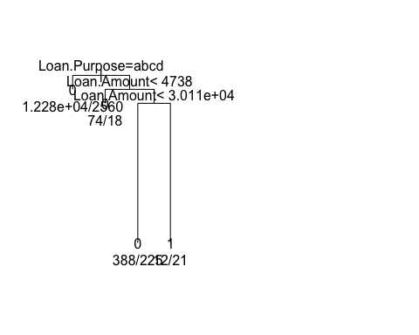

## $x  
## [1] 1.875 1.000 2.750 2.000 3.500 3.000 4.000  
##   
## $y  
## [1] 1.0000000 0.9996813 0.9996813 0.9993626 0.9993626 0.9961756 0.9961756  
##   
## NULL  
##   
## Classification tree:  
## rpart(formula = as.formula(frml1), data = X, control = rpart.control(cp = cp))  
##   
## Variables actually used in tree construction:  
## [1] Loan.Amount Loan.Purpose  
##   
## Root node error: 2824/15578 = 0.18128  
##   
## n= 15578   
##   
## CP nsplit rel error xerror xstd  
## 1 0.0010623 0 1.00000 1.0000 0.017027  
## 2 0.0010000 3 0.99681 1.0018 0.017039  
## [1] "Class ~ Loan.Amount + Loan.Purpose"  
## [1] "not good tree"  
## [1] "Class ~ Loan.Amount + Address.State"  
## [1] "not good tree"  
## [1] "Class ~ Loan.Amount + Debt.To.Income.Ratio"  
## [1] "not good tree"  
## [1] "Class ~ Loan.Amount + No..Delinquencies.In.Last.2.Years"  
## [1] "not good tree"  
## [1] "Class ~ Loan.Amount + Earliest.Credit.Line.Opened"  
## [1] "not good tree"  
## [1] "Class ~ Loan.Amount + FICO.Credit.Score"  
## [1] "not good tree"  
## [1] "Class ~ Loan.Amount + No..Inquiries.In.Last.6.Months"  
## [1] "not good tree"  
## [1] "Class ~ Loan.Amount + Months.Since.Last.Delinquency"  
## [1] "not good tree"  
## [1] "Class ~ Loan.Amount + No..Of.Credit.Lines"

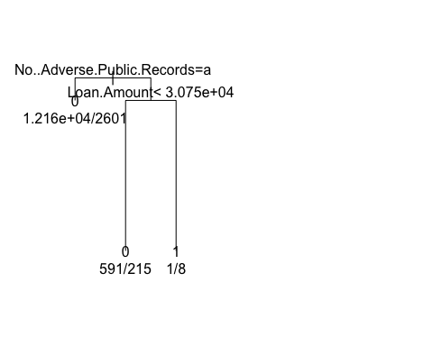

## $x  
## [1] 1.75 1.00 2.50 2.00 3.00  
##   
## $y  
## [1] 1.0000000 0.9996282 0.9996282 0.9971494 0.9971494  
##   
## NULL  
##   
## Classification tree:  
## rpart(formula = as.formula(frml1), data = X, control = rpart.control(cp = cp))  
##   
## Variables actually used in tree construction:  
## [1] Loan.Amount No..Adverse.Public.Records  
##   
## Root node error: 2824/15578 = 0.18128  
##   
## n= 15578   
##   
## CP nsplit rel error xerror xstd  
## 1 0.0012394 0 1.00000 1 0.017027  
## 2 0.0010000 2 0.99752 1 0.017027  
## [1] "Class ~ Loan.Amount + No..Adverse.Public.Records"  
## [1] "not good tree"  
## [1] "Class ~ Loan.Amount + Total.Credit.Balance"  
## [1] "not good tree"  
## [1] "Class ~ Loan.Amount + Use.Of.Credit.Line"  
## [1] "not good tree"  
## [1] "Class ~ Loan.Amount + Total.Number.Of.Credit.Lines"  
## [1] "not good tree"  
## [1] "Class ~ Loan.Amount + Loan.Application.Description"  
## [1] "not good tree"  
## [1] "generate tree for column Loan.Term starts"  
## [1] "Class ~ Loan.Amount + No..Of.Public.Record.Bankruptcies"  
## [1] "not good tree"  
## [1] "Class ~ Loan.Term + Employment.Length"  
## [1] "not good tree"  
## [1] "Class ~ Loan.Term + Home.Ownership"

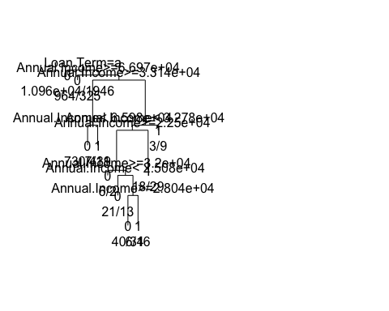

## $x  
## [1] 2.527344 1.000000 4.054688 2.000000 6.109375 3.500000 3.000000  
## [8] 4.000000 8.718750 7.437500 5.875000 5.000000 6.750000 6.000000  
## [15] 7.500000 7.000000 8.000000 9.000000 10.000000  
##   
## $y  
## [1] 1.0000000 0.9996415 0.9996415 0.9992829 0.9992829 0.9960960 0.9946795  
## [8] 0.9946795 0.9960960 0.9957374 0.9929046 0.9925460 0.9925460 0.9911296  
## [15] 0.9911296 0.9890050 0.9890050 0.9929046 0.9957374  
##   
## NULL  
##   
## Classification tree:  
## rpart(formula = as.formula(frml1), data = X, control = rpart.control(cp = cp))  
##   
## Variables actually used in tree construction:  
## [1] Annual.Income Loan.Term   
##   
## Root node error: 2824/15578 = 0.18128  
##   
## n= 15578   
##   
## CP nsplit rel error xerror xstd  
## 1 0.0010623 0 1.00000 1.0000 0.017027  
## 2 0.0010000 9 0.98902 1.0074 0.017076  
## [1] "Class ~ Loan.Term + Annual.Income"

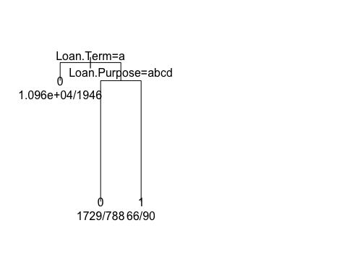

## $x  
## [1] 1.75 1.00 2.50 2.00 3.00  
##   
## $y  
## [1] 1.0000000 0.9987252 0.9987252 0.9902266 0.9902266  
##   
## NULL  
##   
## Classification tree:  
## rpart(formula = as.formula(frml1), data = X, control = rpart.control(cp = cp))  
##   
## Variables actually used in tree construction:  
## [1] Loan.Purpose Loan.Term   
##   
## Root node error: 2824/15578 = 0.18128  
##   
## n= 15578   
##   
## CP nsplit rel error xerror xstd  
## 1 0.0042493 0 1.0000 1.0000 0.017027  
## 2 0.0010000 2 0.9915 0.9915 0.016970  
## [1] "Class ~ Loan.Term + Loan.Purpose"  
## [1] "not good tree"  
## [1] "Class ~ Loan.Term + Address.State"  
## [1] "not good tree"  
## [1] "Class ~ Loan.Term + Debt.To.Income.Ratio"  
## [1] "not good tree"  
## [1] "Class ~ Loan.Term + No..Delinquencies.In.Last.2.Years"  
## [1] "not good tree"  
## [1] "Class ~ Loan.Term + Earliest.Credit.Line.Opened"  
## [1] "not good tree"  
## [1] "Class ~ Loan.Term + FICO.Credit.Score"  
## [1] "not good tree"  
## [1] "Class ~ Loan.Term + No..Inquiries.In.Last.6.Months"  
## [1] "not good tree"  
## [1] "Class ~ Loan.Term + Months.Since.Last.Delinquency"  
## [1] "not good tree"  
## [1] "Class ~ Loan.Term + No..Of.Credit.Lines"  
## [1] "not good tree"  
## [1] "Class ~ Loan.Term + No..Adverse.Public.Records"  
## [1] "not good tree"  
## [1] "Class ~ Loan.Term + Total.Credit.Balance"

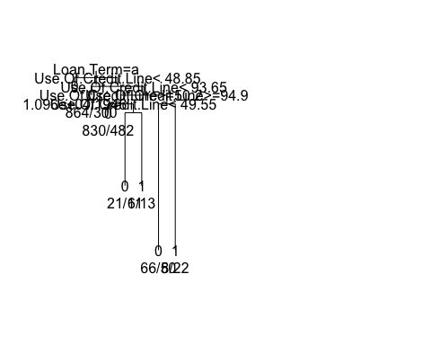

## $x  
## [1] 2.28125 1.00000 3.56250 2.00000 5.12500 3.75000 3.00000 4.50000  
## [9] 4.00000 5.00000 6.50000 6.00000 7.00000  
##   
## $y  
## [1] 1.0000000 0.9997025 0.9997025 0.9994051 0.9994051 0.9991076 0.9988102  
## [8] 0.9988102 0.9963314 0.9963314 0.9991076 0.9941501 0.9941501  
##   
## NULL  
##   
## Classification tree:  
## rpart(formula = as.formula(frml1), data = X, control = rpart.control(cp = cp))  
##   
## Variables actually used in tree construction:  
## [1] Loan.Term Use.Of.Credit.Line  
##   
## Root node error: 2824/15578 = 0.18128  
##   
## n= 15578   
##   
## CP nsplit rel error xerror xstd  
## 1 0.0012394 0 1.00000 1.0000 0.017027  
## 2 0.0010000 6 0.99256 1.0014 0.017036  
## [1] "Class ~ Loan.Term + Use.Of.Credit.Line"  
## [1] "not good tree"  
## [1] "Class ~ Loan.Term + Total.Number.Of.Credit.Lines"  
## [1] "not good tree"  
## [1] "Class ~ Loan.Term + Loan.Application.Description"  
## [1] "not good tree"  
## [1] "generate tree for column Employment.Length starts"  
## [1] "Class ~ Loan.Term + No..Of.Public.Record.Bankruptcies"  
## [1] "not good tree"  
## [1] "Class ~ Employment.Length + Home.Ownership"  
## [1] "not good tree"  
## [1] "Class ~ Employment.Length + Annual.Income"  
## [1] "not good tree"  
## [1] "Class ~ Employment.Length + Loan.Purpose"  
## [1] "not good tree"  
## [1] "Class ~ Employment.Length + Address.State"  
## [1] "not good tree"  
## [1] "Class ~ Employment.Length + Debt.To.Income.Ratio"  
## [1] "not good tree"  
## [1] "Class ~ Employment.Length + No..Delinquencies.In.Last.2.Years"  
## [1] "not good tree"  
## [1] "Class ~ Employment.Length + Earliest.Credit.Line.Opened"  
## [1] "not good tree"  
## [1] "Class ~ Employment.Length + FICO.Credit.Score"  
## [1] "not good tree"  
## [1] "Class ~ Employment.Length + No..Inquiries.In.Last.6.Months"  
## [1] "not good tree"  
## [1] "Class ~ Employment.Length + Months.Since.Last.Delinquency"  
## [1] "not good tree"  
## [1] "Class ~ Employment.Length + No..Of.Credit.Lines"  
## [1] "not good tree"  
## [1] "Class ~ Employment.Length + No..Adverse.Public.Records"  
## [1] "not good tree"  
## [1] "Class ~ Employment.Length + Total.Credit.Balance"  
## [1] "not good tree"  
## [1] "Class ~ Employment.Length + Use.Of.Credit.Line"  
## [1] "not good tree"  
## [1] "Class ~ Employment.Length + Total.Number.Of.Credit.Lines"  
## [1] "not good tree"  
## [1] "Class ~ Employment.Length + Loan.Application.Description"  
## [1] "not good tree"  
## [1] "generate tree for column Home.Ownership starts"  
## [1] "Class ~ Employment.Length + No..Of.Public.Record.Bankruptcies"  
## [1] "not good tree"  
## [1] "Class ~ Home.Ownership + Annual.Income"  
## [1] "not good tree"  
## [1] "Class ~ Home.Ownership + Loan.Purpose"  
## [1] "not good tree"  
## [1] "Class ~ Home.Ownership + Address.State"  
## [1] "not good tree"  
## [1] "Class ~ Home.Ownership + Debt.To.Income.Ratio"  
## [1] "not good tree"  
## [1] "Class ~ Home.Ownership + No..Delinquencies.In.Last.2.Years"  
## [1] "not good tree"  
## [1] "Class ~ Home.Ownership + Earliest.Credit.Line.Opened"  
## [1] "not good tree"  
## [1] "Class ~ Home.Ownership + FICO.Credit.Score"  
## [1] "not good tree"  
## [1] "Class ~ Home.Ownership + No..Inquiries.In.Last.6.Months"  
## [1] "not good tree"  
## [1] "Class ~ Home.Ownership + Months.Since.Last.Delinquency"  
## [1] "not good tree"  
## [1] "Class ~ Home.Ownership + No..Of.Credit.Lines"  
## [1] "not good tree"  
## [1] "Class ~ Home.Ownership + No..Adverse.Public.Records"  
## [1] "not good tree"  
## [1] "Class ~ Home.Ownership + Total.Credit.Balance"  
## [1] "not good tree"  
## [1] "Class ~ Home.Ownership + Use.Of.Credit.Line"  
## [1] "not good tree"  
## [1] "Class ~ Home.Ownership + Total.Number.Of.Credit.Lines"  
## [1] "not good tree"  
## [1] "Class ~ Home.Ownership + Loan.Application.Description"  
## [1] "not good tree"  
## [1] "generate tree for column Annual.Income starts"  
## [1] "Class ~ Home.Ownership + No..Of.Public.Record.Bankruptcies"  
## [1] "not good tree"  
## [1] "Class ~ Annual.Income + Loan.Purpose"  
## [1] "not good tree"  
## [1] "Class ~ Annual.Income + Address.State"  
## [1] "not good tree"  
## [1] "Class ~ Annual.Income + Debt.To.Income.Ratio"  
## [1] "not good tree"  
## [1] "Class ~ Annual.Income + No..Delinquencies.In.Last.2.Years"  
## [1] "not good tree"  
## [1] "Class ~ Annual.Income + Earliest.Credit.Line.Opened"  
## [1] "not good tree"  
## [1] "Class ~ Annual.Income + FICO.Credit.Score"  
## [1] "not good tree"  
## [1] "Class ~ Annual.Income + No..Inquiries.In.Last.6.Months"  
## [1] "not good tree"  
## [1] "Class ~ Annual.Income + Months.Since.Last.Delinquency"  
## [1] "not good tree"  
## [1] "Class ~ Annual.Income + No..Of.Credit.Lines"  
## [1] "not good tree"  
## [1] "Class ~ Annual.Income + No..Adverse.Public.Records"  
## [1] "not good tree"  
## [1] "Class ~ Annual.Income + Total.Credit.Balance"  
## [1] "not good tree"  
## [1] "Class ~ Annual.Income + Use.Of.Credit.Line"  
## [1] "not good tree"  
## [1] "Class ~ Annual.Income + Total.Number.Of.Credit.Lines"  
## [1] "not good tree"  
## [1] "Class ~ Annual.Income + Loan.Application.Description"  
## [1] "not good tree"  
## [1] "generate tree for column Loan.Purpose starts"  
## [1] "Class ~ Annual.Income + No..Of.Public.Record.Bankruptcies"  
## [1] "not good tree"  
## [1] "Class ~ Loan.Purpose + Address.State"  
## [1] "not good tree"  
## [1] "Class ~ Loan.Purpose + Debt.To.Income.Ratio"

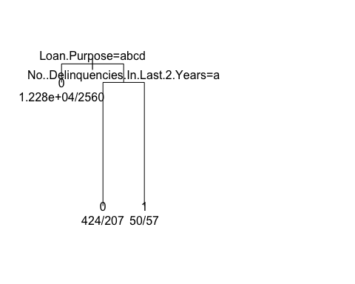

## $x  
## [1] 1.75 1.00 2.50 2.00 3.00  
##   
## $y  
## [1] 1.0000000 0.9996282 0.9996282 0.9971494 0.9971494  
##   
## NULL  
##   
## Classification tree:  
## rpart(formula = as.formula(frml1), data = X, control = rpart.control(cp = cp))  
##   
## Variables actually used in tree construction:  
## [1] Loan.Purpose No..Delinquencies.In.Last.2.Years  
##   
## Root node error: 2824/15578 = 0.18128  
##   
## n= 15578   
##   
## CP nsplit rel error xerror xstd  
## 1 0.0012394 0 1.00000 1.0000 0.017027  
## 2 0.0010000 2 0.99752 1.0046 0.017057  
## [1] "Class ~ Loan.Purpose + No..Delinquencies.In.Last.2.Years"  
## [1] "not good tree"  
## [1] "Class ~ Loan.Purpose + Earliest.Credit.Line.Opened"  
## [1] "not good tree"  
## [1] "Class ~ Loan.Purpose + FICO.Credit.Score"  
## [1] "not good tree"  
## [1] "Class ~ Loan.Purpose + No..Inquiries.In.Last.6.Months"

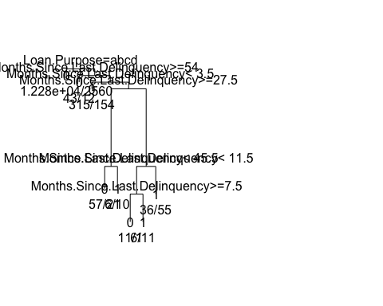

## $x  
## [1] 2.109375 1.000000 3.218750 2.000000 4.437500 3.000000 5.875000  
## [8] 4.500000 4.000000 5.000000 7.250000 6.500000 6.000000 7.000000  
## [15] 8.000000  
##   
## $y  
## [1] 1.0000000 0.9995751 0.9995751 0.9991501 0.9991501 0.9987252 0.9987252  
## [8] 0.9937677 0.9923513 0.9923513 0.9937677 0.9919972 0.9902266 0.9902266  
## [15] 0.9919972  
##   
## NULL  
##   
## Classification tree:  
## rpart(formula = as.formula(frml1), data = X, control = rpart.control(cp = cp))  
##   
## Variables actually used in tree construction:  
## [1] Loan.Purpose Months.Since.Last.Delinquency  
##   
## Root node error: 2824/15578 = 0.18128  
##   
## n= 15578   
##   
## CP nsplit rel error xerror xstd  
## 1 0.0012394 0 1.00000 1.00000 0.017027  
## 2 0.0010000 7 0.99008 0.99469 0.016992  
## [1] "Class ~ Loan.Purpose + Months.Since.Last.Delinquency"  
## [1] "not good tree"  
## [1] "Class ~ Loan.Purpose + No..Of.Credit.Lines"  
## [1] "not good tree"  
## [1] "Class ~ Loan.Purpose + No..Adverse.Public.Records"

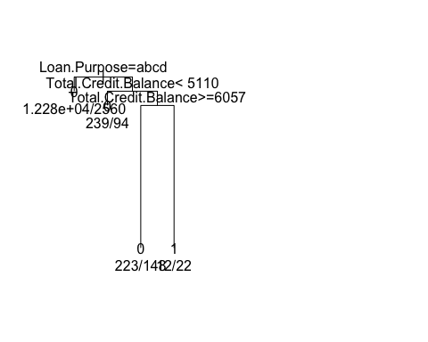

## $x  
## [1] 1.875 1.000 2.750 2.000 3.500 3.000 4.000  
##   
## $y  
## [1] 1.0000000 0.9996459 0.9996459 0.9992918 0.9992918 0.9957507 0.9957507  
##   
## NULL  
##   
## Classification tree:  
## rpart(formula = as.formula(frml1), data = X, control = rpart.control(cp = cp))  
##   
## Variables actually used in tree construction:  
## [1] Loan.Purpose Total.Credit.Balance  
##   
## Root node error: 2824/15578 = 0.18128  
##   
## n= 15578   
##   
## CP nsplit rel error xerror xstd  
## 1 0.0011804 0 1.00000 1.0000 0.017027  
## 2 0.0010000 3 0.99646 1.0025 0.017043  
## [1] "Class ~ Loan.Purpose + Total.Credit.Balance"

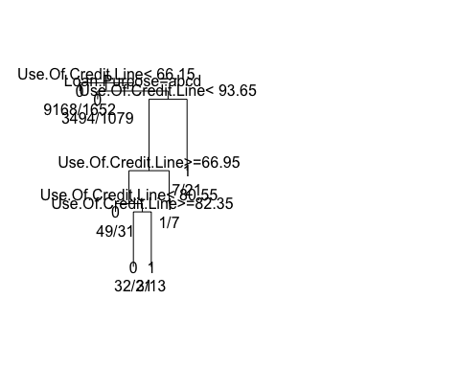

## $x  
## [1] 2.484375 1.000000 3.968750 2.000000 5.937500 4.875000 3.750000  
## [8] 3.000000 4.500000 4.000000 5.000000 6.000000 7.000000  
##   
## $y  
## [1] 1.0000000 0.9994688 0.9994688 0.9989377 0.9989377 0.9943343 0.9922096  
## [8] 0.9916785 0.9916785 0.9881374 0.9881374 0.9922096 0.9943343  
##   
## NULL  
##   
## Classification tree:  
## rpart(formula = as.formula(frml1), data = X, control = rpart.control(cp = cp))  
##   
## Variables actually used in tree construction:  
## [1] Loan.Purpose Use.Of.Credit.Line  
##   
## Root node error: 2824/15578 = 0.18128  
##   
## n= 15578   
##   
## CP nsplit rel error xerror xstd  
## 1 0.0016525 0 1.00000 1.0000 0.017027  
## 2 0.0010000 6 0.98938 1.0007 0.017032  
## [1] "Class ~ Loan.Purpose + Use.Of.Credit.Line"  
## [1] "not good tree"  
## [1] "Class ~ Loan.Purpose + Total.Number.Of.Credit.Lines"  
## [1] "not good tree"  
## [1] "Class ~ Loan.Purpose + Loan.Application.Description"  
## [1] "not good tree"  
## [1] "generate tree for column Address.State starts"  
## [1] "Class ~ Loan.Purpose + No..Of.Public.Record.Bankruptcies"  
## [1] "not good tree"  
## [1] "Class ~ Address.State + Debt.To.Income.Ratio"  
## [1] "not good tree"  
## [1] "Class ~ Address.State + No..Delinquencies.In.Last.2.Years"  
## [1] "not good tree"  
## [1] "Class ~ Address.State + Earliest.Credit.Line.Opened"  
## [1] "not good tree"  
## [1] "Class ~ Address.State + FICO.Credit.Score"  
## [1] "not good tree"  
## [1] "Class ~ Address.State + No..Inquiries.In.Last.6.Months"  
## [1] "not good tree"  
## [1] "Class ~ Address.State + Months.Since.Last.Delinquency"  
## [1] "not good tree"  
## [1] "Class ~ Address.State + No..Of.Credit.Lines"  
## [1] "not good tree"  
## [1] "Class ~ Address.State + No..Adverse.Public.Records"  
## [1] "not good tree"  
## [1] "Class ~ Address.State + Total.Credit.Balance"  
## [1] "not good tree"  
## [1] "Class ~ Address.State + Use.Of.Credit.Line"  
## [1] "not good tree"  
## [1] "Class ~ Address.State + Total.Number.Of.Credit.Lines"  
## [1] "not good tree"  
## [1] "Class ~ Address.State + Loan.Application.Description"  
## [1] "not good tree"  
## [1] "generate tree for column Debt.To.Income.Ratio starts"  
## [1] "Class ~ Address.State + No..Of.Public.Record.Bankruptcies"  
## [1] "not good tree"  
## [1] "Class ~ Debt.To.Income.Ratio + No..Delinquencies.In.Last.2.Years"  
## [1] "not good tree"  
## [1] "Class ~ Debt.To.Income.Ratio + Earliest.Credit.Line.Opened"  
## [1] "not good tree"  
## [1] "Class ~ Debt.To.Income.Ratio + FICO.Credit.Score"  
## [1] "not good tree"  
## [1] "Class ~ Debt.To.Income.Ratio + No..Inquiries.In.Last.6.Months"  
## [1] "not good tree"  
## [1] "Class ~ Debt.To.Income.Ratio + Months.Since.Last.Delinquency"  
## [1] "not good tree"  
## [1] "Class ~ Debt.To.Income.Ratio + No..Of.Credit.Lines"  
## [1] "not good tree"  
## [1] "Class ~ Debt.To.Income.Ratio + No..Adverse.Public.Records"  
## [1] "not good tree"  
## [1] "Class ~ Debt.To.Income.Ratio + Total.Credit.Balance"  
## [1] "not good tree"  
## [1] "Class ~ Debt.To.Income.Ratio + Use.Of.Credit.Line"  
## [1] "not good tree"  
## [1] "Class ~ Debt.To.Income.Ratio + Total.Number.Of.Credit.Lines"  
## [1] "not good tree"  
## [1] "Class ~ Debt.To.Income.Ratio + Loan.Application.Description"  
## [1] "not good tree"  
## [1] "generate tree for column No..Delinquencies.In.Last.2.Years starts"  
## [1] "Class ~ Debt.To.Income.Ratio + No..Of.Public.Record.Bankruptcies"  
## [1] "not good tree"  
## [1] "Class ~ No..Delinquencies.In.Last.2.Years + Earliest.Credit.Line.Opened"  
## [1] "not good tree"  
## [1] "Class ~ No..Delinquencies.In.Last.2.Years + FICO.Credit.Score"  
## [1] "not good tree"  
## [1] "Class ~ No..Delinquencies.In.Last.2.Years + No..Inquiries.In.Last.6.Months"  
## [1] "not good tree"  
## [1] "Class ~ No..Delinquencies.In.Last.2.Years + Months.Since.Last.Delinquency"  
## [1] "not good tree"  
## [1] "Class ~ No..Delinquencies.In.Last.2.Years + No..Of.Credit.Lines"  
## [1] "not good tree"  
## [1] "Class ~ No..Delinquencies.In.Last.2.Years + No..Adverse.Public.Records"  
## [1] "not good tree"  
## [1] "Class ~ No..Delinquencies.In.Last.2.Years + Total.Credit.Balance"  
## [1] "not good tree"  
## [1] "Class ~ No..Delinquencies.In.Last.2.Years + Use.Of.Credit.Line"  
## [1] "not good tree"  
## [1] "Class ~ No..Delinquencies.In.Last.2.Years + Total.Number.Of.Credit.Lines"  
## [1] "not good tree"  
## [1] "Class ~ No..Delinquencies.In.Last.2.Years + Loan.Application.Description"  
## [1] "not good tree"  
## [1] "generate tree for column Earliest.Credit.Line.Opened starts"  
## [1] "Class ~ No..Delinquencies.In.Last.2.Years + No..Of.Public.Record.Bankruptcies"  
## [1] "not good tree"  
## [1] "Class ~ Earliest.Credit.Line.Opened + FICO.Credit.Score"  
## [1] "not good tree"  
## [1] "Class ~ Earliest.Credit.Line.Opened + No..Inquiries.In.Last.6.Months"  
## [1] "not good tree"  
## [1] "Class ~ Earliest.Credit.Line.Opened + Months.Since.Last.Delinquency"  
## [1] "not good tree"  
## [1] "Class ~ Earliest.Credit.Line.Opened + No..Of.Credit.Lines"  
## [1] "not good tree"  
## [1] "Class ~ Earliest.Credit.Line.Opened + No..Adverse.Public.Records"  
## [1] "not good tree"  
## [1] "Class ~ Earliest.Credit.Line.Opened + Total.Credit.Balance"  
## [1] "not good tree"  
## [1] "Class ~ Earliest.Credit.Line.Opened + Use.Of.Credit.Line"  
## [1] "not good tree"  
## [1] "Class ~ Earliest.Credit.Line.Opened + Total.Number.Of.Credit.Lines"  
## [1] "not good tree"  
## [1] "Class ~ Earliest.Credit.Line.Opened + Loan.Application.Description"  
## [1] "not good tree"  
## [1] "generate tree for column FICO.Credit.Score starts"  
## [1] "Class ~ Earliest.Credit.Line.Opened + No..Of.Public.Record.Bankruptcies"  
## [1] "not good tree"  
## [1] "Class ~ FICO.Credit.Score + No..Inquiries.In.Last.6.Months"  
## [1] "not good tree"  
## [1] "Class ~ FICO.Credit.Score + Months.Since.Last.Delinquency"  
## [1] "not good tree"  
## [1] "Class ~ FICO.Credit.Score + No..Of.Credit.Lines"  
## [1] "not good tree"  
## [1] "Class ~ FICO.Credit.Score + No..Adverse.Public.Records"  
## [1] "not good tree"  
## [1] "Class ~ FICO.Credit.Score + Total.Credit.Balance"  
## [1] "not good tree"  
## [1] "Class ~ FICO.Credit.Score + Use.Of.Credit.Line"  
## [1] "not good tree"  
## [1] "Class ~ FICO.Credit.Score + Total.Number.Of.Credit.Lines"  
## [1] "not good tree"  
## [1] "Class ~ FICO.Credit.Score + Loan.Application.Description"  
## [1] "not good tree"  
## [1] "generate tree for column No..Inquiries.In.Last.6.Months starts"  
## [1] "Class ~ FICO.Credit.Score + No..Of.Public.Record.Bankruptcies"  
## [1] "not good tree"  
## [1] "Class ~ No..Inquiries.In.Last.6.Months + Months.Since.Last.Delinquency"  
## [1] "not good tree"  
## [1] "Class ~ No..Inquiries.In.Last.6.Months + No..Of.Credit.Lines"  
## [1] "not good tree"  
## [1] "Class ~ No..Inquiries.In.Last.6.Months + No..Adverse.Public.Records"  
## [1] "not good tree"  
## [1] "Class ~ No..Inquiries.In.Last.6.Months + Total.Credit.Balance"  
## [1] "not good tree"  
## [1] "Class ~ No..Inquiries.In.Last.6.Months + Use.Of.Credit.Line"

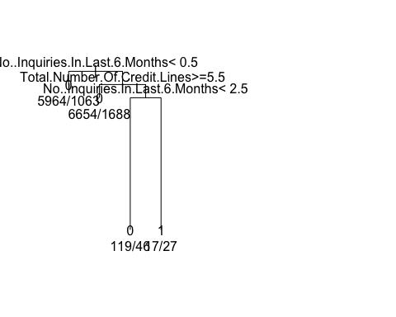

## $x  
## [1] 1.875 1.000 2.750 2.000 3.500 3.000 4.000  
##   
## $y  
## [1] 1.0000000 0.9996459 0.9996459 0.9992918 0.9992918 0.9957507 0.9957507  
##   
## NULL  
##   
## Classification tree:  
## rpart(formula = as.formula(frml1), data = X, control = rpart.control(cp = cp))  
##   
## Variables actually used in tree construction:  
## [1] No..Inquiries.In.Last.6.Months Total.Number.Of.Credit.Lines   
##   
## Root node error: 2824/15578 = 0.18128  
##   
## n= 15578   
##   
## CP nsplit rel error xerror xstd  
## 1 0.0011804 0 1.00000 1.0000 0.017027  
## 2 0.0010000 3 0.99646 1.0007 0.017032  
## [1] "Class ~ No..Inquiries.In.Last.6.Months + Total.Number.Of.Credit.Lines"  
## [1] "not good tree"  
## [1] "Class ~ No..Inquiries.In.Last.6.Months + Loan.Application.Description"  
## [1] "not good tree"  
## [1] "generate tree for column Months.Since.Last.Delinquency starts"  
## [1] "Class ~ No..Inquiries.In.Last.6.Months + No..Of.Public.Record.Bankruptcies"  
## [1] "not good tree"  
## [1] "Class ~ Months.Since.Last.Delinquency + No..Of.Credit.Lines"  
## [1] "not good tree"  
## [1] "Class ~ Months.Since.Last.Delinquency + No..Adverse.Public.Records"  
## [1] "not good tree"  
## [1] "Class ~ Months.Since.Last.Delinquency + Total.Credit.Balance"  
## [1] "not good tree"  
## [1] "Class ~ Months.Since.Last.Delinquency + Use.Of.Credit.Line"  
## [1] "not good tree"  
## [1] "Class ~ Months.Since.Last.Delinquency + Total.Number.Of.Credit.Lines"  
## [1] "not good tree"  
## [1] "Class ~ Months.Since.Last.Delinquency + Loan.Application.Description"  
## [1] "not good tree"  
## [1] "generate tree for column No..Of.Credit.Lines starts"  
## [1] "Class ~ Months.Since.Last.Delinquency + No..Of.Public.Record.Bankruptcies"  
## [1] "not good tree"  
## [1] "Class ~ No..Of.Credit.Lines + No..Adverse.Public.Records"  
## [1] "not good tree"  
## [1] "Class ~ No..Of.Credit.Lines + Total.Credit.Balance"  
## [1] "not good tree"  
## [1] "Class ~ No..Of.Credit.Lines + Use.Of.Credit.Line"  
## [1] "not good tree"  
## [1] "Class ~ No..Of.Credit.Lines + Total.Number.Of.Credit.Lines"  
## [1] "not good tree"  
## [1] "Class ~ No..Of.Credit.Lines + Loan.Application.Description"  
## [1] "not good tree"  
## [1] "generate tree for column No..Adverse.Public.Records starts"  
## [1] "Class ~ No..Of.Credit.Lines + No..Of.Public.Record.Bankruptcies"  
## [1] "not good tree"  
## [1] "Class ~ No..Adverse.Public.Records + Total.Credit.Balance"  
## [1] "not good tree"  
## [1] "Class ~ No..Adverse.Public.Records + Use.Of.Credit.Line"  
## [1] "not good tree"  
## [1] "Class ~ No..Adverse.Public.Records + Total.Number.Of.Credit.Lines"  
## [1] "not good tree"  
## [1] "Class ~ No..Adverse.Public.Records + Loan.Application.Description"  
## [1] "not good tree"  
## [1] "generate tree for column Total.Credit.Balance starts"  
## [1] "Class ~ No..Adverse.Public.Records + No..Of.Public.Record.Bankruptcies"  
## [1] "not good tree"  
## [1] "Class ~ Total.Credit.Balance + Use.Of.Credit.Line"  
## [1] "not good tree"  
## [1] "Class ~ Total.Credit.Balance + Total.Number.Of.Credit.Lines"  
## [1] "not good tree"  
## [1] "Class ~ Total.Credit.Balance + Loan.Application.Description"  
## [1] "not good tree"  
## [1] "generate tree for column Use.Of.Credit.Line starts"  
## [1] "Class ~ Total.Credit.Balance + No..Of.Public.Record.Bankruptcies"  
## [1] "not good tree"  
## [1] "Class ~ Use.Of.Credit.Line + Total.Number.Of.Credit.Lines"  
## [1] "not good tree"  
## [1] "Class ~ Use.Of.Credit.Line + Loan.Application.Description"  
## [1] "not good tree"  
## [1] "generate tree for column Total.Number.Of.Credit.Lines starts"  
## [1] "Class ~ Use.Of.Credit.Line + No..Of.Public.Record.Bankruptcies"  
## [1] "not good tree"  
## [1] "Class ~ Total.Number.Of.Credit.Lines + Loan.Application.Description"  
## [1] "not good tree"  
## [1] "generate tree for column Loan.Application.Description starts"  
## [1] "Class ~ Total.Number.Of.Credit.Lines + No..Of.Public.Record.Bankruptcies"  
## [1] "not good tree"  
## [1] "generate tree for column No..Of.Public.Record.Bankruptcies starts"  
## [1] "Class ~ Loan.Application.Description + No..Of.Public.Record.Bankruptcies"  
## [1] "not good tree"  
## [1] "Class ~ No..Of.Public.Record.Bankruptcies + Class"  
## [1] "not good tree"

options(warn=0)